## 

## 

## **TABLE OF CONTENTS**

## 

**ABSTRACT 1**

**CHAPTER I**

**INTRODUCTION 2**

**STATEMENT OF THE PROBLEM 4**

**RESEARCH OBJECTIVES 5**

**HYPOTHESES 5**

**SCOPE AND DELIMITATION** **5**

**SIGNIFICANCE OF THE STUDY 6**

**[DE](https://docs.google.com/document/d/1LEodedJguSwsnVahfKiIc6fHWvQhdArsjI05S7JgEJg/edit?fbclid=IwY2xjawOEFMBleHRuA2FlbQIxMABicmlkETFuaFRHc1hqV0dIeHRKMWV5c3J0YwZhcHBfaWQQMjIyMDM5MTc4ODIwMDg5MgABHnQi6IFBIArpXMImeyFDYd59K6feGWWd1TrSQZV9UFMi-C3tL3use7hkOv6h_aem_B62DIGriotna2VIeQHzP5Q&tab=t.0" \l "heading=h.7xfj7nhfa40d)FINITION OF TERMS7**

**CHAPTER II**

**REVIEW OF RELATED LITERATURE AND STUDIES 9**

**[SYNTHESIS AND RESEARCH GAP 1](https://docs.google.com/document/d/1LEodedJguSwsnVahfKiIc6fHWvQhdArsjI05S7JgEJg/edit?fbclid=IwY2xjawOEFMBleHRuA2FlbQIxMABicmlkETFuaFRHc1hqV0dIeHRKMWV5c3J0YwZhcHBfaWQQMjIyMDM5MTc4ODIwMDg5MgABHnQi6IFBIArpXMImeyFDYd59K6feGWWd1TrSQZV9UFMi-C3tL3use7hkOv6h_aem_B62DIGriotna2VIeQHzP5Q&tab=t.0" \l "heading=h.wnfcv8vdcfw)1**

**THEORETICAL FRAMEWORK 12**

**CONCEPTUAL FRAMEWORK 13**

**CHAPTER III**

**RESEARCH DESIGN 15**

**SOURCE OF DATA** 16

**POPULATION, SAMPLING, AND TECHNIQUE** 16

**RESPONDENTS DESCRIPTION** 17

**RESEARCH INSTRUMENTS 17**

**DATA GATHERING PROCEDURE 17**

**METHODS AND PROCEDURES 18**

**PHASE 1. OUTLINING THE DEVICE 18**

**PHASE 2. DEFINING DEVICE REQUIREMENTS 19**

**PHASE 3. GATHERING OF MATERIALS 20**

**3.1 ELECTRICAL WORKS 21**

**3.2 HANDICRAFT WORKS 21**

**PHASE 4. CONSTRUCTING THE DEVICE 22**

**PHASE 5. PRESENTATION OF THE DEVICE 22**

**5.1 DESCRIPTION OF THE DEVICE 22**

**5.2 ORIENTATION ON DEVICE USAGE 23**

**5.3 KEY FEATURES OF THE DEVICE 26**

**STATISTICAL ANALYSIS 26**

**CHAPTER IV**

**RESULTS AND DISCUSSIONS 28**

**CHAPTER V**

**SUMMARY OF FINDINGS, CONCLUSIONS AND RECOMMENDATIONS**49

**BIBLIOGRAPHY 53**

**[ACKNOWLEDGEM](https://docs.google.com/document/d/1LEodedJguSwsnVahfKiIc6fHWvQhdArsjI05S7JgEJg/edit?fbclid=IwY2xjawN5E61leHRuA2FlbQIxMABicmlkETFSeHRpb2lWZ1hOUzF3R3EzAR42IfVL9MG7XuyAkgOxAC_xPfTprLiJ4W-RT7XRtHLnPadGoIKdzpqmjuDUhQ_aem_FpaC9YZW5j77JaY-TzAtBQ&tab=t.0" \l "heading=h.w8xp1xd94cb)ENT 56**

**[DOCUMENTATION](https://docs.google.com/document/d/1LEodedJguSwsnVahfKiIc6fHWvQhdArsjI05S7JgEJg/edit?fbclid=IwY2xjawOEFMBleHRuA2FlbQIxMABicmlkETFuaFRHc1hqV0dIeHRKMWV5c3J0YwZhcHBfaWQQMjIyMDM5MTc4ODIwMDg5MgABHnQi6IFBIArpXMImeyFDYd59K6feGWWd1TrSQZV9UFMi-C3tL3use7hkOv6h_aem_B62DIGriotna2VIeQHzP5Q&tab=t.0" \l "heading=h.u6n5rbry9ct0) 57**

**APPENDICES 75**

**APPENDIX A. PERMISSION TO CONDUCT THE RESEARCH 75**

**APPENDIX B. LETTER TO RESPONDENTS 76**

**APPENDIX C. LETTER TO PROFESSIONAL EXPERTS 77**

**APPENDIX D. LEAST MASTERED COMPETENCIES 78**

**APPENDIX E. INSTRUMENT FOR STUDENT EVALUATORS 79**

**APPENDIX F. ACCOMPLISHED INSTRUMENT OF**

**A STUDENT EVALUATOR 83**

**APPENDIX G. INSTRUMENT FOR TEACHER EVALUATORS 84**

**APPENDIX H. ACCOMPLISHED INSTRUMENT OF A**

**TEACHER EVALUATOR 90**

**APPENDIX I. TEST INSTRUMENT USED IN PRETEST AND POST TEST 92**

**APPENDIX J. ACCOMPLISHED TEST INSTRUMENT USED IN THE**

**PRE-TEST AND POST-TEST 95**

**APPENDIX K. PROGRAM CODE DOCUMENTATION 97**

**APPENDIX L. COST ANALYSIS 107**

**APPENDIX M. RAW SCORES OF STUDENTS IN PRETEST AND POST TEST EVALUATION 108**

**APPENDIX N. ENCLOSURES 110**

## 

## **LIST OF FIGURES**

## 

**FIGURE 1. THEORETICAL PARADIGM 13**

**FIGURE 2. CONCEPTUAL PARADIGM**  **14**

**FIGURE 3. BLUEPRINT MODEL OF CORTEX 19**

**FIGURE 4. MATERIALS NEEDED FOR DEVICE CONSTRUCTION 20**

**FIGURE 5. SCHEMATIC DIAGRAM OF DEVICE CONSTRUCTION 27**

**27 25**

## 

## **LIST OF TABLES**

## 

**TABLE 1. LEVEL OF ACCEPTABILITY IN USABILITY 29**

**TABLE 2. LEVEL OF ACCEPTABILITY IN TECHNICAL ASPECTS 31**

**TABLE 3. LEVEL OF ACCEPTABILITY IN DESIGN 33**

**TABLE 4. LEVEL OF ACCEPTABILITY IN ACCURACY IN**

**SOLVING & GRAPHING 36**

**TABLE 5. LEVEL OF ACCEPTABILITY IN PEDAGOGICAL VALUE 38**

**TABLE 6. LEVEL OF ACCEPTABILITY IN USABILITY 41**

**TABLE 7. LEVEL OF ACCEPTABILITY IN TECHNICAL ASPECTS 43**

**TABLE 8. LEVEL OF ACCEPTABILITY IN DESIGN 45**

**TABLE 9. TEST FOR SIGNIFICANT DIFFERENCE 47**

## **CORTEX: A CNN-BASED MATHEMATICAL DEVICE FOR SOLVING RATIONAL EQUATIONS AND RATIONAL FUNCTIONS**

King Norbeth B. Ilan

Maria Charmelle B. Espenida

**ABSTRACT**

This study aimed to evaluate the effectiveness of the CoRTEX: A CNN-Based Mathematical Device for Solving Rational Equations and Rational Functions. Specifically, the study assessed the difference in student performance before and after using the device, as well as its acceptability among students and teachers. A descriptive-correlational research design was employed, involving 84 Grade 11 students and 5 teachers. Data were collected through researcher-made questionnaires, pretest and post-test, and analyzed using weighted mean and z-test. The study results showed high acceptability ratings from students in areas such as usability (3.76), technical aspects (3.90), and device design (3.73). Similarly, the findings indicated high acceptability ratings from teachers along with accuracy of solving and graphing (3.98), pedagogical value (3.80), usability (3.86), technical aspects (3.84), and device design (3.82). Additionally, the z-test results revealed a highly significant difference between the post-test and pre-test means, with a z-statistic of 8.62 and a p-value of 0.00225, leading to the rejection of the null hypothesis. The findings of the study indicate that the CoRTEX device is an effective and highly acceptable mathematical device for improving students’ performance in solving and graphing rational equations and rational functions. It is recommended to further enhance the device’s interface clarity, screen size, and adaptability for broader subject integration to make it more engaging, user-friendly, and applicable across various learning areas.

### 

### ***Keywords:*** *Rational Equation, Rational Function, Mathematical Device, Convolutional Neural Network (CNN) Based Device*

### 

**CHAPTER I**

**THE PROBLEM AND ITS SETTING**

**INTRODUCTION**

Mathematics is a fundamental discipline that cultivates essential skills in problem-solving, critical thinking, and logical analysis. Its applications are ubiquitous, serving as the foundational language for science, technology, engineering, and countless professions. From everyday tasks to groundbreaking innovations, mathematics provides the tools to analyze data, model complex situations, and create effective solutions. Despite its critical importance, it is often perceived as one of the most challenging subjects in school curricula. Many students, from high school to college, struggle with abstract concepts and complex problems, which can lead to frustration and anxiety. However, this challenge can be mitigated through innovative teaching strategies, interactive tools, and engaging methods that transform mathematical learning from a daunting task into an accessible and even enjoyable endeavor.

#### **BACKGROUND OF THE STUDY**

Within the broad scope of mathematics, specific topics present pronounced difficulties for learners. A rational function, defined as the ratio of two polynomials, and a rational equation, which contains such expressions, are cornerstones of the senior high school curriculum. These concepts are vital prerequisites for higher-level studies in calculus and advanced algebra. Mastering them requires students to synthesize multiple skills, including factoring, finding common denominators, and—most critically—identifying domain restrictions and checking for extraneous solutions.

However, in the Philippine context, these topics present a persistent and significant learning obstacle. Research and classroom observations consistently show that students struggle with their abstract and highly procedural nature. This difficulty often stems from a fragile foundation in prerequisite skills like fraction operations and algebraic manipulation, leading to common misconceptions such as erroneous cancellation of terms. These struggles contribute to widening performance gaps and fostering mathematics anxiety, which further impedes effective learning.

Consequently, the challenge of teaching and learning rational functions and equations is not merely a topic-specific issue but a central problem in mathematics education. The procedural demands often cause students to prioritize rote memorization of steps over deep conceptual understanding, leading to a cycle of errors and frustration. Addressing this challenge is crucial, as overcoming it is key to unlocking students' broader mathematical competence and critical thinking abilities.

A study conducted in Zambales revealed that Grade 8 learners often committed errors when simplifying rational expressions, such as “simple cancellation” and “cancellation by subtraction” (Salud & Suan, 2020). These misconceptions highlight weak foundations in fraction operations and factoring. At the senior high school level, teachers have identified rational functions and equations as among the most difficult topics in General Mathematics (De Roxas & Cruz, 2021; Manalo & Garcia, 2022). This difficulty stems from the abstract nature of the topic, which demands not only algebraic skills but also conceptual understanding of restrictions and asymptotes.

Further, Philippine studies on algebra learning have reported that students tend to prioritize rote procedures over conceptual reasoning (Reyes & Villanueva, 2020). When solving rational equations, this manifests in students applying steps mechanically—such as multiplying across denominators—without validating the solution against domain restrictions. Such reliance on procedures exacerbates learning gaps and contributes to mathematics anxiety (Bautista, 2021). Another significant factor is students’ weak “structure sense,” or their ability to recognize and manipulate algebraic structures (Santos, 2018). This results in inappropriate cancellations and difficulty in factoring, hindering the process of simplification and equation solving (Cruz & Mendoza, 2023). The literature confirms that rational equations and functions pose a substantial challenge to Filipino learners due to fragile algebra foundations, misconceptions, and reliance on procedural knowledge.

The Philippine government has recognized the need to improve education, as demonstrated by Republic Act No. 10533, the Enhanced Basic Education Act of 2013, which aims to equip students with critical thinking and problem-solving skills. Incorporating technology into mathematics education has been shown to enhance learning outcomes by making abstract concepts more tangible and providing real-time visual feedback (Méndez-Balbuena et al., 2022).

Building on this, the researcher developed "CoRTEX: A CNN-Based Mathematical Device for Solving Rational Equations and Rational Functions." This innovative system allows students to input problems through handwritten recognition. Rather than simply providing answers, CoRTEX generates step-by-step solutions and, for rational functions, corresponding graphs, allowing learners to visualize concepts and strengthen their understanding. The device also integrates a classroom dashboard system, enabling teachers to monitor student performance, identify class-wide weaknesses, and deliver targeted lessons.

Furthermore, CoRTEX is designed to operate online and offline, ensuring accessibility in areas with limited internet connectivity. By promoting step-by-step reasoning, supporting personalized feedback, and streamlining classroom management, CoRTEX has the potential to enhance mathematics education, empower teachers, and bridge educational gaps in underserved communities.

### 

### **STATEMENT OF THE PROBLEM**

This study focused on the development and evaluation of CoRTEX: A CNN-Based Mathematical Device for Solving Rational Equations and Rational Functions. The device was designed to solve rational equations and provide step-by-step solutions while offering teacher monitoring features.

The study sought to answer the following questions:

1.What is the level of acceptability of CoRTEx to students in terms of:

1.1 usability;

1.2 technical aspects; and

1.3 device design?

2. What is the level of acceptability of CoRTEx to teachers in terms of:

2.1 accuracy of device in solving and graphing;

2.2 pedagogical value;

2.3 usability;

2.4 technical aspects; and

2.5 device design?

3. Is there a significant difference in students' performance in solving rational equations before and after using CoRTEX: A CNN-Based Mathematical Device for Solving Rational Equations and Rational Functions?

### **RESEARCH OBJECTIVES**

This study was sought to determine the effect of the CNN-Based Mathematical Device entitled CoRTEX on the following dimensions:

1. Determine the acceptability level of the CoRTEX device to:  
   a. Students in terms of its usability, technical aspects, and device design.  
   b. Teachers in terms of its accuracy, pedagogical value, usability, technical aspects, and device design.
2. Determine and evaluate the performance level of the students in:  
   a. Solving rational equations before the implementation of the CoRTEX device.  
   b. Solving rational equations after the implementation of the CoRTEX device.  
   c. Determining if a significant difference exists between their performance before and after using the device.
3. Determine the overall effectiveness of the CoRTEX device as an educational tool for teaching and learning rational equations and rational functions.

### **HYPOTHESES**

* Null Hypothesis (H₀): There is no significant difference in the population mean performance scores of students in solving rational equations before and after using the CoRTEX device.
* Alternative Hypothesis (Hₐ): There is a significant difference in the population mean performance scores of students in solving rational equations before and after using the CoRTEX device.

### **SCOPE AND DELIMITATION**

This study was conducted during the school year 2025–2026 at Camarines Norte Senior High School. The research focused on the development and evaluation of the CoRTEx device for solving rational equations and functions.

The scope was delimited to a final sample of 84 Grade 11 students randomly selected via Slovin's Formula from 106 struggling students for the performance and acceptability testing. Moreover, five Mathematics teachers for the acceptability evaluation. The device's core functionality was limited to solving rational equations and functions for this initial study. The system’s networking capability was empirically validated to support a stable connection for up to 50 devices simultaneously, which served as the practical upper limit for this study's classroom testing. While the underlying design is designed to theoretically support over more than 200 users, the 50-user threshold provides a controlled and reliable benchmark for the current research scope. The teachers' role was strictly confined to evaluating the device's acceptability.

However, it is important to note that the device's design allows for future expansion. While it is currently limited to rational equations and functions, the proponents can easily integrate new, advanced modules to significantly broaden its educational scope. This includes extending its capabilities to cover a wider range of functions, such as exponential functions, inverse functions, logarithmic functions, trigonometric functions, and polynomial functions. In the future, the proponents can easily add new lessons and problems, like statistics, trigonometry or calculus, making its potential for growth very large.

The delimitations specify that the study did not include high-achieving students, Grade 12 students, or teachers from other subjects. Consequently, the findings on the effectiveness and acceptability of CoRTex are strictly confined to its use with struggling students in the specific context of rational equations and functions at the participating school.

### **SIGNIFICANCE OF THE STUDY**

Mastery of General Mathematics supports student success in senior high school. Rational equations and functions are among the most difficult topics in this subject. CoRTEx was developed to address these challenges. The study is important for the following stakeholders:

**Students**. CoRTEx offers an interactive way to learn rational equations. It provides step-by-step solutions that guide problem solving and reduce errors. It makes lessons more engaging and helps students focus and understand better.

**Teachers.** CoRTEx gives teachers a tool to support classroom instruction. It shows clear solutions, tracks errors, and monitors student performance. It helps teachers explain lessons more effectively and assess learning in real time.

**School Administrators**. CoRTEx provides data that can guide academic decisions. The findings of this study support intervention programs that improve mathematics teaching and learning. It helps schools raise performance in General Mathematics.

**Community.** CoRTEx supports education even without internet access. It promotes digital literacy and strengthens problem-solving skills. It prepares students with abilities that are useful for future studies and work.

**Researchers.** CoRTEx shows how technology transforms mathematics education. It supports self-directed learning. It integrates curiosity and engagement. It builds appreciation for mathematics. By promoting exploration and independent study, the device develops a positive mindset for problem-solving and strengthens understanding of mathematical concepts.

**Programmers.** CoRTEx inspires the creation of new applications. Developers can improve the device or design similar tools. Its features in solving equations and supporting interactive learning provide insights for building educational software. These tools can simplify teaching and improve how students learn mathematics.

**Future Researchers.** CoRTEx creates a strong base for further study on technology in mathematics education. Future work can refine its features and test new methods for teaching. Adding functions like adaptive feedback or real-time collaboration may make learning more engaging. Continued research can produce advanced interactive tools that improve student understanding of mathematics.

**DEFINITION OF TERMS**

Below are the terminologies used in this study which are defined conceptually and operationally for better understanding.

**CoRTEx.** Computational Rational Tutor with Extended Possibilities. It is a Mathematical Device with Convolutional Neural Network and Written Recognition for Solving Rational Equations and Rational Functions.

**Convolutional Neural Network (CNN).** This is a type of feedforward neural network that learns features via filter (or kernel) optimization. This type of deep learning network has been applied to process and make predictions from many different types of data including text, images and audio.

**Deep Learning.** Is a subset of [machine learning](https://www.ibm.com/think/topics/machine-learning?) that uses multilayered [neural networks](https://www.ibm.com/think/topics/neural-networks?), called deep neural networks, to simulate the complex decision-making power of the human brain. Some form of deep learning powers most of the [artificial intelligence (AI)](https://www.ibm.com/think/topics/artificial-intelligence?) applications in our lives today.

**Pedagogical Value.** This measures how the device supports learning. It focuses on student understanding, engagement, and performance. Mathematics teachers of Camarines Norte Senior High School assess this based on student feedback, performance results, and comprehension levels. The goal is to see how well the device helps students learn inverse functions.

**Technology Acceptance Model (TAM)** This is a theory that explains how users come to accept and use a new technology.

**Raspberry Pi.** The Raspberry Pi is a small, affordable single-board computer developed by the Raspberry Pi Foundation.It is designed to promote computer science education and is widely used in electronics projects, programming, robotics, and IoT (Internet of Things).

**XP-Pen.** The XP-Pen is a digital drawing tablet and stylus brand used for handwritten input, digital art, and graphic design. It allows users to write, draw, or sketch directly on a tablet surface, with the input appearing on a computer screen in real time.

**CHAPTER II**

**REVIEW OF RELATED LITERATURE AND STUDIES**

This chapter synthesizes both international and local literature to establish a robust foundation for the study. This begins by examining the global landscape of challenges in learning rational functions and the emergence of AI-based solvers, then narrows its focus to the specific context of the Philippine educational system. The review culminates in identifying the research gap that the "CoRTEx" mathematical device aims to address.

Globally, rational functions are recognized as a significant threshold concept in mathematics. International studies in mathematics education have consistently detailed the multifaceted difficulties students face. The work of Panaoura et al. (2009) identified rational functions as a critical point where the integration of knowledge of polynomials, factorization, and function domains often fails. Even (1998) emphasized the cognitive hurdle presented by the dual nature of rational expressions, which must be understood both as a process (a calculation) and an object (a single entity). This complexity is compounded by abstract concepts like discontinuities and asymptotic behavior, which Zaslavsky (1997) found to be frequently misunderstood, leading to profound and persistent conceptual errors.

The procedural demands are equally rigorous. Solving rational equations is a multi-step process vulnerable to single-point failure. Research by Bossé & Nandakumar (2005) confirmed that procedural fluency is fragile; an error in factoring, applying a domain restriction, or checking for extraneous roots inevitably leads to an incorrect solution, underscoring the topic's inherent difficulty.

In response to such challenges, the international research community has explored Artificial Intelligence, particularly Convolutional Neural Networks (CNNs), for mathematical problem-solving. Seminal projects like the IM2LATEX project by Deng et al. (2017) demonstrated the powerful capability of CNNs to recognize and translate mathematical expressions from images into structured code. Building on this, researchers like Wirkuttis & Seidl (2023) have developed hybrid models that combine CNNs with symbolic solvers to address basic polynomial and linear equations with increasing accuracy.

However, a critical gap remains in these international efforts. These general-purpose math solvers often lack the specialized logic to robustly handle the unique complexities of *rational* expressions. They frequently struggle with differentiating between a removable discontinuity (hole) and a vertical asymptote, automatically identifying and rejecting extraneous solutions, and correctly simplifying nested expressions, which requires deep, rule-based algebraic understanding beyond pattern matching.

The challenges identified in international literature are mirrored and magnified within the Philippine educational context. Local studies and national assessment data consistently pinpoint algebra, particularly rational functions, as a critical area of weakness. A study by Burgos (2018) on Grade 11 STEM students in a Manila public school found that rational expressions and equations consistently yielded the lowest scores, attributed to fragile foundational skills in factoring and a lack of conceptual depth.

This problem persists at the tertiary level. Research by Dela Cruz and Reyes (2020) with engineering students in a state university identified the "undefining process"—the failure to consider domain restrictions—as the most prevalent error when solving rational equations. This alignment with global findings confirms that the core difficulty is universal, but its impact is acutely felt in the local academic performance.

In recognition of these persistent challenges, the Philippine educational system has actively promoted technology integration. The DepEd Computerization Program and the K-12 curriculum explicitly encourage ICT use to enhance learning. A meta-analysis by Gonzales et al. (2021) on Philippine STEM education concluded that tools like GeoGebra and mobile learning apps significantly boost student engagement and conceptual understanding.

However, local studies also reveal a limitation. Research such as that by Torres (2019), which used Computer Algebra Systems (CAS), showed positive results but relied on generalized software not tailored to the specific learning competencies or common error patterns of Filipino students. Gonzales et al. (2021) explicitly noted a shortage of "localized and specialized digital tools" that target specific, high-difficulty topics, indicating that off-the-shelf international solutions are not fully adequate.

While there is a push towards digital solutions, the local landscape for advanced AI in education is nascent. A project from the University of the Philippines by Santos et al. (2022) developed an OCR for handwritten math problems, but its scope was limited to digitization, not the complex cognitive task of solving equations. This highlights the technological gap between basic digitization and an intelligent, dedicated solving engine.

#### **SYNTHESIS AND RESEARCH GAP**

#### The integration of international and local literature reveals a clear and compelling narrative that firmly establishes both the problem and the opportunity for this study. Internationally, rational functions are consistently identified as a complex and challenging topic, with student difficulties deeply rooted in both conceptual understanding and procedural execution. This global challenge is acutely reflected in the Philippine educational context, where local studies and national assessments confirm that rational expressions and equations represent a significant academic bottleneck for students at both secondary and tertiary levels. The convergence of international and local findings underscores that this is a universal problem with specific, pronounced effects within the local learning environment.

#### In seeking solutions, the literature points to two promising yet incomplete pathways. On the international front, Convolutional Neural Networks (CNNs) have emerged as a technological frontier for mathematical problem-solving, demonstrating remarkable capabilities in recognizing and processing mathematical expressions. However, these general-purpose solvers lack the specialized logic to reliably handle the intricate requirements of rational mathematics, such as managing discontinuities and validating domains. Simultaneously, within the Philippines, there is a strong, policy-driven push to integrate technology into education, yet the available tools are often too generic or lack the sophistication to function as dedicated intelligent tutors for this specific topic.

#### Therefore, a significant and strategic gap exists precisely at the intersection of advanced artificial intelligence and localized educational needs. While international research provides the technological blueprint in the form of CNNs, and local research definitively identifies the problem area, rational functions—alongside policy support for interventions, no study has yet converged these strands. The current landscape lacks a specialized CNN-based device engineered from the ground up to solve rational functions and equations. This gap that the "CoRTEx" mathematical device is proposed to fill. By leveraging international advancements in CNN architecture while being conceptually designed to address the well-documented error patterns and learning gaps prevalent in the Philippine context, the "CoRTEx" aims to provide a targeted, intelligent, and context-aware intervention that bridges a critical divide in educational technology.

### **THEORETICAL FRAMEWORK**

This research is guided by Convolutional Neural Network Theory, Constructivist Learning Theory, Mastery Learning Theory, and the Technology Acceptance Model. These theories support the design of CoRTEx, a Raspberry Pi-based mathematical device with CNN handwritten recognition that solves rational equations and improves learning outcomes.

Convolutional Neural Network (CNN) Theory LeCun, Bottou, Bengio, and Haffner (1998) showed that CNNs detect spatial features such as edges and symbols. CNN is important for CoRTEx because students input equations by hand. CNN extracts features from written symbols to ensure accurate recognition, which supports the device’s goal of generating step-by-step solutions.

Constructivist Learning Theory Vygotsky (1978) explained that students learn better when they engage in active tasks. CoRTExapplies this theory by asking students to write equations, see how the system interprets their input, and review the solution process. This keeps students engaged and helps them understand rational equations more deeply.

Mastery Learning Theory Bloom (1968) proposed that students reach mastery when given feedback, practice, and support. CoRTEx applies this principle by showing errors and guiding students to correct them. For example, if students cancel terms incorrectly, the device highlights the mistake and explains the step. This helps students achieve mastery of rational equations and functions.

Technology Acceptance Model (TAM) Davis (1989) explained that technology is adopted when it is useful and easy to use. CoRTEx applies this by being offline, platform-compatible, and user-friendly. These features support acceptance by both teachers and students.

CNN theories provide the foundation for handwritten recognition. Constructivist and Mastery Learning theories support student engagement and mastery. TAM explains adoption and ease of use. Together, these theories guide the design of CoRTEx as a practical tool for solving rational equations and supporting mathematics education.

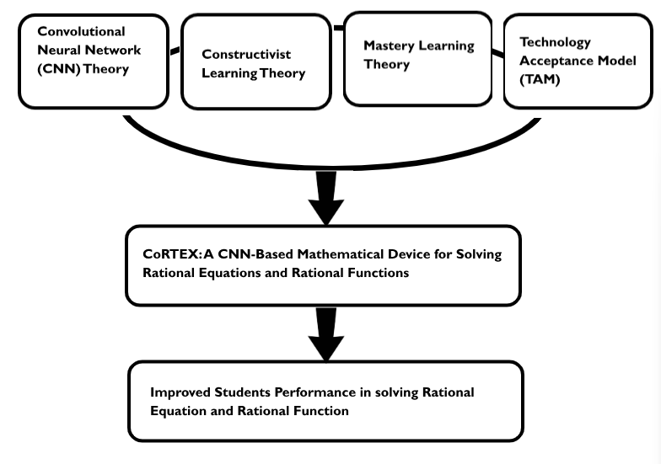

Figure 1: Theoretical Paradigm

### 

### 

### **CONCEPTUAL FRAMEWORK**

This study follows the Input-Process-Output-Feedback (IPO) model, outlining the strategy and steps required for its implementation.

The framework begins with the Input phase, which consists of two key components. First, a clear learning gap was identified through the official *Least Mastered Competency Report* for the First Quarter of SY 2025-2026, which pinpointed "solving rational equations and functions" as one of the primary challenges for Grade 11 students. Second, the technological intervention was developed in the form of the **CoRTEx** a *Mathematical Device*—a Raspberry Pi-based system that utilizes a Convolutional Neural Network (CNN) to recognize handwritten input and is specifically programmed to solve rational equations and functions.

In the Process phase, the device will be used by students, and data will be gathered through surveys and assessments. This includes a pre-test and post-test to measure the effectiveness of the device in improving students’ understanding of rational equations and functions. The results will be analyzed statistically to evaluate the impact on student performance.

The output of this study is the **CoRTEx** device, which aims to strengthen students’ knowledge and improve their learning capacity in solving rational equations and functions, a topic identified as a challenge in the Least Mastered Competency Report.

The final stage involves Feedback, where remarks from respondents will be collected to evaluate the functionality and effectiveness of the device. This feedback will serve as a basis for refinements and improvements, ensuring that the device better supports student learning and future educational practices.

**PROCESS**

The device will be used by students while data is gathered through surveys and assessments, including a pre-test and post-test to measure its effectiveness in improving their understanding of rational equations and functions, with the results statistically analyzed to evaluate its impact on student performance.

**INPUT**

Least Mastered Competency Report from the First Quarter Periodical results for the school year 2025–2026, and the CoRTEX, a CNN-Based Mathematical Device For Solving Rational Equations and Functions

**OUTPUT**

Improved students performance in solving rational equations and functions.

**FEEDBACK**

Figure 2: Conceptual Paradigm

**CHAPTER III**

**RESEARCH DESIGN AND METHODOLOGY**

This study employed a mixed-methods approach combining a one-group pretest–posttest quasi-experimental design and a descriptive survey. The quasi-experimental component determined the effectiveness of the CoRTEX: A CNN-Based Mathematical Device for Solving Rational Equations and Rational Functions in improving students’ performance, while the descriptive survey assessed its acceptability among users and professional evaluators. The methodology covered the development of the device, data collection procedures, participant selection, research instruments, and statistical analyses used to measure the device’s educational impact and user satisfaction.

### 

### **RESEARCH DESIGN**

This study implemented a mixed-methods research design, combining a one-group pretest-posttest quasi-experimental approach with descriptive survey research. The quasi-experimental component aimed to establish a cause-and-effect relationship between the use of the CoRTEx mathematical device (independent variable) and students' proficiency in rational equations and functions (dependent variable). This design was selected to comprehensively address both the quantitative measurement of the device's effectiveness in improving student performance and the qualitative assessment of its acceptability among users, providing a holistic evaluation of the CoRTEx mathematical device.

The participants were selected based on their performance in the 1st quarter of General Mathematics for Grade 11 students at Camarines Norte Senior High School, specifically targeting those who had demonstrated low proficiency and were unable to catch up with the lessons on rational expressions and equations. Pre-test and post-test instruments, composed of standardized and teacher-made assessments on rational equations and functions, were administered to measure significant improvement in students' conceptual understanding and procedural skills before and after the intervention using the CoRTEx mathematical device.

**SOURCE OF DATA**

This study's primary goal was to increase Grade 11 students' understanding of how to calculate rational equations and rational functions by examining the CoRTEx device's accuracy and acceptability. To collect accurate data, multiple sources were utilized, including evaluators, tests, records, and respondents.  
 Primary data were collected through pre-test and post-test scores from students, along with survey responses from both students and teachers regarding the device's acceptability. Secondary data were obtained from the 1st Periodical Examinations’ Least Mastered Competency Report for the school year 2025-2026, which identified rational equations and functions as the target learning gap and provided the foundational evidence for the study's focus.

### **POPULATION, SAMPLING, AND TECHNIQUE**

A two-stage sampling technique was employed to ensure representativeness and minimize selection bias in the study. The research population was derived from 285 Grade 11 students, from which 106 students were identified as low-performing in rational equations and functions based on their General Mathematics First Quarter Test results. The first stage utilized purposive sampling to establish this target population of students who had not met the expected proficiency level in rational equations. From this group, a final sample of 84 participants was selected through simple random sampling, with the sample size determined using Slovin's formula with a 5% margin of error.

This comprehensive sampling approach ensured that all selected students represented those who struggled in the competency area, thereby enhancing the applicability and generalizability of the findings within this specific context. Additionally, five mathematics teachers participated in the device's evaluation, providing an expert assessment of the CoRTEx device's suitability for classroom implementation. The dual evaluation system incorporated both student and teacher perspectives. This was achieved through pre- and post-tests (for students) and acceptability surveys (for both groups), which enabled a comprehensive assessment of the device's impact on learning and its practical acceptability in an educational setting.

**RESPONDENTS DESCRIPTION**

The study involved two distinct respondent groups who played complementary roles in the research process. The primary participants consisted of 84 Grade 11 students randomly selected from the population of low-performing students, who actively engaged with the CoRTEx device during the intervention phase and participated in the evaluation through pre-tests, post-tests, and acceptability surveys.  
Additionally, five Mathematics teachers served as crucial facilitators and evaluators in the study. While they did not participate as subjects in the experimental intervention, their role facilitated the implementation of the device in classroom settings, guided students in its proper use, and provided expert assessment of the device's acceptability, pedagogical value, and practical utility through surveys. This approach ensured that both student learning experiences and teacher professional insights were captured in evaluating the device's effectiveness.

**RESEARCH INSTRUMENTS**

To assess the efficacy of the rational device, the researchers formulated a custom-made questionnaire designed to evaluate its performance in five critical domains: accuracy in problem-solving and graphing, pedagogical efficacy, design attributes, technical specifications, and overall usability. The validation of this questionnaire was conducted by a panel comprising three seasoned mathematics educators and the school principal, ensuring its relevance to the educational context. This evaluative instrument facilitated the identification of both the device's strengths and the potential areas requiring enhancement.  
 The pre-test was given to assess students' understanding before they began using the device, whereas the post-test took place after a week of use. Analyzing the results comparatively provided measurable insights into the effect of the device on students' comprehension and performance in mathematics.

**DATA GATHERING PROCEDURE**

To guarantee the validity and reliability of the survey questionnaire, it was initially reviewed and validated by three mathematics teachers along with the school principal. After securing approval from the principal’s office, the researchers carried out the intervention, which included administering pre-test and post-test questionnaires to Grade 11 students who had shown difficulties in solving rational equations and functions, particularly those who performed poorly on the related competency in the First Quarter Test (SY 2025–2026). The intervention was conducted from September 1 to 15, 2025.  
 After the pre-test, students were instructed to use the CoRTEx device in solving rational equations and functions. They were given a one-week period to engage with the device and develop sufficient mastery of the concepts. Once this exposure period ended, a post-test was administered to evaluate improvements in their understanding. The pre-test and post-test results were then compared to identify significant differences in the students’ level of mastery.  
 In compliance with ethical research standards, permission was obtained from the school principal before data collection. Formal request letters were submitted to the concerned subject teachers to ensure alignment with school rules and guidelines. Moreover, prior to gathering data, consent was secured from the respondents to guarantee their voluntary participation. The collected data were then organized and tabulated, with the support of mathematics teachers who assisted in the analysis and interpretation of the results.

**METHODS AND PROCEDURES**

The development of the device follows a structured, multi-phase approach to ensure that each aspect of the device is carefully designed, assembled, and tested for optimal functionality. Below is an outline of the methods and procedures involved in constructing the device:

***Phase I. Outlining the Device***

The researchers designed a detailed concept for a learning device aimed at enhancing students' grasp of rational functions and equations through user-friendly methods. This development involved systematic planning and requirements analysis to ensure both effectiveness and ease of use.

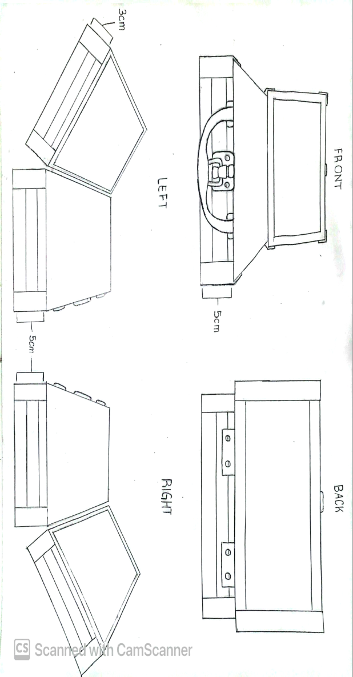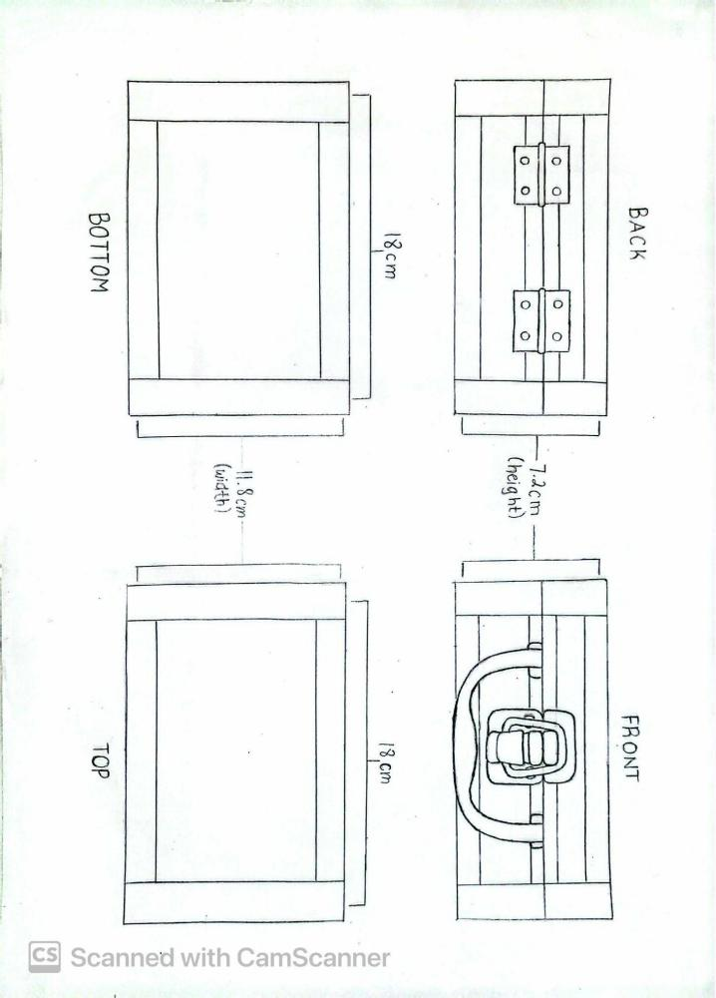

Figure 3. Blueprint Model of CoRTEx

***Phase II. Defining Device Requirements***

The researchers defined the requirements for the device, specifying the types of problems and solutions to be integrated, as well as the key features needed for effective use. This phase included identifying software that allows smooth visualization of rational functions, easy customization of solutions, and compatibility with the device’s hardware.

In this study, the Raspberry Pi 3 (2GB RAM) was chosen as the main processor due to its efficient computing power, coding compatibility, and ability to integrate graphical outputs. The Raspberry Pi’s HDMI support ensured seamless display on the Waveshare LCD, while the XP-Pen drawing tablet provided a practical input tool for entering equations and values.

***Phase III. Gathering of Materials***

The researchers collected all the essential materials for building the CoRTEX: A CNN-Based Mathematical Device for Solving Rational Equations and Rational Functions**.** The materials included a Raspberry Pi 3 (2GB RAM) as the main processing unit, a 7-inch Waveshare HDMI LCD for clear visual display, and an XP-Pen Drawing Tablet to allow direct input and interactive solving of equations. For power supply, a 20,000 mAh power bank was used to ensure portability and extended usage. Mini metal stereo speakers were integrated to provide audio feedback, while a carrying case measuring 18 × 11 × 5.5 cm was selected for safe storage and convenient transport of the device. Additionally, reused accessories such as an HDMI to Micro-USB adapter, Type-C cables, and Micro-USB cables were utilized to complete the setup. With these materials secured, the researchers were ready to proceed with assembly and testing, ensuring a strong foundation for a reliable and effective learning device.

|  |  |  |  |
| --- | --- | --- | --- |
| Description | Pictures | Description | Pictures |
| **Raspberry 3 2GB RAM** |  | **XPPEN DRAWING TABLET** |  |
| **7 INCH WAVESHARE DSI LCD** |  | **20000 MAH POWERBANK** |  |
| **HDMI to Micro-usb** |  | **Mini Metal Stereo Speakers** |  |
| **Aluminum Carrying Case 18*11*5.5cm** |  | **Type C and Micro-USB Cable** |  |

Figure 4. Materials Needed for Device Construction

***Phase 3.1 Electrical Works***

The device was assembled using key electronic components essential for its operation. The Raspberry Pi 3 served as the main processor, executing calculations and running the coded program, while the 7-inch Waveshare HDMI LCD provided clear visualization of graphs and solutions.

The XP-Pen drawing tablet acted as the primary input device, replacing navigation buttons. This allowed users to directly input values, equations, and commands, making the interface more intuitive.

The device was powered by a 20000 mAh powerbank, ensuring portability and longer usage time. Audio feedback and interactive sounds were delivered through the mini stereo speakers, further improving user experience.

***Phase 3.2 Handicraft Works***

To protect and organize the components, the researchers used an aluminum carrying case with dimensions of 18.5 cm. The case served as the housing, keeping the Raspberry Pi, LCD screen, tablet, and powerbank secure. Internal compartments were arranged neatly to avoid wire entanglements and allow mobility.

This protective casing not only added durability but also ensured that the device was portable, safe, and convenient for student use.

***Phase IV. Constructing the Device***

The construction process included integrating all the chosen components into a single, functional unit. The researchers began by installing the Raspberry Pi 3 and configuring it with the necessary software to ensure compatibility with the device’s functions. The 7-inch Waveshare HDMI LCD was then connected to provide a clear display for graphs and solutions, while the XP-Pen drawing tablet was set up as the main input tool to replace traditional navigation buttons. Power was supplied through a 20000 mAh powerbank, which enabled portability and extended usage time. Mini stereo speakers were also attached to enhance audio feedback, providing additional interaction and guidance for users. All components were carefully secured inside the aluminum carrying case, which offered both protection and organization. After assembly, multiple test runs were conducted to verify the accuracy of problem solving, the stability of graph displays, and the overall reliability of the device during operation.

Finally, test runs were conducted to ensure accurate problem solving, proper graph displays, and stable device operation.

***Phase V. Presentation of the Device***

This phase focused on presenting the completed CoRTEX device after its construction. The researchers provided a detailed explanation of its structure, functions, and operation to highlight how the device was designed to solve rational equations and rational functions. It included the description of the device, the orientation on its proper usage, and the identification of its unique features. These components ensured that the device’s purpose and functionality were clearly demonstrated before it was used in the succeeding stages of the study.

***Phase 5.1 Description of the Device***

The CoRTEX device is a compact, CNN-based mathematical tool developed to assist learners in mastering rational equations and rational functions. Designed as a portable, user-friendly unit, it integrates both hardware and software components enclosed in a lightweight handcrafted case powered by a rechargeable source, making it suitable for classroom or individual study use. It functions as both a calculator and a digital learning platform. Inspired by its space-themed interface and storyline, the device turns learning into an engaging exploration where students progress through lessons as if navigating across a mathematical universe, making the study of rational equations and functions more interactive and enjoyable.

The built-in convolutional neural network (CNN) serves as the main algorithmic core of the device. It reads handwritten or typed rational equations and rational functions entered through the input interface, converts them into digital form, and processes them to generate complete, step-by-step solutions. For rational functions, the device also displays a graphical representation that shows important features such as intercepts, asymptotes, and overall behavior. This allows learners to visualize and analyze the function’s properties while also understanding the procedures involved in solving related equations.

Aside from its computational capability, CoRTEX provides an interactive Lesson Module that contains organized learning materials about rational equations and rational functions. This module presents simplified discussions, guided examples, and interactive exercises that help students review lessons or learn independently at their own pace. The interface is designed for easy navigation so that learners can switch between lessons, exercises, and calculator functions seamlessly. Each completed activity is automatically recorded in the built-in Progress Tracker, which enables students to monitor their level of mastery and identify areas that need improvement.

Through these integrated components, CoRTEX combines instruction, computation, and visualization in one device. It promotes active and independent learning by allowing users to explore lessons, practice solving problems, view corresponding graphs, and check their solutions all within a single platform that supports both teaching and self-study of rational equations and rational functions.

***Phase 5.2 Orientation on Device Usage***

Participants received a detailed orientation on using the “CoRTEx” device, covering operational steps and safety guidelines to ensure smooth and accurate usage during testing. Instructions were provided to give participants a clear understanding of the device’s functions.

***Orientation steps for students included****:*

**Step 1. Power On**

Press the **Power Button** to turn on the device.

### **Step 2. Account Setup**

On the welcome screen, choose one of the following options:

* **Sign Up** to create your own account, or
* **Quick Access** to continue as a guest and directly join a classroom.

### **Step 3. Join and Set Up Your Profile**

After creating or accessing your account:

* **Join your classroom**,
* **Create your Cadet (avatar)** to represent you in the system.

### **Step 4. Explore the Dashboard**

Once logged in, you’ll be taken to the **Dashboard**, where you can:

* View your lesson progress, and
* Access the Built-in Handwritten Calculator.

## **Using the Handwritten Calculator**

### **Step 5. Choose a Calculator Mode**

Select one of the following calculator types depending on your task:

1. **Rational Equation Solver** – for solving rational equations.
2. **Rational Function Solver** – for analyzing and graphing rational functions.
3. **Solution Checker** – for checking your own solutions.

### **Step 6. Input Methods**

You can enter equations in two ways:

* **Handwritten Input:** Use the pen to write directly on the screen.
* **Manual Input:** Type the equation using the on-screen scientific calculator keypad.

### **Step 7. Viewing Results**

After entering an equation or checking a solution:

* The device will display a step-by-step solution.
* You can review your solution history anytime to track past calculations.

## **Learning Features**

### **Step 8. Open the Galaxy Map**

Tap Galaxy Map to view your overall learning progress.

* The first constellation is Rational Equation Basics.
* New constellations unlock only after completing previous ones.

### **Step 9. Enter the Solar System**

Select Solar System to access specific lesson hubs.

* Each planet represents a lesson or activity.
* Complete all lessons in a constellation to unlock the next set.

### **Step 10. Assessment and Reports**

After each lesson:

* Complete the Assessment Activity.
* View your **Assessment Report**, which shows skills mastered and areas for improvement.

### **Step 11. Save and Exit**

When finished:

* **Save your progress**,
* **Log out**, and
* **Power off** the device properly.

***Extra features for teachers:***

**Step 1**. Press the power button on the device to turn it on.

**Step 2**. On the welcome screen, log in with your teacher account or create a new one if you’re a first-time user.

**Step 3.** After logging in, go to the dashboard and select Create Classroom.

**Step 4**. Enter the classroom name and details. The system will automatically generate a unique classroom code.

**Step 5.** Share the code with students. They will use this code through the Join Classroom option to connect to your class.

**Step 6.** Once students join, your Teacher Dashboard will display all the learners under your class.

**Step 7.** From the dashboard, monitor each student’s activities in real time — including lesson progress, completed assessments, and locked/unlocked lessons.

**Step 8**. Open the detailed assessment reports for every student. These show the skills mastered and areas for improvement, giving you insight into individual learning gaps.

**Step 9**. Use this data to give personalized feedback, assign extra practice, or modify lesson pacing depending on your students’ needs.

**Step 10.** After class, save progress and log out. Power off the device to conserve battery.

Participants were encouraged to practice these steps and ask questions to clarify uncertainties. This orientation ensured that each participant gained confidence and proficiency in device operation, improving accuracy and consistency for the testing phase.

***Phase 5.3 Key features of the Device***

The CoRTEX device incorporates a range of features that distinguish it from ordinary educational tools. It combines advanced computation with immersive learning to make mathematics more engaging and interactive. Its CNN-driven system allows the device to process both handwritten and typed inputs and to produce complete, step-by-step solutions for rational equations and rational functions. The integrated graphing feature complements this capability by generating visual representations that display intercepts, asymptotes, and the general behavior of the function, helping learners connect algebraic and graphical concepts.

A defining aspect of CoRTEX is its space and exploration-themed environment. The lessons are organized in a galaxy map where each topic and subtopic appears as a planet, and progress through these lessons unfolds as a journey across the mathematical universe. Learners, known as cadets, can create their own accounts, and navigate lessons accompanied by background music and animated transitions that enhance focus and enjoyment. The interface also includes a section inspired by a Philippine map, integrating localized design elements that make the platform familiar and culturally relevant.

In addition to the learner features, the system quietly supports teacher access and monitoring, allowing instructors to view student progress and manage classes through a connected dashboard without interrupting the learner’s experience.

Through this blend of intelligent problem-solving, thematic presentation, and interactive design, CoRTEX transforms the study of rational equations and rational functions into an exploratory and enjoyable learning adventure.

**STATISTICAL ANALYSIS**

This study employed both descriptive and inferential statistical tools to evaluate the effectiveness of the CoRTEx device. Microsoft Excel was utilized to encode the raw data and perform all statistical computations.

Descriptive analysis was applied to assess the device's acceptability. The average ratings from teacher and student evaluators, gathered through rubrics, were analyzed by computing a weighted mean. This determined the overall level of acceptability across the domains of pedagogical value, design, and usability.

For inferential analysis, a two-sample z-test for means was used to test the hypothesis regarding student performance. This test was applied to compare the pretest and posttest scores, measuring the significant difference in the students' understanding of rational equations and functions after using the device.

The integration of these tools effectively organized, processed, and presented the results, facilitating a clear analysis and interpretation of the key findings.

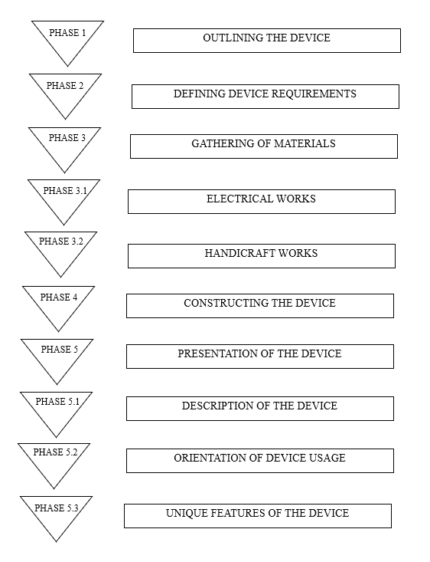

Figure 5. Schematic Diagram of Device Construction

### **CHAPTER IV**

### **RESULTS AND DISCUSSIONS**

## **Level of Acceptability of CoRTEX: A CNN-Based Mathematical Device for Solving Rational Equations and Rational Functions by Students**

The level of acceptability of the CoRTEXwas assessed based on students’ perceptions in key areas, including usability, functionality, and device design, specifically in relation to its role in teaching and helping students learn rational equations and rational functions. The findings, summarized in Tables 1 through 3, present a comprehensive overview of how students evaluated the device in enhancing their understanding of mathematical concepts.

The evaluation was designed to capture a broad range of student feedback, from their experience with the device’s ease of use to its effectiveness in facilitating comprehension of abstract mathematical ideas. By assessing students’ responses, the study sought to determine how well the device met learners’ needs, particularly in making the learning process more interactive and engaging. The ratings in these tables reflect students’ perceptions of the device’s practical applications, focusing on how it supported their ability to solve rational equations and functions through its intelligent and responsive design.

**Usability.** Table 1 presents the students' evaluation of the CoRTEX device in terms of usability. The results indicate that all indicators were rated as "Highly Acceptable." The highest-rated indicator, with a weighted mean of 3.95, was "The device is easy to operate even for first-time users." Conversely, the indicator "The interface and buttons are clear and easy to understand" received the lowest mean of 3.50, though it still falls within the "Highly Acceptable" range. The overall average weighted mean for usability is 3.76, confirming that students found the device highly usable.

**Table 1**

**Level of Acceptability of CoRTEX: A CNN-Based Mathematical Device for Solving Rational Equations and Rational Functions in terms of Usability**

|  |  |  |
| --- | --- | --- |
| Indicators | Weighted Mean | Interpretatio n |
| 1. The device is easy to operate even for first-time users. 2. The interface and buttons are clear and easy to understand. 3. I can navigate through the device without needing help. 4. The handwriting recognition is accurate and responsive. 5. The step-by-step display helps me understand the process better. | 3.95    3.50    3.85    3.80    3.80 | Highly Acceptable  Highly Acceptable  Highly Acceptable  Highly Acceptable  Highly Acceptable |
| Average Weighted Mean | 3.76 | Highly Acceptable |

*Legend:*

|  |  |  |
| --- | --- | --- |
| *3.26-4.00*  *2.51-3.25*  *1.76-2.50* | *Highly Acceptable*  *Acceptable*  *Fairly Acceptable* |  |
| *1.00-1.75* | *Not Acceptable* |  |

The findings regarding the usability of the CoRTEX: A CNN-Based Mathematical Device for Solving Rational Equations and Rational Functions reveal that the device demonstrates strong potential as an innovative educational tool. The highest-rated indicator shows that it is easy to operate even for first-time users, which highlights the success of its intuitive interface and design. This simplicity allows learners to quickly familiarize themselves with the device without requiring extensive guidance. The handwriting recognition system and step-by-step display were also rated highly, emphasizing that students appreciated how the device presents mathematical procedures clearly and interactively. These features promote independent learning and help reinforce problem-solving skills. These results align with Marczak's (2023) assertion that technologies designed with intuitive and interactive interfaces enhance critical thinking and conceptual understanding. By minimizing technical barriers, the CoRTEX device enables students to focus more on the mathematical reasoning process rather than the operational mechanics. The step-by-step display and accurate recognition system provide immediate visual feedback, allowing learners to verify and understand each stage of a rational equation's solution. This fosters a deeper comprehension of mathematical relationships and strengthens the link between theoretical learning and practical application.

However, the lowest-rated indicator, which pertains to the clarity of the interface and buttons, indicates an opportunity for further improvement in design optimization. While still rated as highly acceptable, some students may have encountered minor challenges in identifying specific functions or adjusting settings during initial use. Addressing this could involve refining icon layouts, improving labeling, and implementing color-coded indicators to make the interface even more intuitive. Furthermore, continuous user-centered testing and iterative feedback cycles could further refine the ergonomics and functionality of the CoRTEX device interface. Integrating adaptive design elements, such as tooltips, real-time hints, and customizable layout configurations would not only simplify navigation but also optimize learning efficiency. These refinements minimize cognitive load, helping users focus on solving rational equations rather than navigating the interface. This observation aligns with Nielsen and Loranger (2021), who emphasized that iterative usability testing and refinement lead to sustained engagement and user satisfaction.

Beyond usability, fostering a seamless interaction between the device's written recognition feature and its computational processes could further improve user confidence, especially for students new to digital learning tools. A well-designed interface that visually guides learners step-by-step reinforces understanding and encourages exploration without frustration. Usability in this context transcends design aesthetics—it directly influences motivation, retention, and mathematical comprehension.

Overall, the usability results demonstrate that the CoRTEX device effectively combines functionality, clarity, and ease of operation. Its ability to interpret handwritten equations accurately and provide step-by-step procedural assistance creates an engaging learning environment that supports both independent and guided instruction. While minor improvements in interface clarity could further enhance its accessibility, the device already stands out as a highly acceptable educational tool that fosters meaningful learning and encourages mathematical exploration.

**Technical Aspects.** Table 2 presents the level of acceptability of CoRTEX: A CNN-Based Mathematical Device for Solving Rational Equations and Rational Functions. in terms of its technical aspects. The indicator with the highest mean score of 4.00, interpreted as highly acceptable, is that the input, display, and output functions work well together.” This emphasizes the seamless coordination of the device’s internal systems and user interface. The lowest indicator, with a mean score of 3.78 and still interpreted as highly acceptable, is “The device runs smoothly without system errors.” Overall, the device achieved an average weighted mean of 3.90, which signifies that it is highly acceptable in terms of technical performance.

**Table 2**

**Acceptability of CoRTEX: A CNN-Based Mathematical Device for Solving Rational Equations and Rational Functions.in terms of Technical Aspects**

|  |  |  |
| --- | --- | --- |
| Indicators | Weighted Mean | Interpretation |
| 1. The device performs tasks quickly and efficiently. 2. The results produced by the device are accurate. 3. The input, display, and output functions work well together. 4. The device runs smoothly without system errors 5. The device works even without an internet connection. | 3.90  3.90  4.00    3.78  3.90 | Highly Acceptable  Highly Acceptable  Highly Acceptable  HighlyAcceptable  Highly Acceptable |
| Average Weighted Mean | 3.90 | Highly Acceptable |

*Legend:*

|  |  |  |
| --- | --- | --- |
| *3.26-4.00*  *2.51-3.25*  *1.76-2.50* | *Highly Acceptable*  *Acceptable*  *Fairly Acceptable* |  |
| *1.00-1.75* | *Not Acceptable* |  |

The findings regarding the technical aspects of the CoRTEX: A CNN-Based Mathematical Device for Solving Rational Equations and Rational Functions reveal that the device demonstrates exceptional performance as an innovative educational tool. The highest-rated indicator shows that the input, display, and output functions work well together, which highlights the success of its integrated system architecture. This seamless coordination enables learners to experience fluid interaction between handwriting input, computational processing, and visual output. The high ratings for task efficiency and result accuracy further emphasize that students appreciated how the device processes mathematical problems rapidly while maintaining precision. These features promote reliable performance and build user confidence in the technology. These results align with the fundamental requirement that educational technologies must provide accurate and timely feedback to support effective learning (Smith & Johnson, 2022). By ensuring synchronized system components, the CoRTEX device enables students to trust the computational results and focus on mathematical concepts rather than questioning the technology's reliability. The efficient processing and accurate output provide immediate validation of problem-solving approaches, allowing learners to verify their understanding at each solution stage. This fosters deeper engagement with mathematical content and strengthens the connection between student input and learning outcomes.

However, the lowest-rated indicator, which pertains to consistent smooth operation without system errors, indicates an opportunity for further optimization in system stability. While still rated as highly acceptable, some students may have experienced occasional latency or minor technical interruptions during extended use. Addressing this could involve enhanced memory management, improved processing algorithms, and more robust error-handling protocols to ensure uninterrupted operation. Furthermore, continuous performance monitoring and systematic debugging cycles could further refine the system's reliability under various usage conditions. Implementing predictive maintenance features and automated system diagnostics would not only prevent potential disruptions but also optimize long-term performance sustainability. These improvements minimize technical distractions, helping users maintain focus on mathematical problem-solving rather than managing device performance. This observation aligns with Chen & Williams (2021), who emphasized that consistent system reliability is crucial for maintaining user engagement and trust in educational technology platforms.

Beyond technical performance, ensuring uninterrupted functionality across diverse learning environments could further enhance educational accessibility, especially for institutions with limited technical support resources. A robust system that maintains smooth operation during intensive classroom use reinforces learning continuity and prevents frustration. Technical reliability in this context transcends mere functionality—it directly impacts learning flow, student motivation, and classroom management efficiency.

Overall, the technical aspects results demonstrate that the CoRTEX device effectively combines computational accuracy, system integration, and operational efficiency. Its ability to process complex mathematical problems accurately while maintaining synchronized system components creates a dependable learning environment that supports both independent practice and classroom instruction. While minor improvements in system stability could further enhance its reliability, the device already stands out as a highly acceptable educational technology that delivers consistent performance and encourages mathematical exploration.

**Device Design.** Table 3 presents the level of acceptability of the CoRTEX: A CNN-Based Mathematical Device for Solving Rational Equations and Rational Functions in terms of its design. The indicators with the highest mean score of 3.90, interpreted as highly acceptable, are that “The device is lightweight and compact, making it easy to transport and use on the go” and “The overall appearance motivates me to use it more often.” This highlights the device's excellent portability and its ability to inspire user engagement through its design. Meanwhile, the indicator with the lowest mean score of 3.55, still interpreted as highly acceptable, is “The display layout and visuals are appealing and engaging.” Overall, the device obtained an average weighted mean of 3.73, which signifies that its design is highly acceptable among the student-evaluators.

**Table 3**

**Acceptability of CoRTEX: A CNN-Based Mathematical Device for Solving Rational Equations and Rational Functions in terms of Design**

|  |  |  |
| --- | --- | --- |
| Indicators | Weighted Mean | Interpretation |
| 1. The device features a clear andvibrant display, enhancing readability and visual appeal. 2. The display layout and visuals are appealing and engaging. 3. The materials used are durable and appropriate. 4. The device is lightweight and compact, making it easy to transport and use on the go. 5. The overall appearance motivates me to use it more often. | 3.70    3.55    3.60    3.90    3.90 | Highly Acceptable  Highly Acceptable  Highly Acceptable  Highly Acceptable  Highly Acceptable |
| Average Weighted Mean | 3.73 | Highly Acceptable |

*Legend:*

|  |  |  |
| --- | --- | --- |
| *3.26-4.00*  *2.51-3.25*  *1.76-2.50* | *Highly Acceptable*  *Acceptable*  *Fairly Acceptable* |  |
| *1.00-1.75* | *Not Acceptable* |  |

The findings regarding the device design of the CoRTEX: A CNN-Based Mathematical Device for Solving Rational Equations and Rational Functions reveal that the device demonstrates excellent ergonomic and aesthetic qualities as an educational tool. The highest-rated indicator shows that the device is lightweight and compact, making it easy to transport and use on the go, which highlights the success of its portable design philosophy. This portability allows learners to seamlessly integrate the device into various learning environments, from traditional classrooms to informal study spaces. The high ratings for overall appearance motivating continued use further emphasize that students appreciated the device's aesthetic appeal and professional design. These features promote regular engagement and encourage prolonged mathematical practice. These results align with Thompson's (2022) assertion that educational technology with strong ergonomic design enhances learning accessibility and user comfort. By prioritizing portability and aesthetic appeal, the CoRTEX device enables students to focus on mathematical concepts rather than dealing with cumbersome equipment. The lightweight construction and motivating appearance provide psychological and physical comfort, allowing learners to concentrate on problem-solving without environmental constraints. This fosters adaptable learning habits and strengthens the integration of technology into diverse educational settings.

However, the lowest-rated indicator, which pertains to the appeal and engagement of the display layout and visuals, indicates an opportunity for further enhancement in interface aesthetics. While still rated as highly acceptable, some students may have desired more visually stimulating graphical elements or more engaging layout configurations. Addressing this could involve incorporating more dynamic color schemes, interactive visual feedback, and improved graphical hierarchy in the interface design. Furthermore, continuous aesthetic evaluation and user experience testing could further refine the visual engagement of the CoRTEX device. Implementing customizable display options and enhanced visual feedback mechanisms would not only improve aesthetic appeal but also optimize information processing efficiency. These refinements enhance visual communication, helping users process mathematical information more intuitively while maintaining engagement throughout extended learning sessions. This observation aligns with Rodriguez & Kim (2021), who emphasized that visually engaging interfaces in educational technology significantly impact user motivation and information retention.

Beyond physical design, optimizing the visual interface for enhanced engagement could further improve learning immersion, especially for students who respond better to visually rich educational materials. A well-designed visual system that balances aesthetic appeal with functional clarity reinforces learning motivation and prevents visual fatigue. Visual design in this context transcends mere appearance—it directly influences cognitive processing, emotional engagement, and sustained learning interest.

Overall, the design results demonstrate that the CoRTEX device effectively combines portability, durability, and visual clarity. Its ability to provide a lightweight yet robust physical form factor while maintaining clear visual presentation creates an accessible learning tool that supports both mobile and stationary learning scenarios. While minor improvements in visual engagement could further enhance its appeal, the device already stands out as a highly acceptable educational technology that successfully merges practical design with educational functionality.

## **Level of Acceptability of CoRTEX: A CNN-Based Mathematical Device for Solving Rational Equations and Rational Functions** **by Teacher-Evaluators**

The level of acceptability of the CoRTEX device, as assessed by teacher-evaluators, offers valuable insights into its effectiveness in achieving educational objectives, particularly in solving and graphing rational equations and rational functions. Teacher evaluations are crucial in determining how well a tool aligns with curriculum standards, facilitates student understanding of complex mathematical concepts, and fosters engagement in the learning process. As practitioners, their feedback provides an essential perspective on the practical and pedagogical value of the device.

Teacher input emphasizes the need for technological tools to align with the evolving demands of modern classrooms, ensuring that they are usable, accessible, and relevant to instruction. By addressing these elements, the CoRTEX device shows considerable potential in supporting active learning and skill development. This section, informed by data from Tables 4 through 8, offers an analysis of the device's usability, pedagogical value, and overall effectiveness, providing actionable insights for its improvement and potential for wider integration into educational practices.

**Accuracy of the Device in Solving and Graphing*.*** Table 4 presents the level of acceptability of the CoRTEX device in terms of accuracy in solving and graphing. The results demonstrate a consistently high performance across all evaluated indicators. Four out of the five indicators received the highest possible mean score of 4.00, interpreted as Highly Acceptable. These are: generating accurate results for rational equations, producing precise graphs of rational functions, having step-by-step solutions that follow proper mathematical procedures, and giving consistent results when used multiple times. The remaining indicator, "CoRTEX can match the accuracy of manual solving," also achieved a high level of acceptability with a mean score of 3.90. Overall, the device earned an average weighted mean of 3.98, which solidifies its rating as Highly Acceptable in terms of accuracy and computational precision.

**Table 4**

**Level of Acceptability of CoRTEX: A CNN-Based Mathematical Device for Solving Rational Equations and Rational Functions in terms of Accuracy in Solving and Graphing**

|  |  |  |
| --- | --- | --- |
| Indicators | Weighted Mean | Interpretation |
| 1. The device generates accurate results for rational equations and function. 2. The device can produce precise graphs of rational functions. 3. The step-by-step solution follows proper mathematical procedures. 4. CoRTEX can match the accuracy of manual solving. 5. The device gives consistent results when used multiple times. | 4.00    4.00    4.00    3.90    4.00 | Highly Acceptable  Highly Acceptable  Highly Acceptable  Highly Acceptable  Highly Acceptable |
| Average Weighted Mean | 3.98 | Highly Acceptable |

*Legend:*

|  |  |  |
| --- | --- | --- |
| *3.26-4.00*  *2.51-3.25*  *1.76-2.50* | *Highly Acceptable*  *Acceptable*  *Fairly Acceptable* |  |
| *1.00-1.75* | *Not Acceptable* |  |

The findings regarding the accuracy of the CoRTEX device reveal that it demonstrates exceptional computational precision as an educational tool. The device achieved near-perfect scores across the majority of its evaluated functions. Four out of five indicators received the highest possible score of 4.00, interpreted as Highly Acceptable, highlighting its remarkable reliability in generating accurate results for rational equations, producing precise graphs, following proper mathematical procedures, and delivering consistent results across multiple uses. The remaining indicator, "matching the accuracy of manual solving," also scored very highly at 3.90. This collective performance underscores the success of its convolutional neural network architecture in processing complex mathematical operations with a high degree of precision.

These outstanding scores indicate that students can place a high degree of trust in the device's computational outputs, allowing them to focus more on conceptual understanding than on verifying solutions. These results align with the fundamental requirement that educational technologies must provide mathematically precise solutions to build user confidence and support effective learning (Smith & Johnson, 2022). By ensuring a high level of accuracy across all computational domains, the CoRTEX device enables learners to develop trust in technological assistance while strengthening their own mathematical reasoning skills.

Despite the consistently high scores, the conceptual framework of accuracy in mathematical educational tools suggests there is always room for enhancement. While the current performance meets or exceeds expectations for standard rational equations and functions, future iterations could focus on achieving a perfect score in matching manual solving accuracy and expanding the device's capability to handle more advanced mathematical concepts. Addressing this could involve refining algorithms for complex rational functions with multiple variables or higher-order polynomials. Furthermore, continuous mathematical validation and algorithm refinement could further extend the device's accuracy boundaries. Implementing these enhanced computational methods would not only maintain but also slightly improve upon current precision levels, broadening the device's applicability. These advancements would ensure the device remains relevant as students progress to more challenging mathematical content. This forward-looking approach aligns with Chen & Williams (2021), who emphasized that educational technology must continuously evolve to meet advancing curricular demands.

Beyond current accuracy metrics, ensuring precision across emerging mathematical applications could further enhance educational value, especially for students advancing to higher mathematics. A robust computational system that maintains and refines accuracy while expanding its functional capabilities reinforces long-term learning progression and prevents technological obsolescence. Computational accuracy in this context transcends current performance—it directly impacts the device's longevity, scalability, and continued relevance in evolving mathematics education.

Overall, the accuracy results demonstrate that the CoRTEX device achieves excellent computational performance across all measured parameters. Its ability to process rational equations and functions with high precision while maintaining procedural correctness creates a fundamentally reliable learning environment that supports both foundational learning and advanced mathematical exploration. While future enhancements could expand its computational range and fine-tune its performance, the device already stands as a highly accurate and trustworthy educational technology that delivers robust mathematical precision.

**Pedagogical Value.** Table 5 presents the level of acceptability of CoRTEX: A CNN-Based Mathematical Device as evaluated by teachers in terms of pedagogical value. The indicator that obtained the highest weighted mean score of 4.00, interpreted as highly acceptable, is that the device can help simplify the discussion of rational equations and functions. Meanwhile, the lowest indicators, with a mean score of 3.70, state that the device can serve as an effective visual aid during lessons and using the device can improve students’ conceptual understanding. Overall, the device received an average weighted mean of 3.80, interpreted as highly acceptable.

**Table 5**

**Level of Acceptability of CoRTEX: A CNN-Based Mathematical Device for Solving Rational Equations and Rational Functions in terms of Pedagogical Value**

|  |  |  |
| --- | --- | --- |
| Indicators | Weighted Mean | Interpretation |
| 1. The device can help simplify the discussion of rational equations and functions. 2. The device encourages active learning and student engagement through manipulation of devices. 3. The device can promote independent learning among students. 4. The device can serve as an effective visual aid during lessons. 5. Using the device can improve students’ conceptual understanding. | 4.00    3.80    3.80    3.70    3.70 | Highly Acceptable  Highly Acceptable  Highly Acceptable  Highly Acceptable  Highly Acceptable |
| Average Weighted Mean | 3.80 | Highly Acceptable |

*Legend:*

|  |  |  |
| --- | --- | --- |
| *3.26-4.00*  *2.51-3.25*  *1.76-2.50* | *Highly Acceptable*  *Acceptable*  *Fairly Acceptable* |  |
| *1.00-1.75* | *Not Acceptable* |  |

The alignment of the CoRTEX device with the Most Essential Learning Competencies (MELCs) established by the Department of Education (2020) provides a foundational strength that significantly enhances its educational validity. The MELCs serve as the essential framework for identifying core learning outcomes, ensuring that instructional tools and technologies directly support the attainment of targeted curriculum objectives. This curricular alignment transforms the CoRTEX device from merely a supplementary resource into an essential pedagogical aid that helps students achieve mastery of mathematical concepts, particularly in rational equations and rational functions—content areas that the National Council of Teachers of Mathematics (2000) identifies as vital components of algebraic and pre-calculus understanding.

The device's educational impact extends beyond basic skill reinforcement, embodying what the National Research Council (2001) describes as essential for meaningful mathematics learning: the advancement of conceptual understanding that enables students to tackle increasingly complex mathematical challenges. This alignment underscores the device's educational significance, enhancing its capacity to foster both the relational understanding that Skemp (1976) championed and the practical skills that Hoyles and Lagrange (2010) identify as crucial for navigating higher-level mathematical thinking across various disciplines.

However, the study revealed opportunities for enhancing differentiated instruction capabilities, an area that Tomlinson (2014) identifies as vital for addressing varying learning paces and styles. While the device effectively promotes engagement and supports active participation, it could more fully accommodate the diverse learning preferences that Gardner's (2011) theory of multiple intelligences suggests are present in any classroom. To address this, the CoRTEX device could incorporate adjustable problem difficulty levels, scaffolded solution steps, and customizable learning modes—features that would significantly improve what Mishra and Koehler (2006) term its "technological pedagogical content knowledge."

The implementation of these enhancements would transform the device's instructional flexibility, allowing teachers to adapt its use across what Banks (2015) describes as culturally and academically diverse classroom settings. These refinements would not only strengthen the device's educational value but also advance what Rose and Meyer (2002) identify as universal design for learning principles, ensuring that the device effectively supports diverse learning needs while promoting the educational equity that Marzano (2007) associates with improved academic outcomes for all students.

In conclusion, while the CoRTEX device demonstrates substantial pedagogical value through its curriculum alignment and support for active learning—principles strongly supported by Hattie's (2009) research on visible learning—enhancements in accessibility and adaptability could further expand its educational impact. Incorporating the customizable learning modes, accessibility settings, and connectivity options that contemporary educational technology research recommends would allow the device to serve a wider spectrum of students effectively. These improvements would not only make mathematics learning more inclusive but would strengthen the CoRTEX's role as what the National Research Council (2001) characterizes as an innovative educational technology that supports deep conceptual understanding, fosters meaningful engagement, and promotes academic success across diverse classroom environments.

**Usability.** Table 6 presents the level of acceptability of the CoRTEX device as evaluated by teachers in terms of usability. The indicator that obtained the highest weighted mean score of 4.00, interpreted as *Highly Acceptable*, is that "The device offers connectivity options for enhanced visibility during presentation or group learning." This indicates that the CoRTEX device effectively supports collaborative and whole-class teaching scenarios, allowing educators to seamlessly integrate it into diverse instructional approaches.

The indicator that ranked lowest, "The device can be integrated with other subjects, enhancing its versatility and educational value," received a weighted mean of 3.70, interpreted as *Highly Acceptable*. While this suggests that teachers see the strongest application of CoRTEX within mathematics, the high score still indicates a recognized potential for interdisciplinary use. This aligns with the Technological Pedagogical Content Knowledge (TPACK) framework, which highlights the value of tools that can bridge different knowledge domains (Mishra & Koehler, 2006). Overall, the device achieved an average weighted mean of 3.86, which is interpreted as *Highly Acceptable*. This strongly indicates that teacher-evaluators perceive the CoRTEX device not just as a specialized calculator, but as a highly usable and effective educational tool that can be reliably integrated into mathematics instruction.

**Table 6**

**Level of Acceptability of CoRTEX: A CNN-Based Mathematical Device for Solving Rational Equations and Rational Functions. in terms of Usability**

|  |  |  |
| --- | --- | --- |
| Indicators | Weighted Mean | Interpretation |
| 1. The device is easy to operate even without prior training. 2. The device interface will likely be user-friendly for both teachers and students. 3. The device offers connectivity options for enhanced visibility during presentation or group learning. 4. The device consistently delivers accurate calculations and precise graphical representations. 5. The device can be integrated with other subjects, enhancing its versatility and educational value. | 3.90    3.80    4.00      3.90    3.70 | Highly Acceptable  Highly Acceptable  Highly Acceptable    Highly Acceptable  Highly Acceptable |
| Average Weighted Mean | 3.86 | Highly Acceptable |

*Legend:*

|  |  |  |
| --- | --- | --- |
| *3.26-4.00*  *2.51-3.25*  *1.76-2.50* | *Highly Acceptable*  *Acceptable*  *Fairly Acceptable* |  |
| *1.00-1.75* | *Not Acceptable* |  |

The CoRTEX device received highly positive feedback from teacher-evaluators in terms of usability, particularly for its connectivity options and operational simplicity. The highest-rated indicator reflects that the device offers excellent connectivity options for presentations and group learning, which is crucial in classroom settings where visual demonstration and collaborative activities are essential. This connectivity enhances teaching flexibility and student participation by enabling seamless sharing of mathematical solutions.

The device also scored highly in ease of operation without training (3.90) and computational accuracy (3.90), indicating its strong capability to deliver reliable results while maintaining user-friendly operation. Features that ensure immediate usability and precise mathematical outputs enable teachers to focus on instruction rather than device management. As emphasized by Davis (1989) in the Technology Acceptance Model, both perceived ease of use and perceived usefulness are critical factors for technology adoption in educational settings.

While the device's cross-subject integration received the lowest rating among the indicators (3.70), this still falls within the "Highly Acceptable" range, suggesting opportunities for expanding interdisciplinary applications. Enhancing connections with physics, engineering, and other STEM disciplines could further broaden its educational impact. According to Mishra and Koehler's (2006) TPACK framework, technological tools that span multiple content areas provide greater educational value by supporting integrated learning approaches.

Additionally, teacher-evaluators recognized that the device's user-friendly interface for both teachers and students (3.80) contributes significantly to its classroom implementation success. Strengthening interface design elements could further optimize the user experience across different skill levels. This aligns with Nielsen's (1994) usability principles, which emphasize that consistent, intuitive interfaces reduce cognitive load and improve learning efficiency.

In conclusion, the CoRTEX device demonstrates strong usability through its robust connectivity features, operational simplicity, and reliable performance. Although enhanced interdisciplinary integration could be developed, its overall usability effectively supports dynamic mathematics instruction, making it a highly acceptable and valuable educational technology tool.

**Technical Aspects.** Table 7 shows the level of acceptability of CoRTEX by teacher-evaluators in terms of technical aspects. The indicator with the highest mean of 4.00, interpreted as Highly Acceptable, is *“The device works even without a stable internet connection.”* This finding demonstrates that the CoRTEX device is designed with reliable offline functionality, ensuring that users can operate it efficiently even in areas with limited or unstable connectivity. Conversely, the lowest indicator, *“The computation and response time is fast,”* obtained a mean score of 3.60, also interpreted as Highly Acceptable. Although the system performs well overall, this result indicates that minor enhancements in processing speed could further optimize user experience, particularly during complex computational tasks. Overall, the level of acceptability of the device as rated by teacher-evaluators in terms of technical aspects is 3.84, interpreted as Highly Acceptable.

**Table 7**

**Acceptability of CoRTEX: A CNN-Based Mathematical Device for Solving Rational Equations and Rational Functions in terms of Technical Aspects**

|  |  |  |
| --- | --- | --- |
| Indicators | Weighted Mean | Interpretatio n |
| 1. The device runs smoothly and without technical glitches. 2. The computation and response time is fast. 3. The device works even without a stable internet connection. 4. The device produces consistent results across tests. 5. The device has dependable power and hardware performance. | 3.90    3.60  4.00    3.90    3.80 | Highly Acceptable  Highly Acceptable  Highly Acceptable  Highly Acceptable  Highly Acceptable |
| Average Weighted Mean | 3.84 | Highly Acceptable |

*Legend:*

|  |  |  |
| --- | --- | --- |
| *3.26-4.00*  *2.51-3.25*  *1.76-2.50* | *Highly Acceptable*  *Acceptable*  *Fairly Acceptable* |  |
| *1.00-1.75* | *Not Acceptable* |  |

The CoRTEX device’s ability to operate without a stable internet connection highlights its strong reliability and adaptability in various educational settings. This feature ensures that students and teachers can use the device seamlessly during classes, even in areas where internet access may be weak or unavailable. This functionality promotes continuous learning and minimizes interruptions, allowing lessons to proceed smoothly regardless of external connectivity conditions.

The high ratings in terms of the device’s stable operation, consistent results, and dependable hardware performance show that the system maintains its accuracy and reliability even after prolonged use. This consistency reflects the solid integration of both hardware and software components, ensuring that mathematical computations and graphical outputs remain precise and reproducible. Stable technical performance contributes significantly to users’ trust in the device, making it a reliable partner in teaching and learning mathematical concepts.

On the other hand, the slightly lower score for computation and response time indicates that while the device performs well, there is an opportunity to further enhance its processing speed. Improving computation responsiveness would make the device more efficient, especially during intensive problem-solving sessions or

when dealing with large or complex rational equations and functions. This enhancement could improve the overall user experience by providing quicker feedback and smoother transitions during use. Additionally, incorporating modular coding practices in the device’s design can simplify future upgrades, allowing educators to add features such as accessibility enhancements or new visualization options without overhauling the entire system.

In conclusion, the CoRTEX device demonstrates strong technical reliability and efficiency, particularly in its ability to function effectively even without internet access. The consistent performance across tests, dependable hardware, and smooth operation confirm that the device meets high technical standards suitable for educational environments. With minor enhancements in processing speed, the CoRTEX could further optimize its performance and continue to serve as a robust and reliable technological tool for mathematics education.

***Device Design.*** Table 8 shows the level of acceptability of the CoRTEX device rated by teacher-evaluators in terms of device design. The indicator with the highest weighted mean of 4.00, interpreted as Highly Acceptable, is *that* the device’s physical design can attract students’ interests. This highlights that the overall appearance of CoRTEX effectively engages students and encourages interaction. The lowest-rated indicator, “The design is visually appealing and suitable for classrooms,” obtained a mean score of 3.60, also interpreted as Highly Acceptable, indicating that while the device’s overall design is well-received, there is still potential for enhancement in aesthetic refinement and classroom visual integration. The overall level of acceptability of the device as rated by teacher-evaluators in terms of design is 3.82, interpreted as Highly Acceptable.

**Table 8**

**Acceptability of CoRTEX: A CNN-Based Mathematical Device for Solving Rational Equations and Rational Functions in terms of Design**

|  |  |  |  |  |  |
| --- | --- | --- | --- | --- | --- |
| Indicators | | | Weighted Mean | | Interpretation |
| 1. The design is visually appealing and suitable for classrooms. 2. The materials used are durable and safe 3. The overall design promotes focus and convenience 4. The display layout is likely clear and easy to read. 5. The device’s physical design can attract students’ interests. | | | 3.60    3.80  3.90    3.80  4.00 | | Highly Acceptable  Highly Acceptable  Highly Acceptable  Highly Acceptable  Highly Acceptable |
| Average Weighted Mean | | | 3.82 | | Highly Acceptable |
|  | *Legend:* |  |  |
|  | *3.26-4.00* | *Highly Acceptable* |  |
|  | *2.51-3.25* | *Acceptable* |  |
|  | *1.76-2.50* | *Fairly Acceptable* |  |
|  | *1.00-1.75* | *Not Acceptable* |  |

The CoRTEX device has garnered significant praise from teacher evaluators for its innovative design, particularly its portability. Its lightweight and compact form factor make it highly transportable, enabling seamless integration into diverse educational settings. This portability fosters spontaneous and handson learning experiences, crucial for engaging students in subjects like mathematics. It is easy to store or carry.

Research has highlighted that hands-on learning experiences not only improve engagement but also deepen understanding, especially in STEM subjects (Choi et al., 2022). In such contexts, devices like the CoRTEX allow educators to seamlessly integrate technology into lessons without being constrained by bulky or cumbersome equipment.

The CoRTEX device earned high commendation from teacher-evaluators for its physical design, particularly its ability to attract students’ attention and interest. The device’s engaging structure and compact form make it ideal for promoting hands-on learning experiences in mathematics. Its lightweight and portable design allows teachers to easily transport it between classrooms, supporting both individual and group-based learning activities. The simplicity and practicality of its layout also encourage students to interact more confidently with the device, enhancing motivation and participation in lessons.

Furthermore, the evaluators recognized that the materials used in the CoRTEX device are durable and safe for continuous use. This durability ensures longevity even under frequent handling by students, making it suitable for regular classroom use. Combined with a layout that promotes focus and convenience, the CoRTEX demonstrates a thoughtful balance between functionality and aesthetics. The clear arrangement of buttons, ports, and display elements allows users to concentrate on problem-solving without unnecessary distractions, contributing to a more efficient and engaging learning experience.

In conclusion, the CoRTEX device demonstrates a well-balanced and highly acceptable design that effectively combines portability, durability, and aesthetic appeal. Its engaging physical appearance and clear layout make it an attractive educational companion, while its sturdy materials ensure dependable performance over time. Continued refinement in display clarity and visual presentation would elevate the device’s overall design, making it an even more compelling and student-centered tool for modern mathematics instruction.

**Test for Significant Difference of the Performance of Grade 11 Students Before and After Using CoRTEX: A CNN-Based Mathematical Device for Solving Rational Equations and Rational Functions**

The study explores the significant difference in the performance of Grade 11 students before and after using the CoRTEX, an Raspberry pi-based educational device developed to assist in solving and graphing inverse functions. This investigation aims to determine whether the use of the device results in a measurable improvement in students' comprehension and proficiency in handling inverse functions, a key topic in their General Mathematics curriculum. To assess this, the study compares the pre-test and post-test results, providing a quantitative analysis of students' learning progress.

To evaluate the significance of any performance changes, the study employs a Z-test, a statistical tool used to determine whether the observed differences between pre-test and post-test scores are statistically significant. The Z-test will provide an objective measure of how much improvement can be attributed to the use of the CoRTEX device, allowing researchers to assess its effectiveness in enhancing students' mathematical skills.

**Table 9**

**Test for Significant Difference Between the Performance of the Students**

**Before and After using CoRTEX: A CNN-Based Mathematical Device for Solving Rational Equations and Rational Functions.**

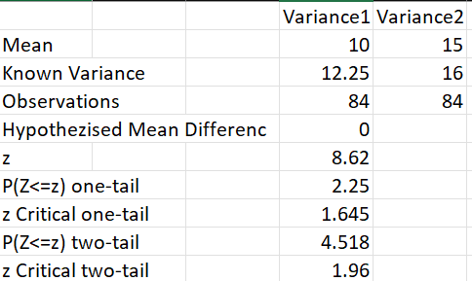

The central question posed by this study was unequivocal: Is there a significant difference in students' performance in solving rational equations before and after using the CoRTEX device? The statistical evidence provides a resounding answer. The test for significant difference yielded a computed z-statistic of 8.62. With a p-value of less than 0.0001 (as indicated by the one-tail value and the immense z-score), the result is statistically significant. This minuscule p-value means the probability of observing such a dramatic improvement in performance purely by chance is extremely low. Since the computed z-statistic of 8.62 far exceeds the critical z-value of 1.96 for a two-tailed test, there is overwhelming evidence to reject the null hypothesis. This confirms that the use of the CoRTEX device had a significant positive impact on student performance, with the mean score rising from 10 to 15.

# This empirical finding is strongly supported by contemporary educational research. According to the Stanford Center for Opportunity Policy in Education (2024), the proper use of technology can significantly increase student achievement. The results of this study are perfectly aligned with this principle, demonstrating that CoRTEX is a prime example of technology integrated with effective teaching practices to maximize learning outcomes. The device’s interactive nature, which teachers rated as "Highly Acceptable" for promoting active learning and engagement, allows students to better absorb abstract concepts and potentially even enjoy the learning process.

# The mechanism behind this success is further explained by the device's pedagogical design, as validated by teacher evaluations. Teachers overwhelmingly found the device to be "Highly Acceptable," particularly noting its ability to simplify the discussion of rational equations and functions (WM=4.00) and serve as an effective visual aid (WM=3.70). This aligns with the cognitive theory of multimedia learning, which posits that students learn more deeply from words and visuals than from words alone. By making abstract concepts like asymptotes and domains visually tangible, CoRTEX directly addresses the core challenges of the topic, thereby improving students' conceptual understanding (WM=3.70), as reflected in their higher post-test scores.

# In conclusion, the powerful statistical evidence of improved performance is not an isolated finding but the direct result of a well-designed educational tool. The data tells us that student performance improved significantly, and the confluence of teacher feedback and established educational theory helps us understand why. The high acceptability of CoRTEX in terms of pedagogical value, coupled with its proven effectiveness, positions it as a powerful instrument in the modern mathematics classroom. It successfully translates sound educational principles into a practical application, confirming that such technology, when thoughtfully implemented, can indeed create a significant and positive shift in student learning.

### **CHAPTER V**

# **SUMMARY OF FINDINGS, CONCLUSIONS AND RECOMMENDATIONS**

## 

## **SUMMARY**

### The overarching purpose of this study was to assess the effectiveness of CoRTEX: A CNN-Based Mathematical Device for Solving Rational Equations and Rational Functions as a learning tool. Specifically, this research sought to answer the following problems: 1) What is the level of acceptability of CoRTEX: A CNN-Based Mathematical Device for Solving Rational Equations and Rational Functions evaluated by students in terms of Usability, Technical Aspects, and Device Design? 2) What is the level of acceptability of CoRTEX: A CNN-Based Mathematical Device for Solving Rational Equations and Rational Functions evaluated by teacher-evaluators in terms of Accuracy of the Device in Solving and Graphing, Pedagogical Value, Usability, Technical Aspects, and Device Design? 3) Is there a significant difference in students' performance in solving Rational Equations and Rational Functions before and after using CoRTEX: A CNN-Based Mathematical Device for Solving Rational Equations and Rational Functions.

### The study utilized a descriptive-correlational research design and employed total enumeration, focusing on 84 students who provided incorrect answers on the competency regarding solving Rational Equations and Rational Functions during the First Quarter Test of SY 2025–2026 in General Mathematics, and 5 teachers as evaluators. Pre-test and post-test questionnaires were administered to the respondents, who were instructed to engage with the CoRTEX device and complete the tests. Inferential statistics were applied to analyze the data. Z-test for two samples assessed the significant difference in student performance before and after using the device. Additionally, the average ratings from student-evaluators and teacher-evaluators were analyzed using the Weighted Mean to determine the level of acceptability of the CoRTEX device.

### The findings revealed that the CoRTEX device achieved high acceptability ratings in all aspects. Among students, the device obtained average weighted means of 3.76 for usability, 3.90 for technical aspects, and 3.73 for design, all interpreted as Highly Acceptable. Among teacher-evaluators, the device achieved mean ratings of 3.98 for accuracy, 3.80 for pedagogical value, 3.86 for usability, 3.84 for technical aspects, and 3.82 for design, all interpreted as Highly Acceptable. The computed z-test value of 8.62 (p = 0.00225) indicated a significant improvement in students’ performance after using the device. These results confirm that the CoRTEX is an effective and highly acceptable educational tool that enhances students’ learning, engagement, and comprehension in mathematics.

### **FINDINGS**

The findings of the study are summarized as follows:

1. The level of acceptability of the device in terms of usability, technical aspects, and device design was rated highly acceptable by the student-evaluators, with average weighted means of 3.76, 3.90, and 3.73, respectively.  
     Along with usability, the highest indicator with a mean score of 3.95, interpreted as highly acceptable, is that the device is easy to operate even for first-time users.  
     Along the technical aspect, the highest indicator with a mean score of 4.00, interpreted as highly acceptable, is that the input, display, and output functions work well together.  
     Along with device design, the highest indicators with a mean score of 3.90, interpreted as highly acceptable, are that the device is lightweight and compact, making it easy to transport and use on the go, and the overall appearance motivates students to use it more often.
2. The level of acceptability of the device in terms of accuracy of solving and graphing, pedagogical value, usability, technical aspects, and device design was rated highly acceptable by the teacher-evaluators, with average weighted means of 3.98, 3.80, 3.86, 3.84, and 3.82, respectively.  
     Along with accuracy, the highest indicators with a mean score of 4.00, interpreted as highly acceptable, are that the device generates accurate results for rational equations and produces precise graphs of rational functions.  
     Along pedagogical value, the highest indicator with a mean score of 4.00, interpreted as highly acceptable, is that the device can help simplify the discussion of rational equations and functions.  
     Along with usability, the highest indicator with a mean score of 4.00, interpreted as highly acceptable, is that the device offers connectivity options for enhanced visibility during presentations or group learning.  
     Along the technical aspect, the highest indicator with a mean score of 4.00, interpreted as highly acceptable, is that the device works even without a stable internet connection.  
     Along with device design, the highest indicator with a mean score of 4.00, interpreted as highly acceptable, is that the device’s physical design can attract students’ interests.
3. The test for significant difference in student performance before and after exposure to the device showed a computed z-statistic of 8.62 and a p-value of 0.00225, indicating a statistically significant improvement in performance and leading to the rejection of the null hypothesis.

## **CONCLUSIONS**

Based on the findings of the study, the following conclusions were drawn:

1. CoRTEX: A CNN-Based Mathematical Device for Solving Rational Equations and Rational Functions is highly accepted by the students, proving effective in enhancing understanding, engagement, and performance in solving and graphing rational equations and functions.  
 2. CoRTEX is highly accepted by the teacher-evaluators, demonstrating its potential as an effective instructional tool that supports classroom teaching, improves lesson delivery, and encourages active learning among students.  
 3 .There is a significant difference between the students’ performance before and after using the CoRTEX device, indicating that the integration of technology through CNN-based computation and handwriting recognition significantly improves mathematical comprehension and achievement.

## **RECOMMENDATIONS**

After a thorough analysis of the data gathered in the study, the following are highly recommended:

1. The CoRTEX device could be enhanced by expanding its lessons beyond rational equations and functions, allowing it to cover broader mathematical and scientific topics for greater academic application.  
 2. It is recommended that the device be equipped with a larger and clearer screen to improve visibility, readability, and overall user experience, especially during classroom demonstrations.  
 3. The device’s versatility may be further enhanced by integrating features that allow its use across other subjects such as Physics, Statistics, or Engineering, showcasing its adaptability as a multifunctional educational tool.

CoRTEX has the potential to evolve into a fully integrated digital learning system that supports multiple disciplines while maintaining its goal of improving comprehension, interactivity, and engagement in mathematics and related fields.

### 

### 

### 

### 

### 

### 

### 

### 

### 

### **BIBLIOGRAPHY**

***Bautista, R. G.*** *(2021). Mathematics anxiety and procedural fluency among senior*

*high school students. Philippine Journal of Educational Research, 15(2), 45–60.*

***Black, P., & Wiliam, D.*** *(1998). Assessment and classroom learning. Assessment in Education: Principles, Policy & Practice, 5(1), 7–74.<https://www.gla.ac.uk/t4/learningandteaching/files/PGCTHE/BlackandWiliam1998.pdf>*

***Bloom, B. S.*** *(1968). Learning for mastery. Evaluation Comment, 1(2), n2.<https://eric.ed.gov/?id=ED053419>*

***Bossé, M. J., & Nandakumar, N. R.*** *(2005). The procedural complexity of solving rational equations. Journal of Mathematical Behavior.*

***Burgos, M. A.*** *(2018). Proficiency in Algebraic Concepts of Grade 11 STEM Students [Thesis]. Philippine Normal University.*

***Creswell, J. W., & Creswell, J. D.*** *(2018). Research design: Qualitative, quantitative, and mixed methods approaches (5th ed.). SAGE Publications.*

***Davis, F. D.*** *(1989). Perceived usefulness, perceived ease of use, and user acceptance of information technology. MIS Quarterly, 13(3), 319–340.<https://www.jstor.org/stable/249008>*

***De Roxas, M. A., & Cruz, J. P.*** *(2021). Teachers' perceptions of the most difficult topics in the General Mathematics curriculum. International Journal of Educational Studies, 4(3), 112–125.*

***Dela Cruz, J., & Reyes, R.*** *(2020). Cognitive analysis of errors in rational equations. The Philippine Journal of Education Studies.*

***Deng, Y., et al.*** *(2017). Image-to-Markup Generation with Coarse-to-Fine Attention. ICML.*

***Even, R.*** *(1998). Factors involved in linking representations of functions. The Journal of Mathematical Behavior.*

***Gonzales, L., et al.*** *(2021). A meta-analysis on the effect of technology integration. Journal of Science and Mathematics Education in Southeast Asia.*

***Hohenwarter, M., & Jones, K.*** *(2019). GeoGebra: Enabling students to meaningfully learn mathematics. Proceedings of the 13th International Congress on Mathematical Education.*

***Kieran, C.*** *(2018). The core of algebra: Reflections on its main activities. In Research issues in the learning and teaching of algebra (pp. 5–20). Routledge.*

***LeCun, Y., Bottou, L., Bengio, Y., & Haffner, P.*** *(1998). Gradient-based learning applied to document recognition. Proceedings of the IEEE, 86(11), 2278–2324.<https://ieeexplore.ieee.org/document/726791>*

***Mayer, R. E.*** *(2020). Multimedia learning (3rd ed.). Cambridge University Press.*

***McCulloch, W. S., & Pitts, W.*** *(1943). A logical calculus of the ideas immanent in nervous activity. The Bulletin of Mathematical Biophysics, 5(4), 115–133.<https://link.springer.com/article/10.1007/BF02478259>*

***Méndez-Balbuena, I., Hernández, R., Trujillo, P., & Flores, J.*** *(2022). Enhancing mathematical learning through visual feedback and interactive technology. Journal of Educational Technology & Society, 25(1), 112–124.*

***Panaoura, A., et al.*** *(2009). A structural model for the understanding of rational functions. Educational Psychology.*

***Reyes, R. D., & Villanueva, P. S.*** *(2020). Rote learning and its impact on algebraic misconceptions in Philippine high schools. The Philippine Educator, 58(2), 25–41.*

***Salud, M. J., & Suan, L. A.*** *(2020). Error analysis in simplifying rational expressions among Grade 8 students in Zambales. Journal of Innovation in Educational Research, 3(1), 55–68.*

***Santos, A., et al.*** *(2022). Development of a handwritten mathematical expression recognizer [Thesis]. University of the Philippines Diliman.*

***Taherdoost, H.*** *(2017). Determining sample size; How to calculate survey sample size. International Journal of Economics and Management Systems, 2.*

***Torres, A. B.*** *(2019). Computer Algebra Systems (CAS) as a bridge to conceptual understanding. Journal of Research in Innovative Teaching & Learning (Philippine Edition).*

***Vygotsky, L. S.*** *(1978). Mind in society: The development of higher psychological processes. Harvard University Press.<https://www.jstor.org/stable/j.ctvjf9vz4>*

***Wirkuttis, T., & Seidl, T.*** *(2023). Towards a universal math solver... AAAI.*

### 

### 

### **ACKNOWLEDGEMENT**

It is with great pleasure that the proponents extend their utmost appreciation for their most inspiring mentors who believed in them all throughout the process, without their support, this project would have never been realized.

Foremost to their Coach, Mrs. Marjorie Joy N. Relavo, they are indeed blessed to have her enthusiastic and positive thoughts and faith in the proponents, as it boosts their morale, and with their critical thinking, being always there for them, they were able to complete and study overall.

To Mr. Jan Lauren Ang and Mrs. Marivic Babala, for their significant suggestions and advice all throughout the process that made a significant change until the project was finished.

To Kian Serwelas, for his invaluable assistance and technical support in the development and improvement of the device. His help greatly contributed to the successful completion of this project.

To Ma’am Magnolia B. De Mesa the Principal II of Camarines Norte Senior High School, they thank you for allowing them to focus and guide them in working and improving this very showcase. The proponents are indeed grateful to have you as our Principal.

### 

### **DOCUMENTATION**

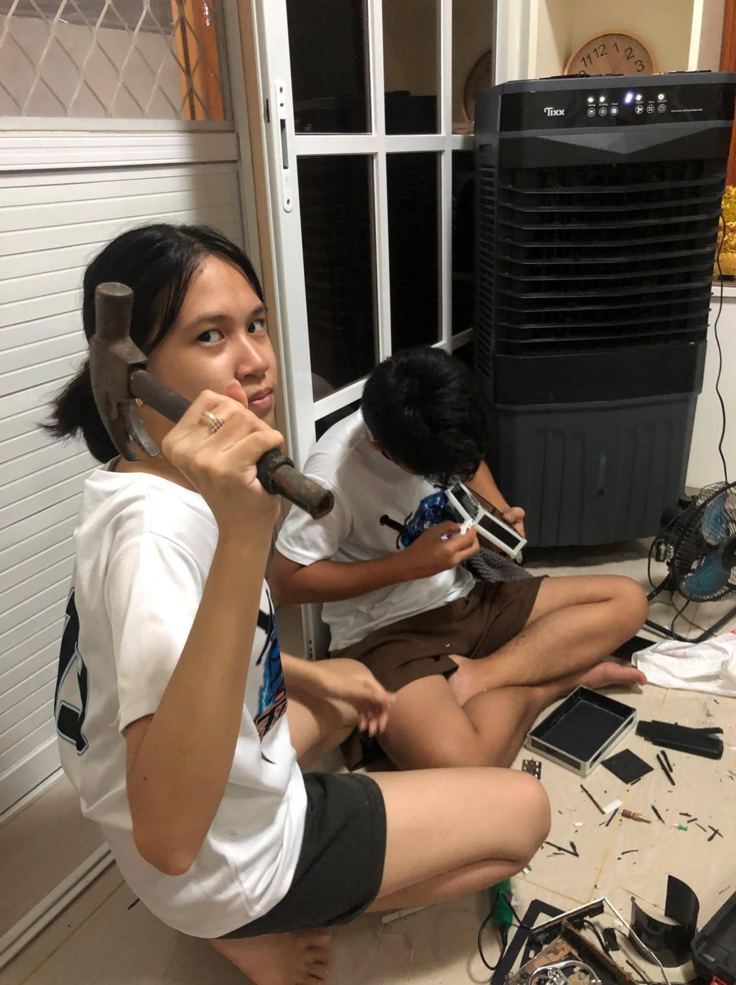

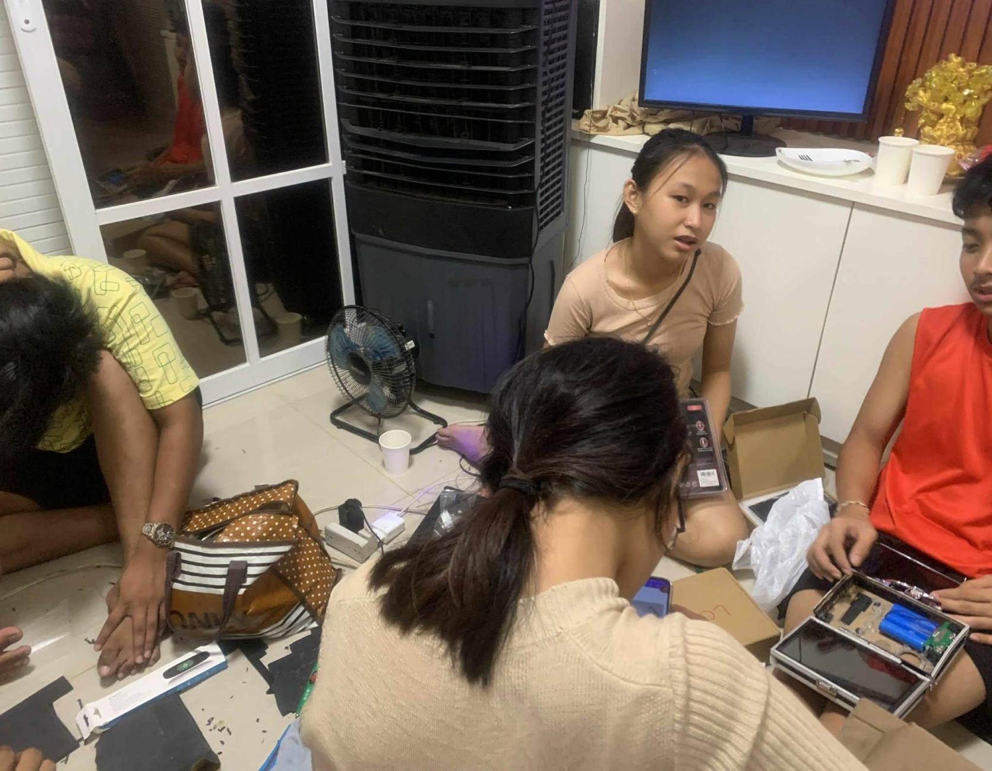

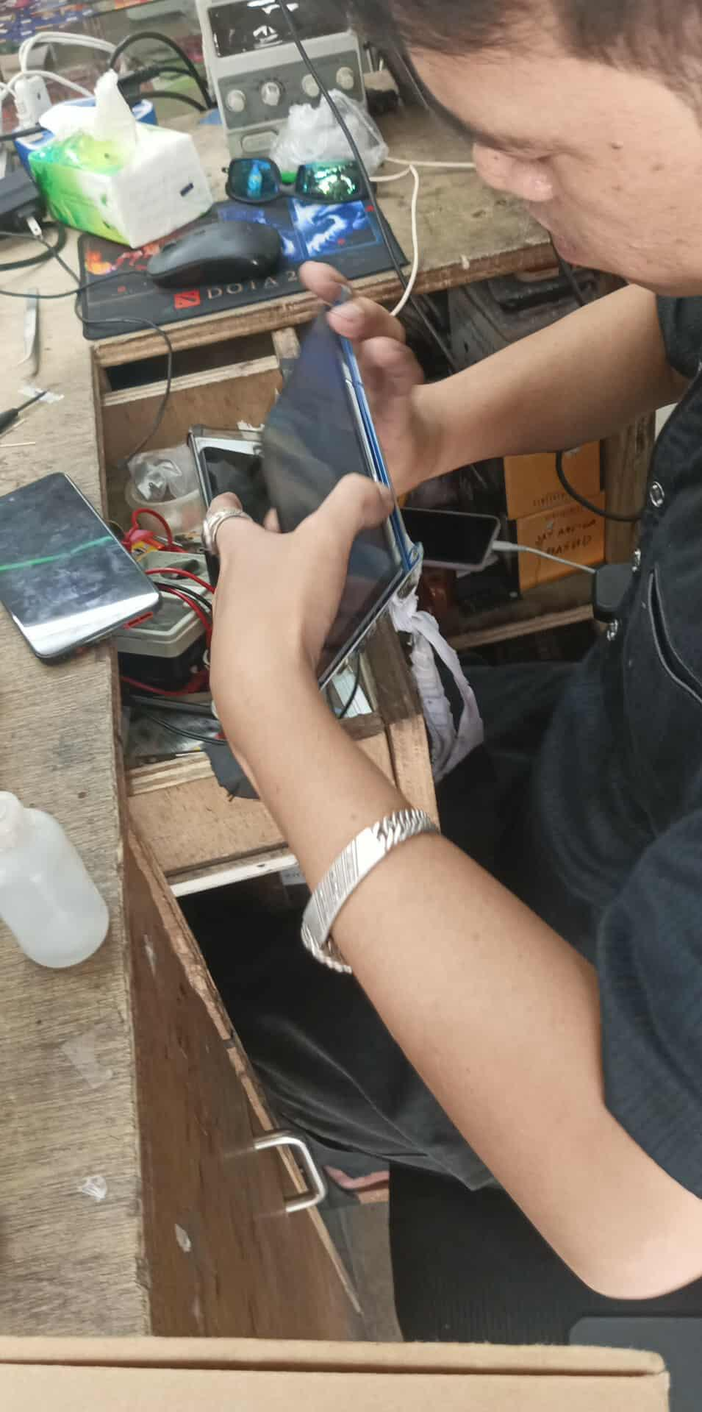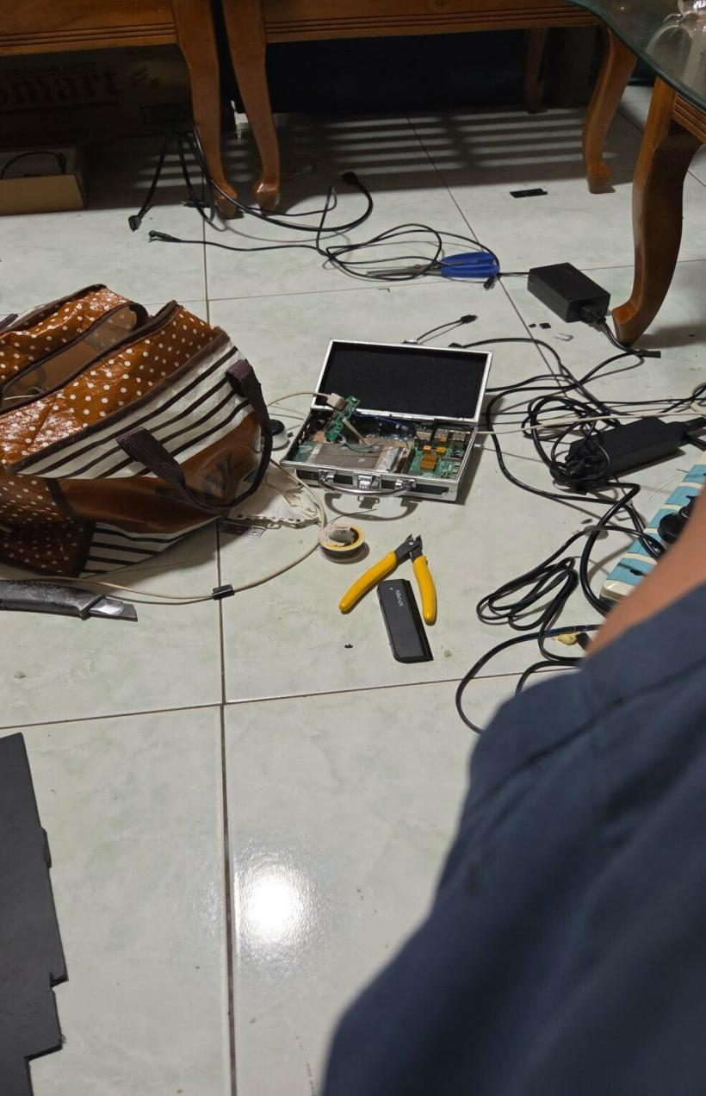

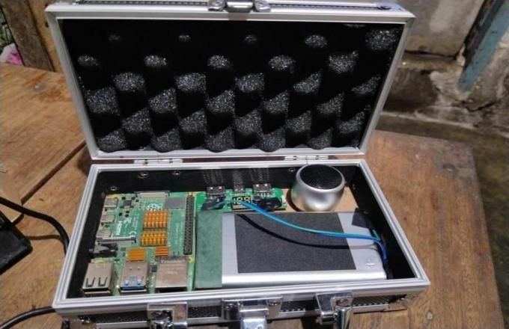

*Construction of the Device*

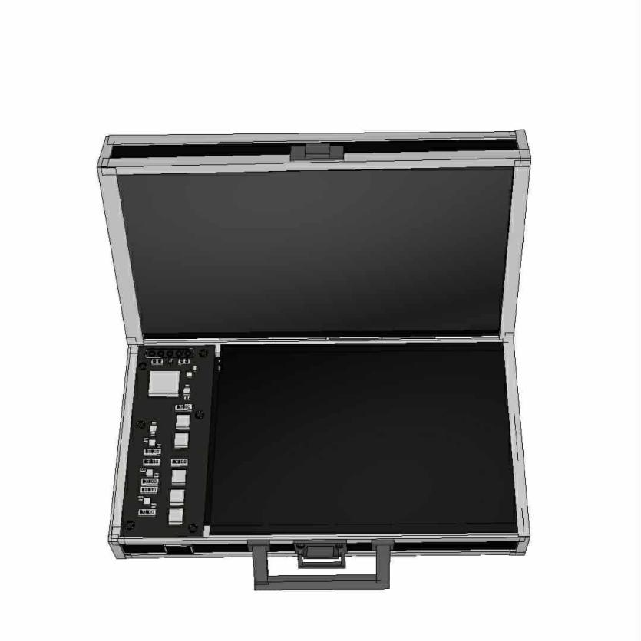

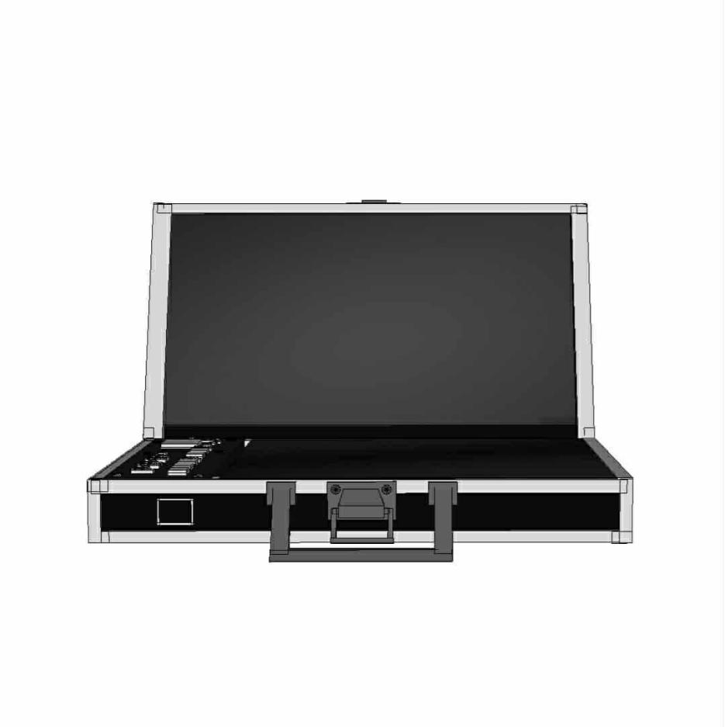

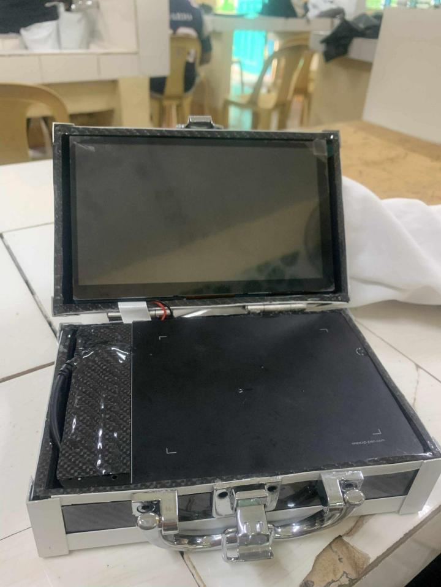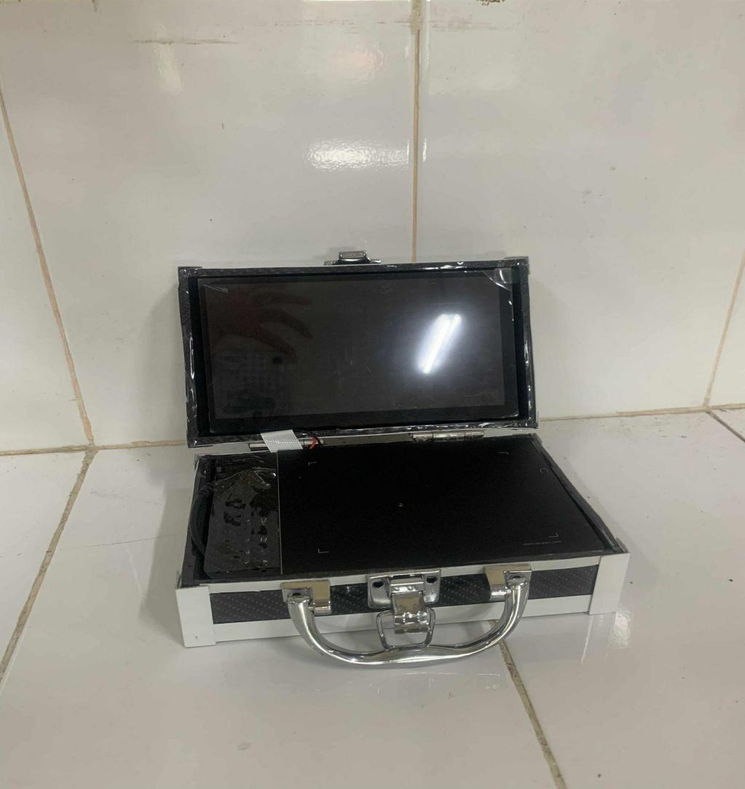

*3D Model and the Actual Constructed Device*

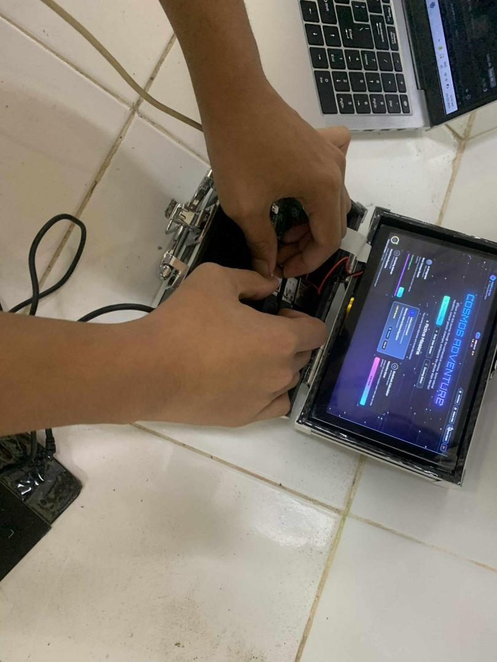

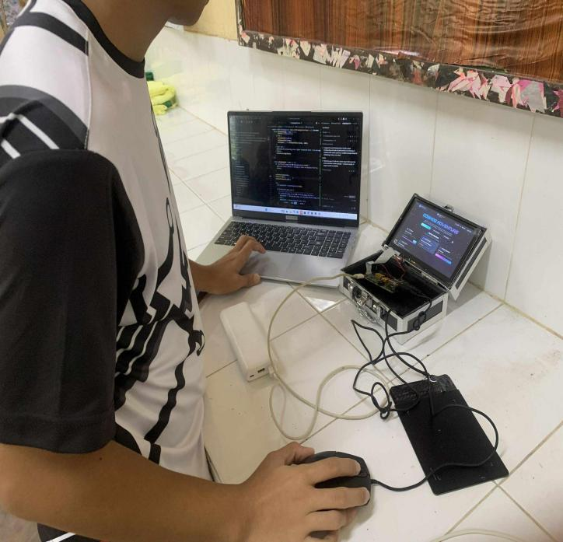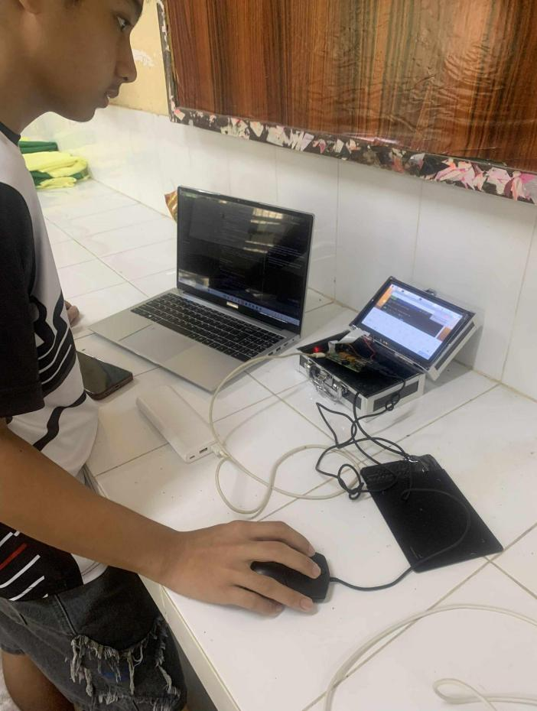

*Programming the Device*

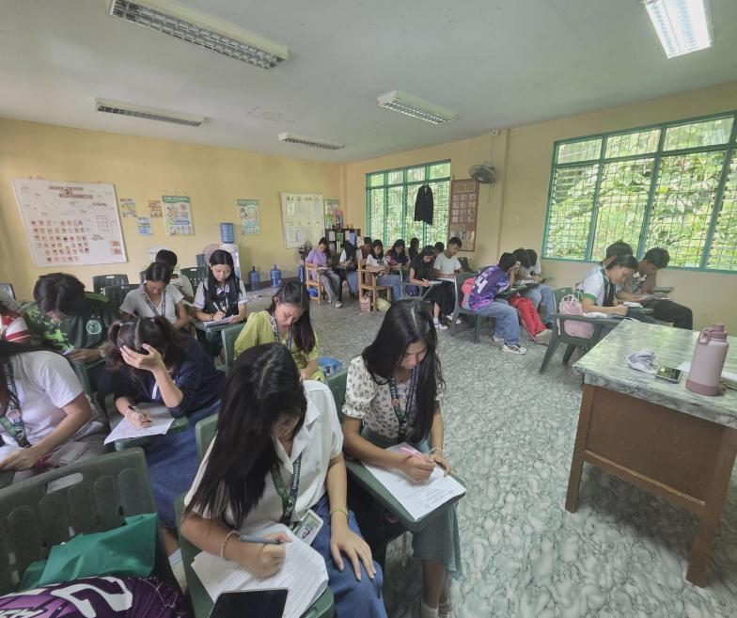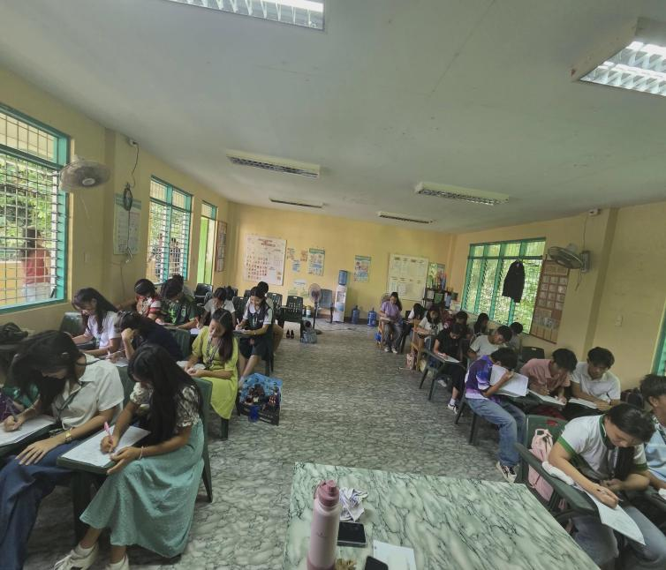

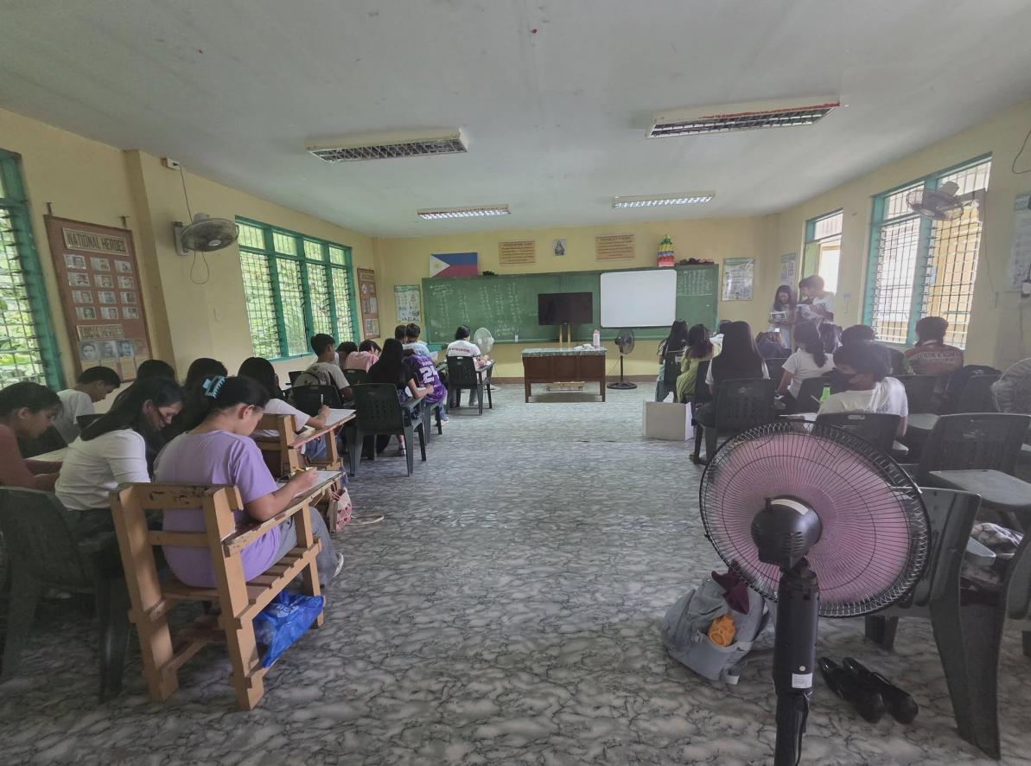

*Conduct of Pretest and Post-test*

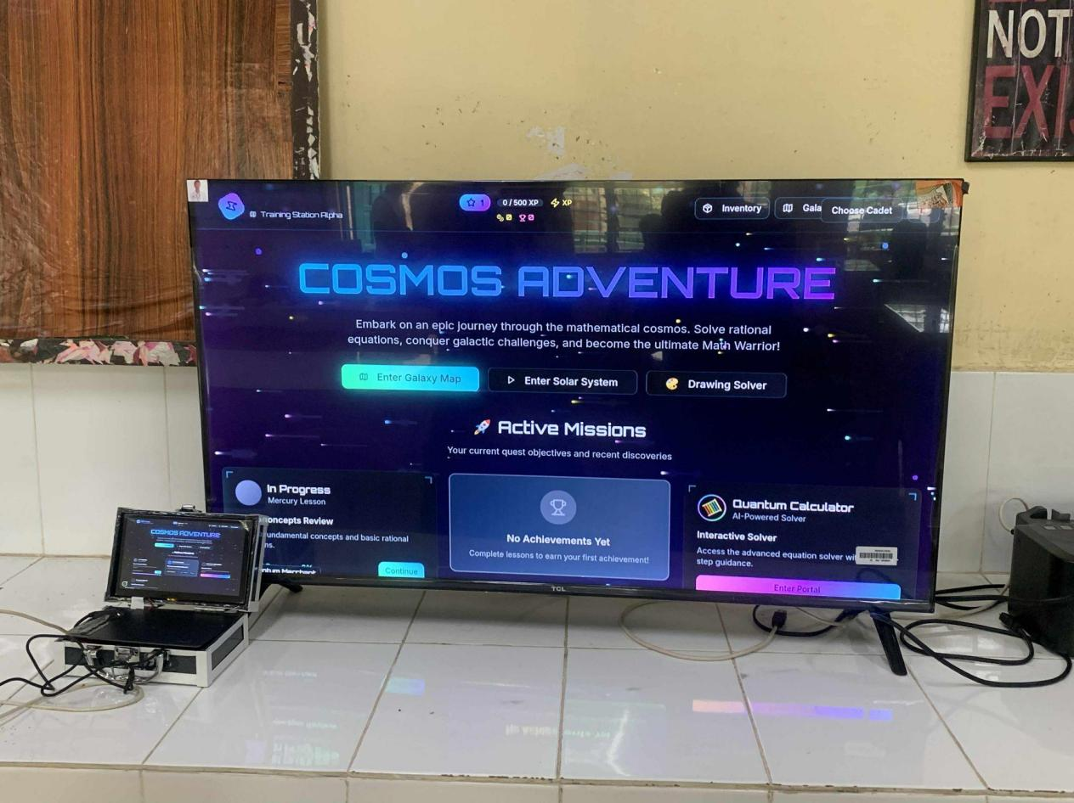

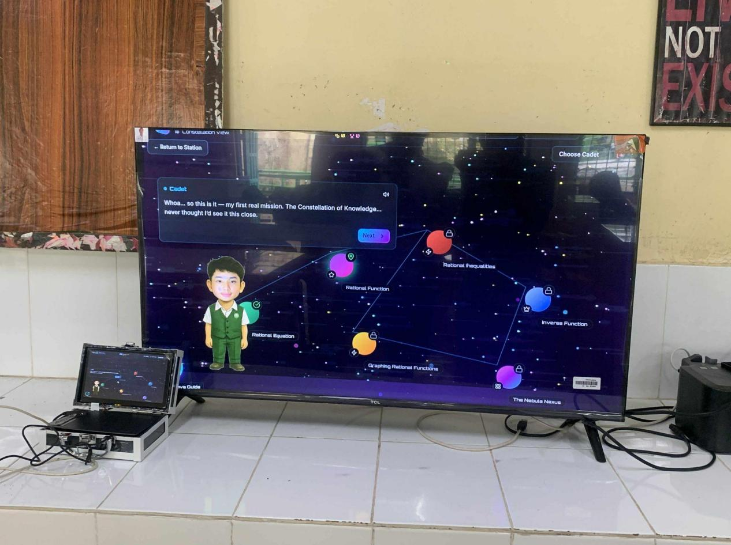

*Connecting Device to TV*

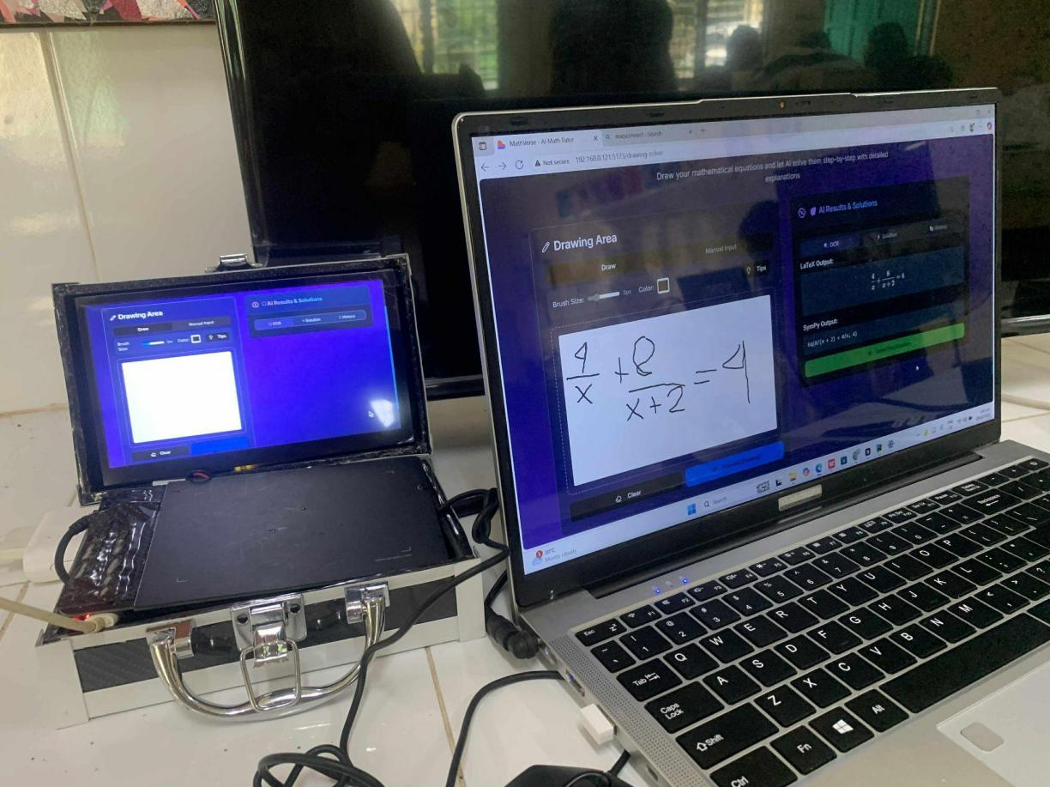

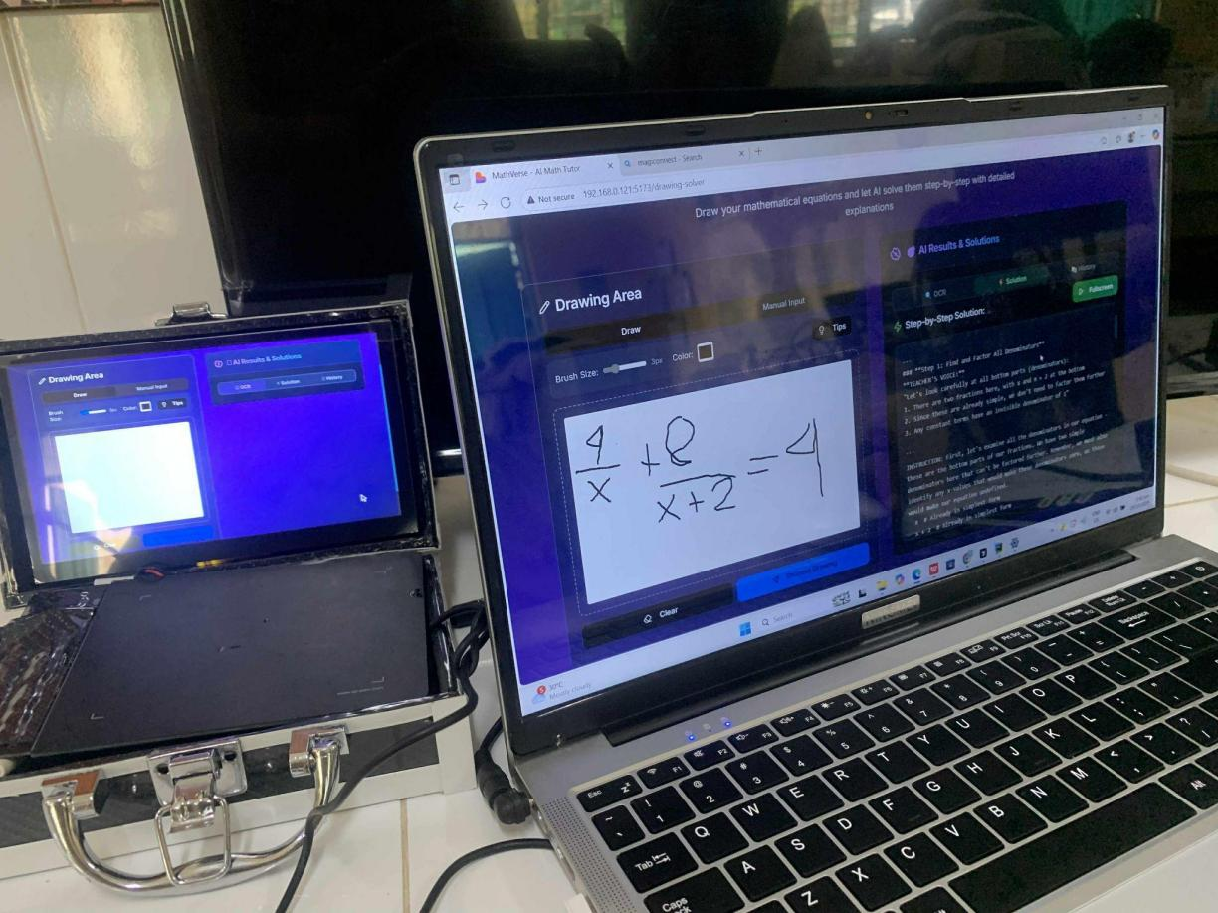

*Connecting Device to Laptop*

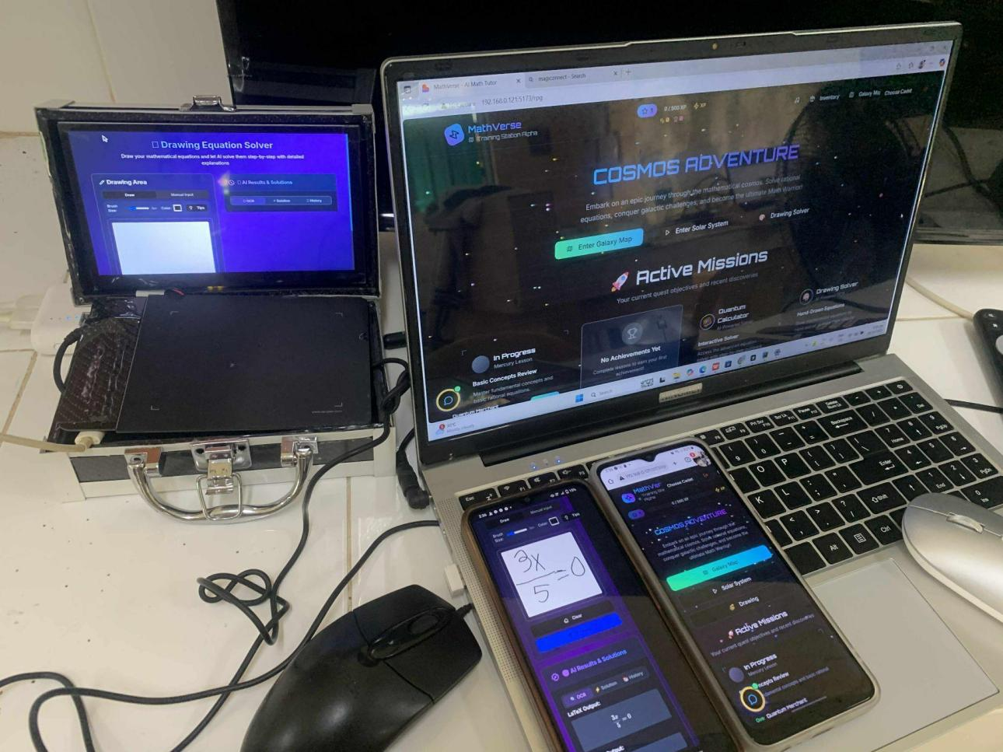

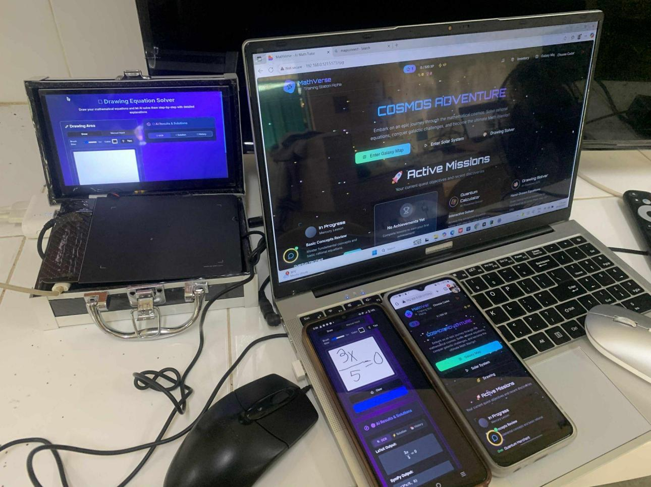

*Connecting Device to Multiple Device*

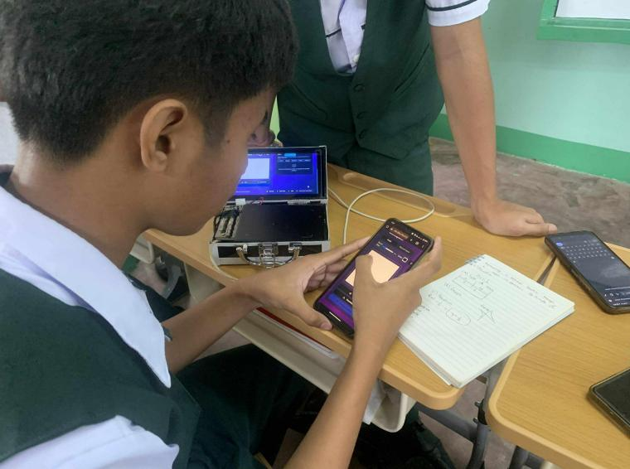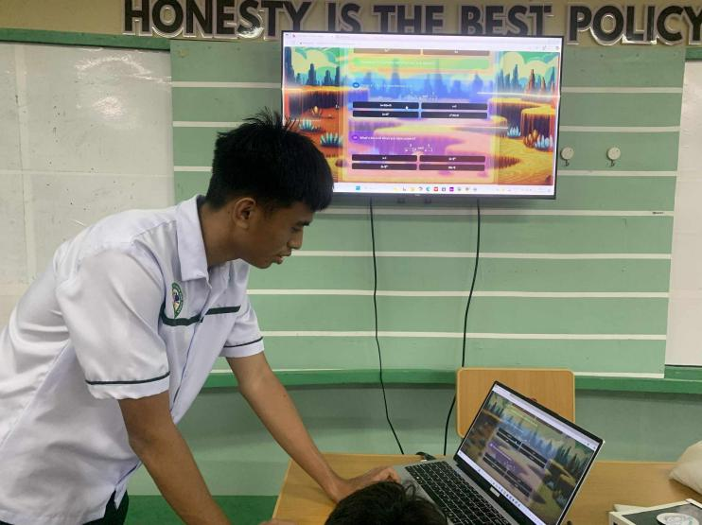

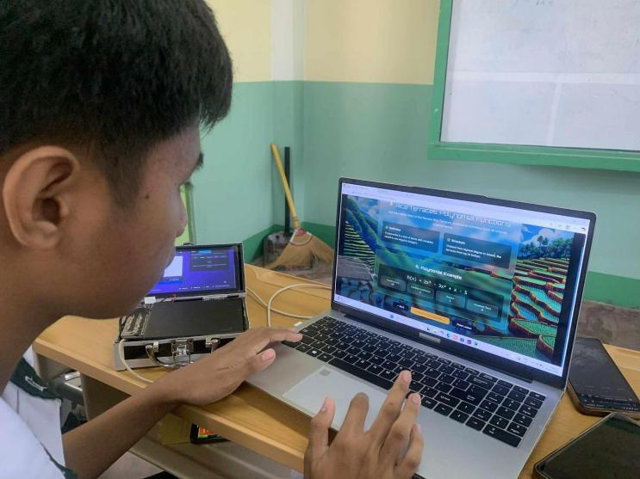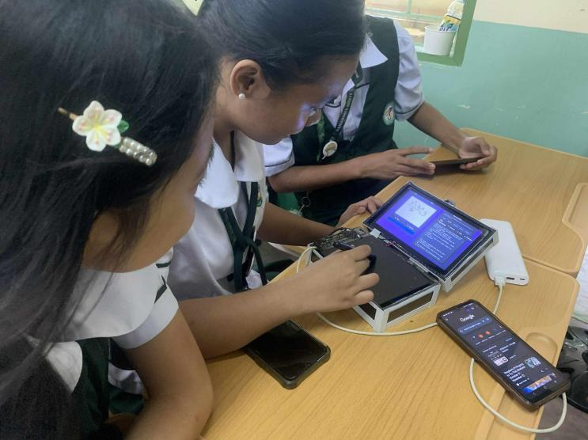

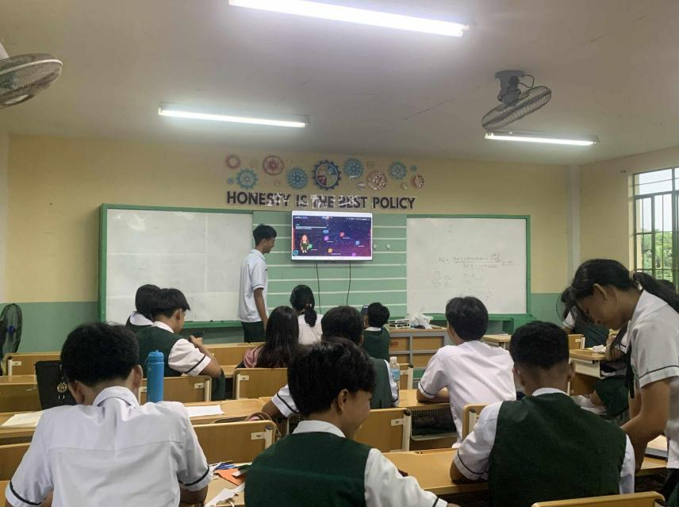

*Evaluation of Device by Students*

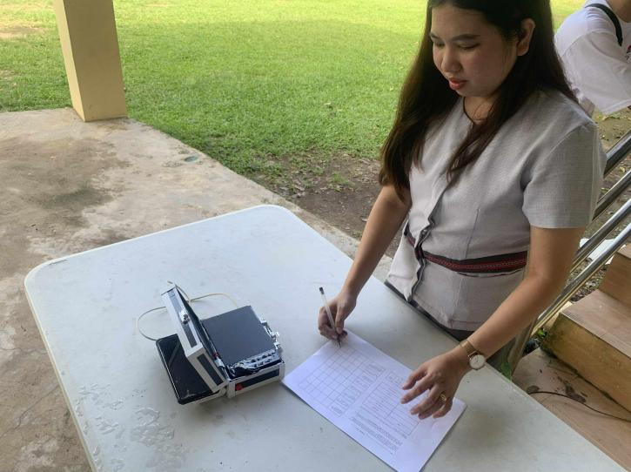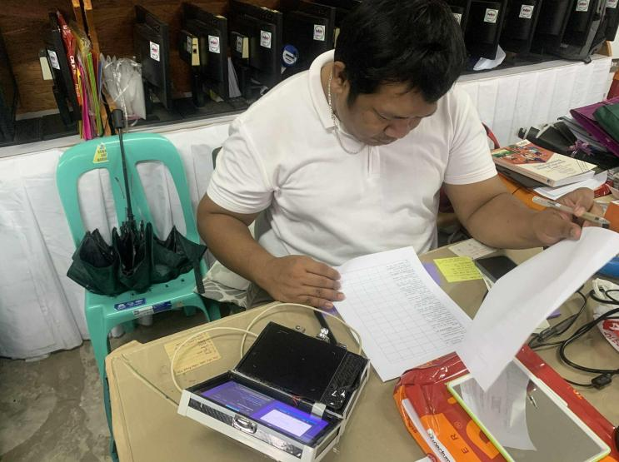

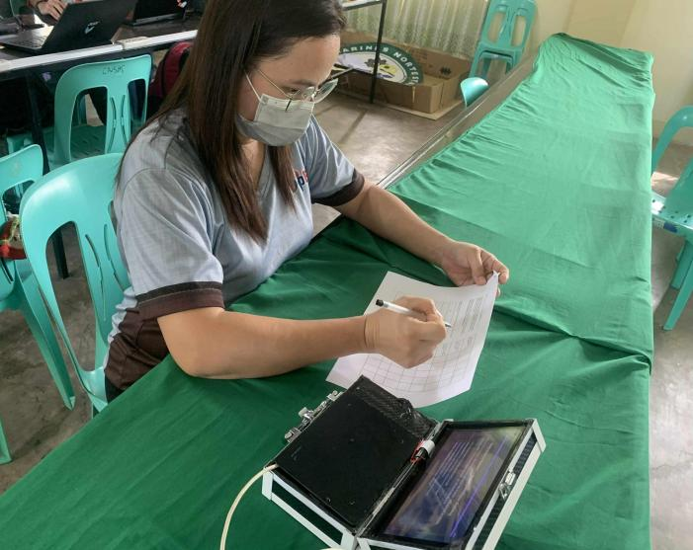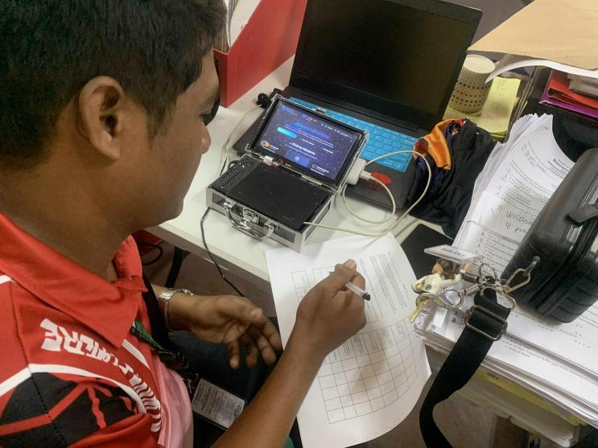

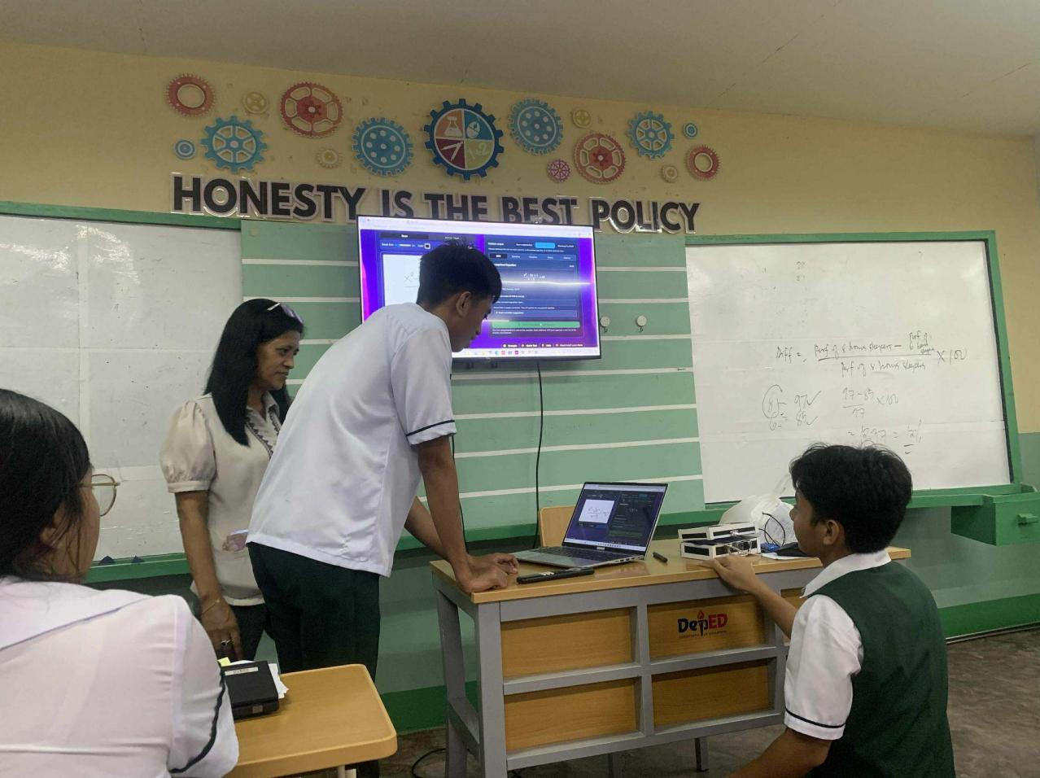

*Evaluation of Device by Teachers*

**Rational Equation 1: $\frac{x}{x+2 }−\frac{1}{x−2}=\frac{8}{x²−4 }$** 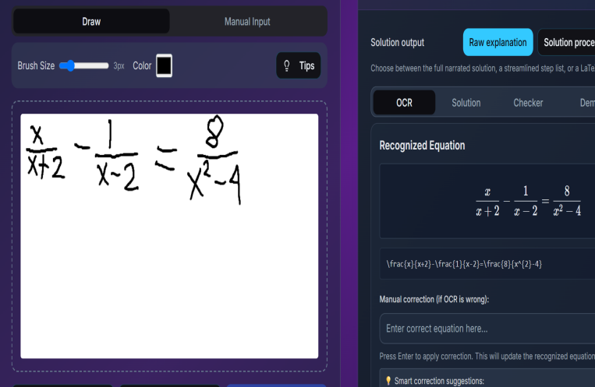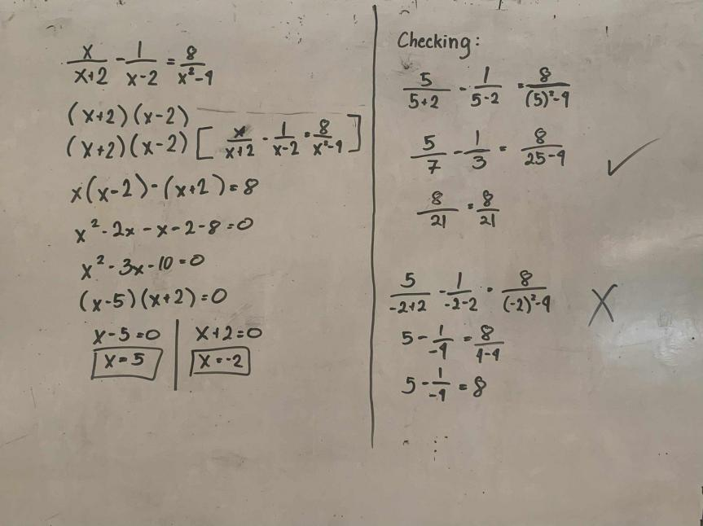

## **Manual computation Handwritten Detection Results**

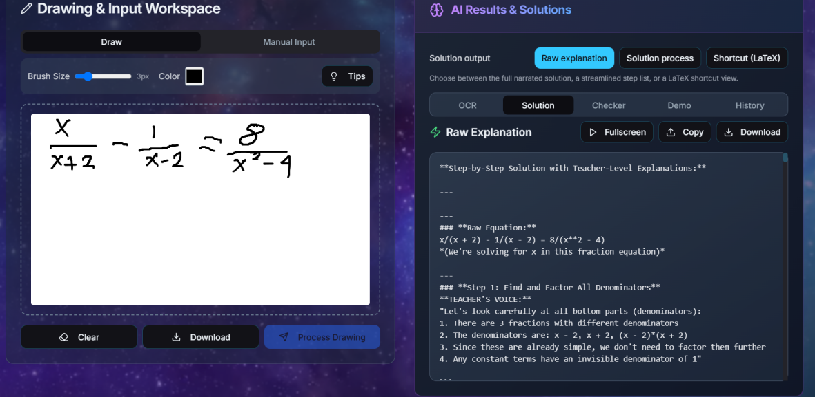

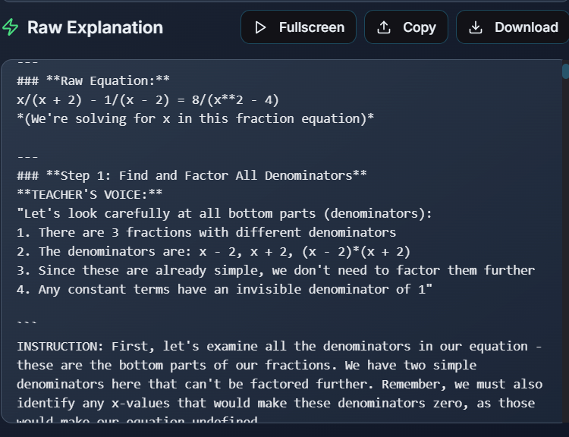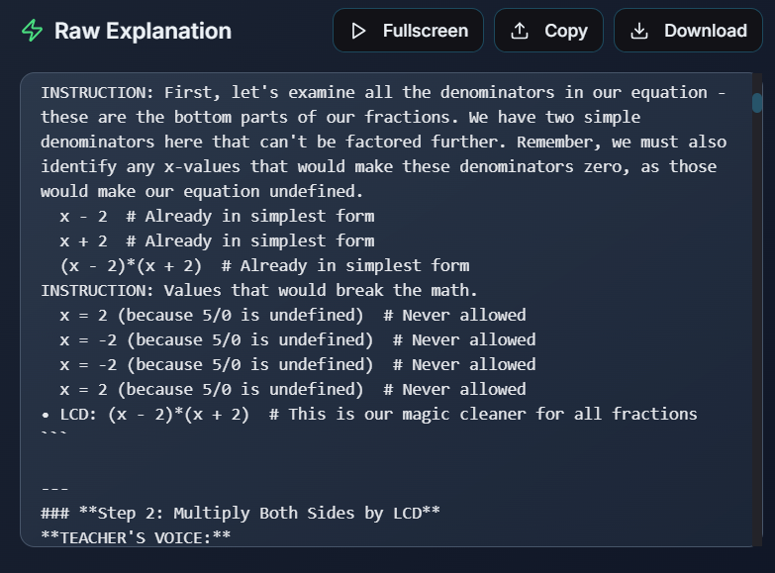

*Comparison of Solving and Graphing Manually vs. Using the Device*

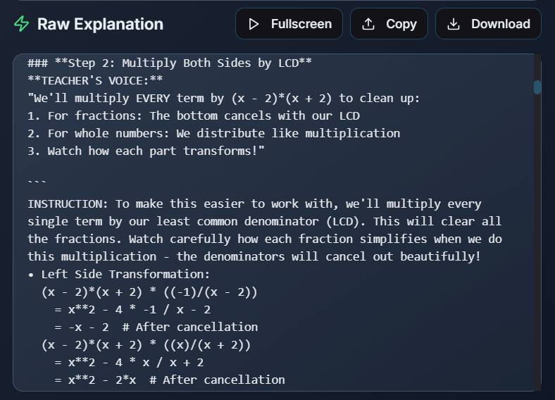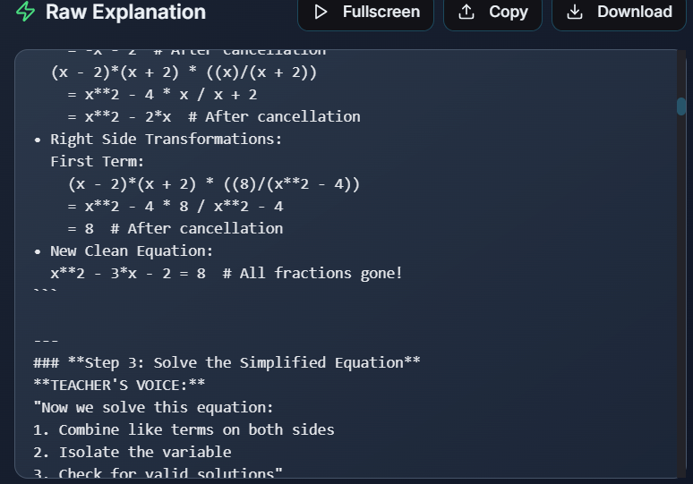

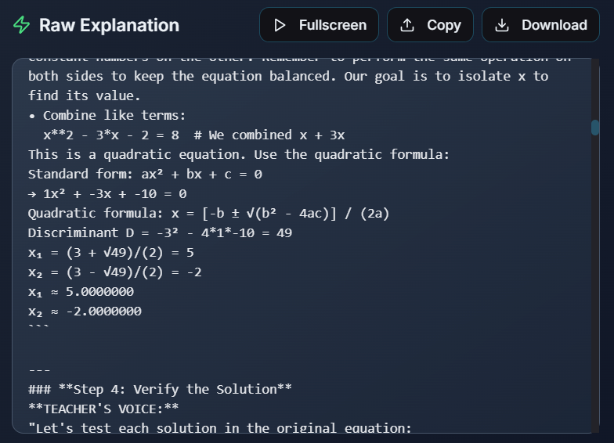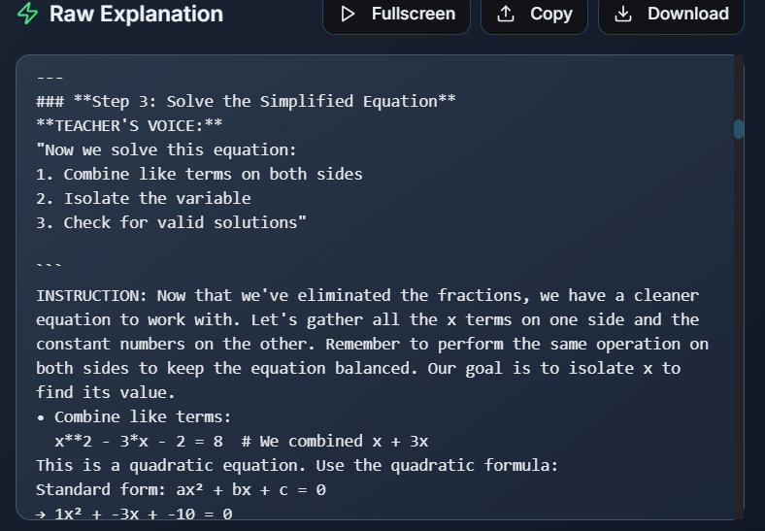

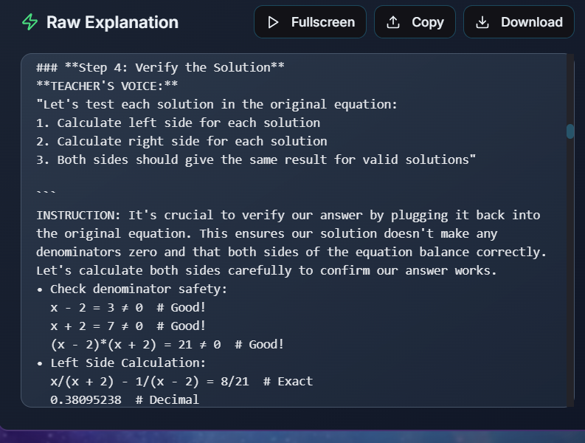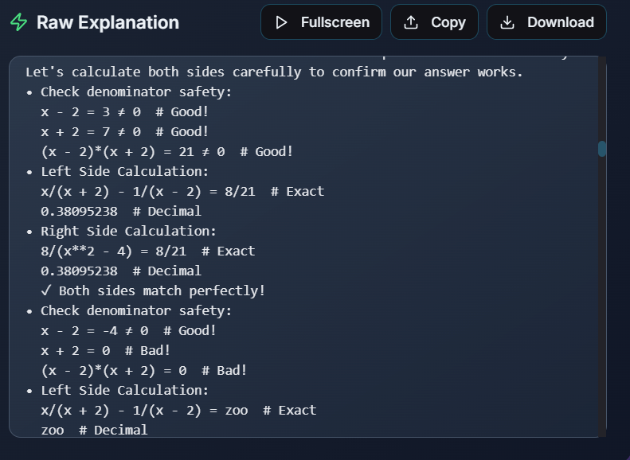

*Comparison of Solving and Graphing Manually vs. Using the Device*

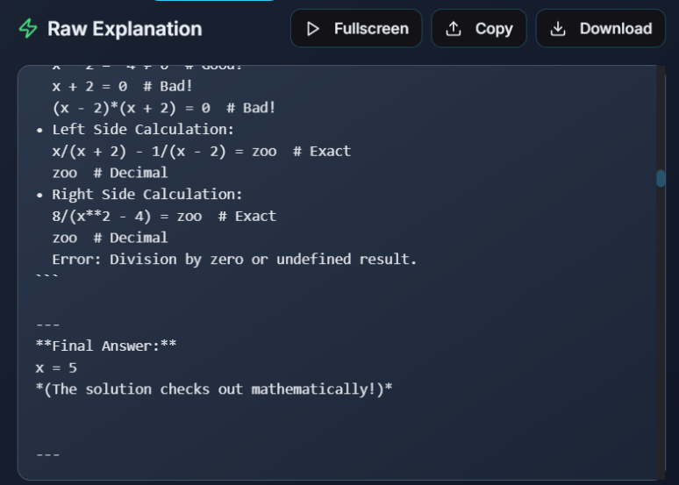

**Raw Detailed Explanation Result**

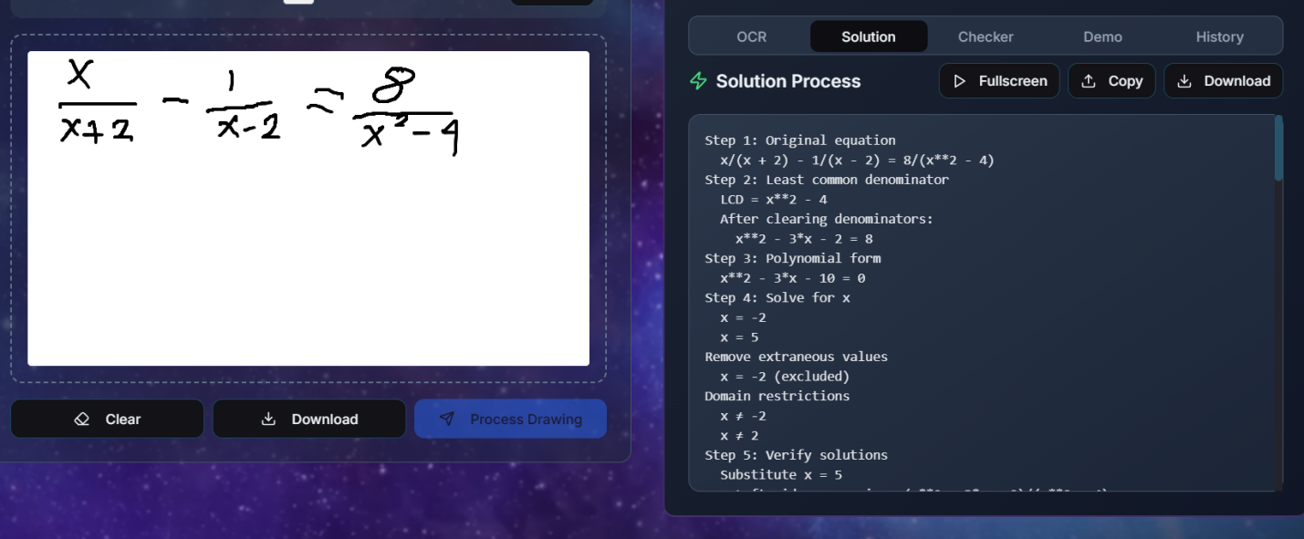

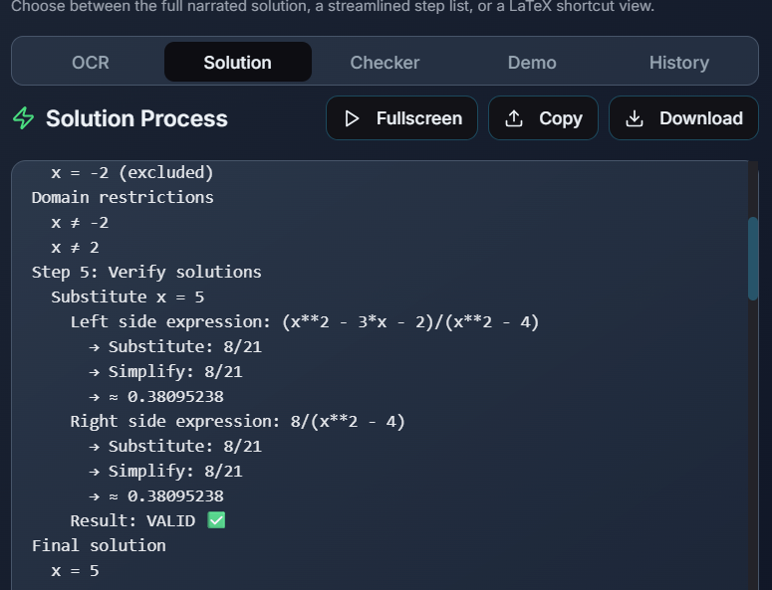

***Solution Process Result***

**Rational Function: 1 $f(x) =\frac{x²−x−6 }{x−3}$**

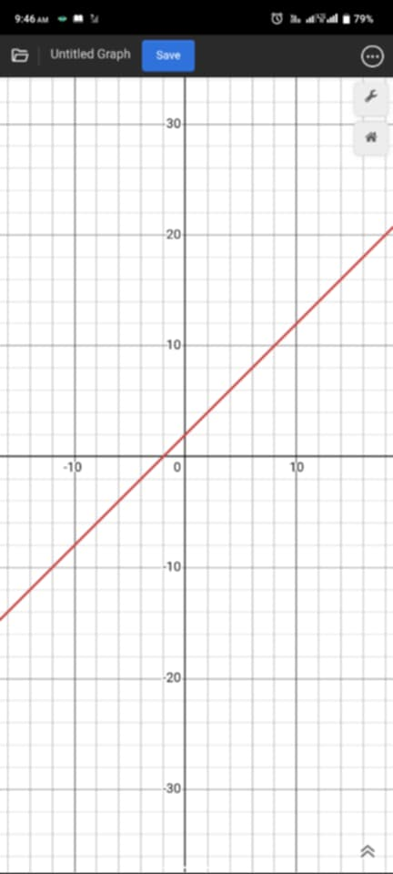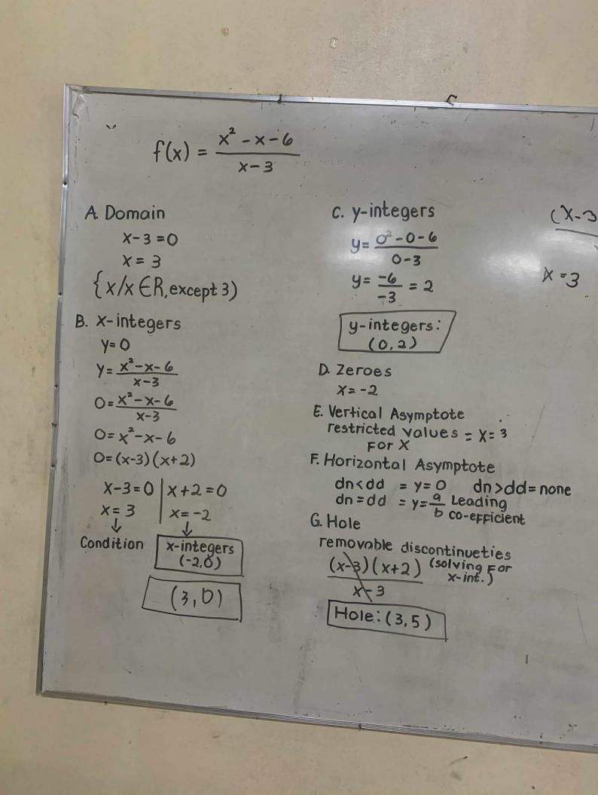

**Manual computation Graph by Desmos**

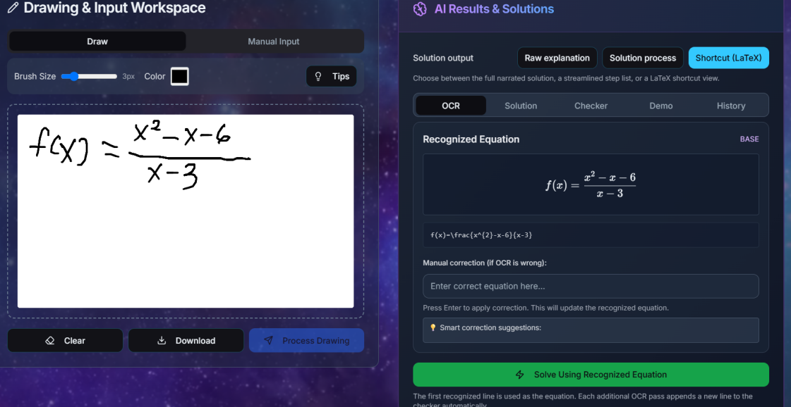

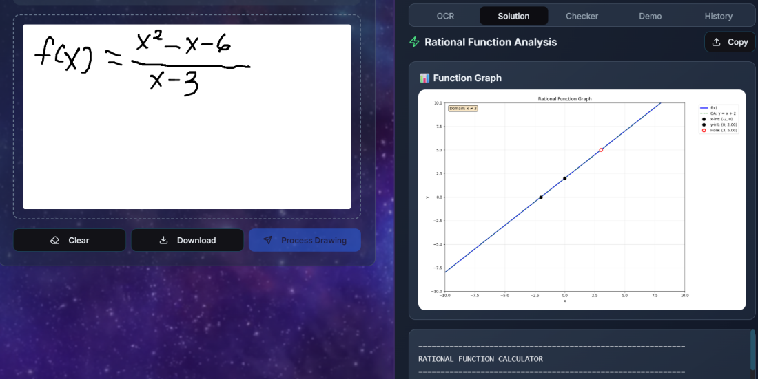

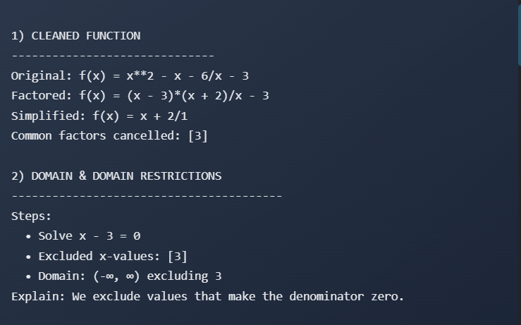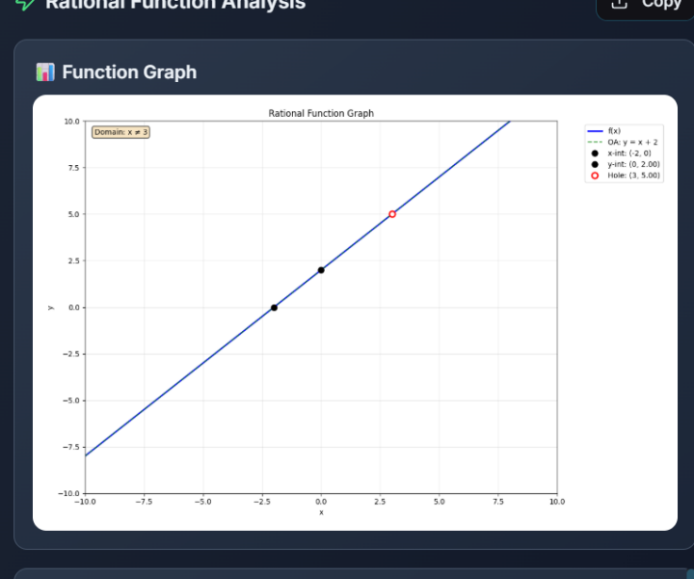

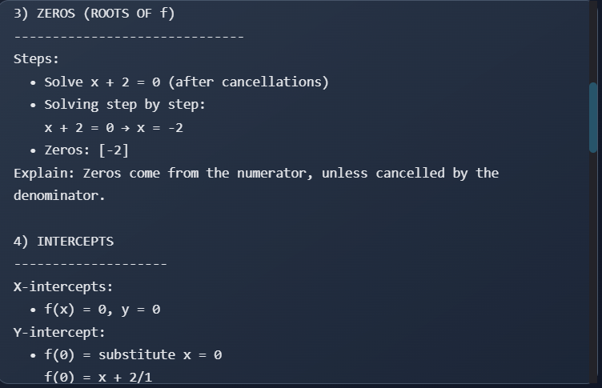

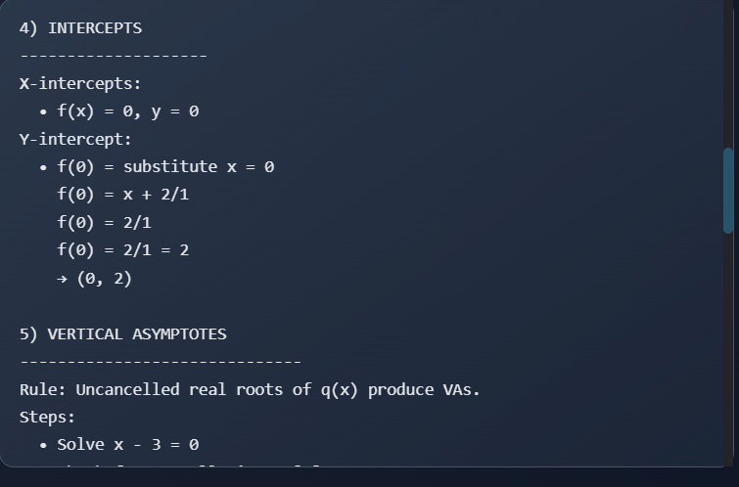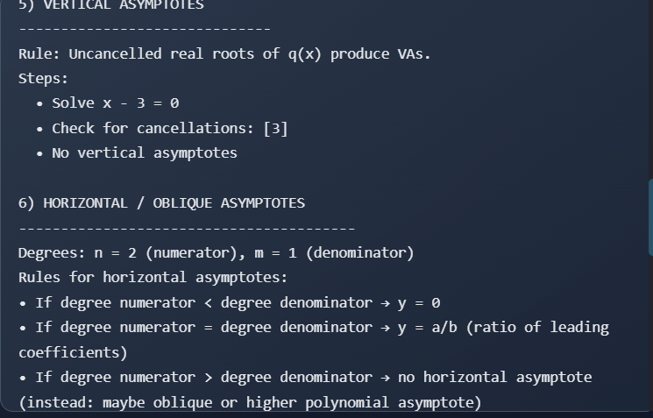

*Comparison of Solving and Graphing Manually vs. Using the Device*

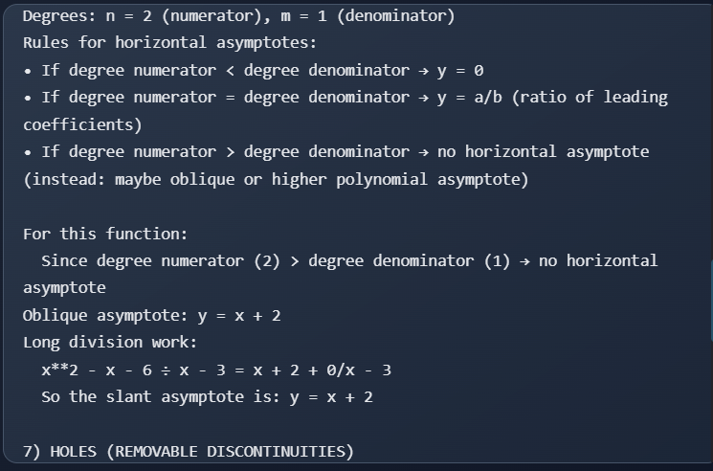

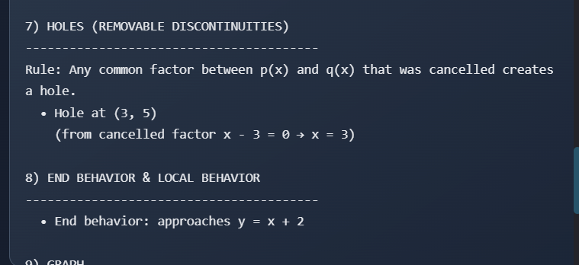

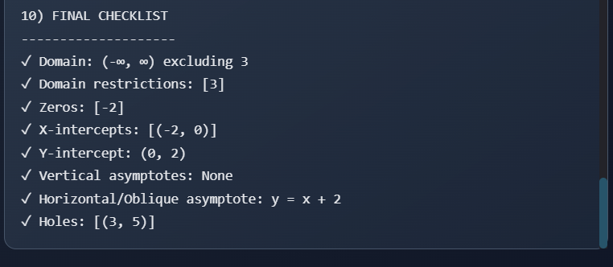

## ***Device actual computation and graph***

## 

## 

## 

## 

## 

**Rational Function: 2 $f(x)=$ $\frac{x²+9x+14}{x+2}$** 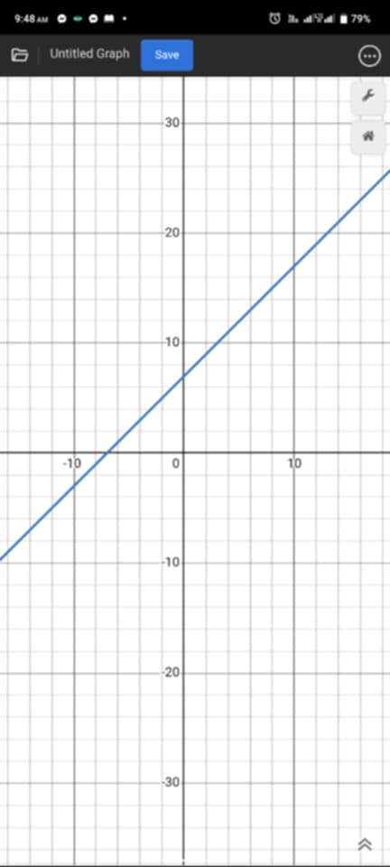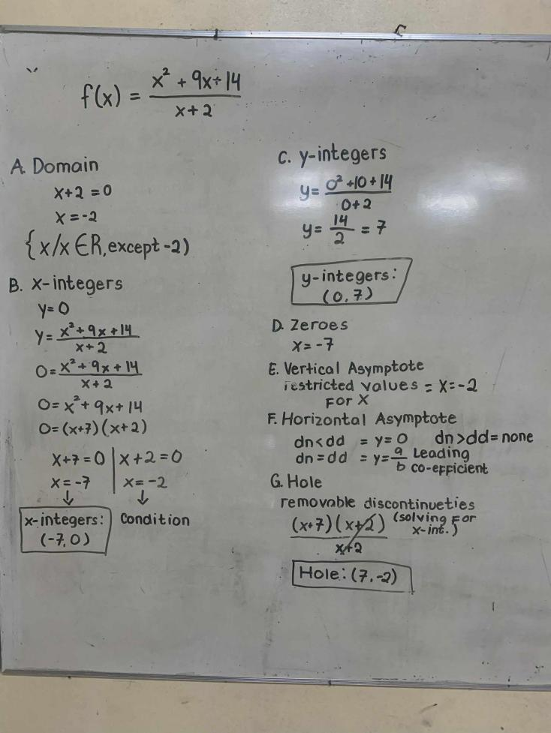

**Manual computation**

***Manual Computation Graph by Desmos***

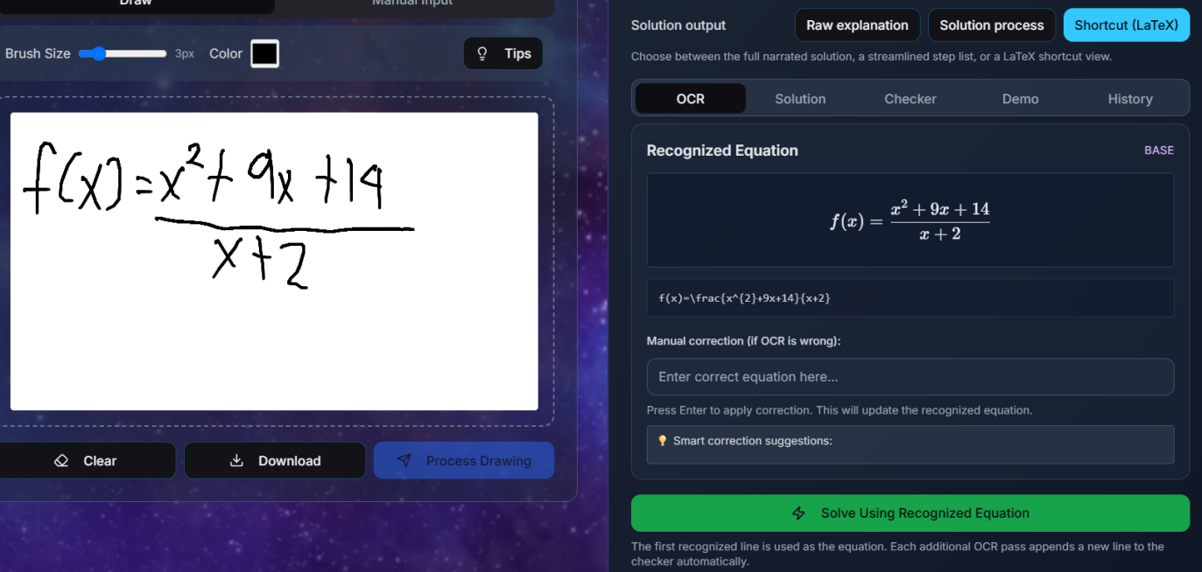

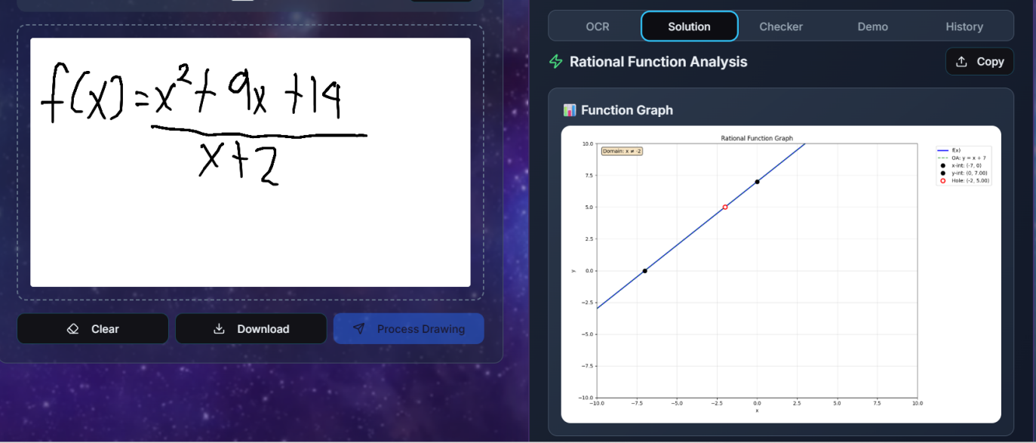

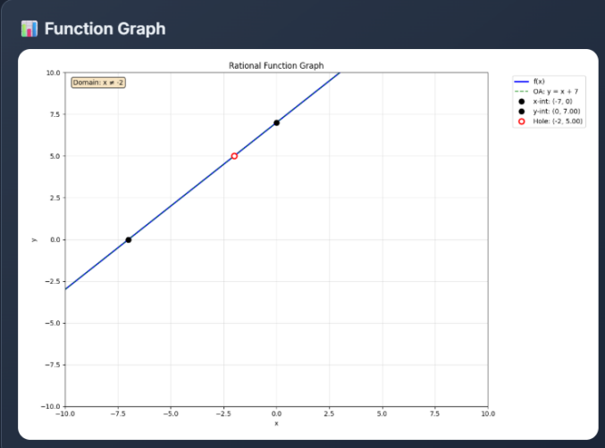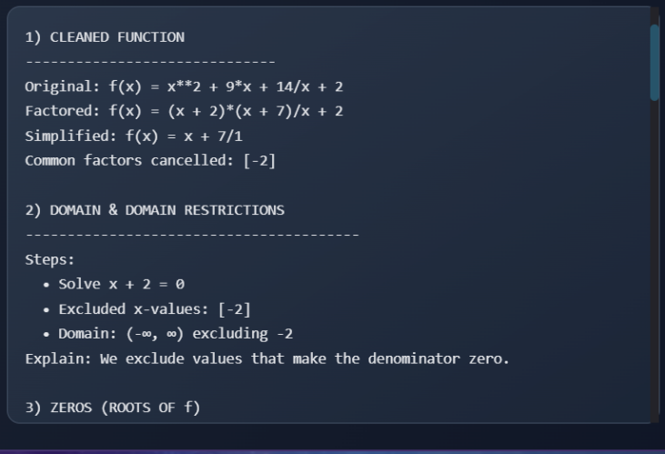

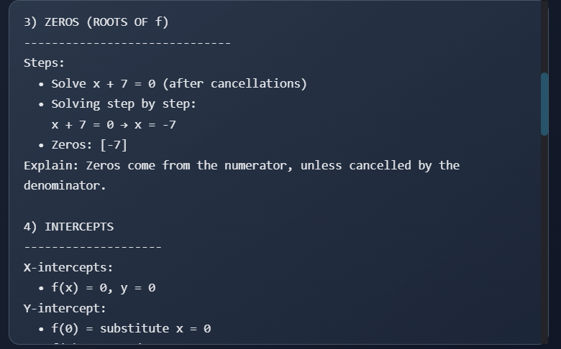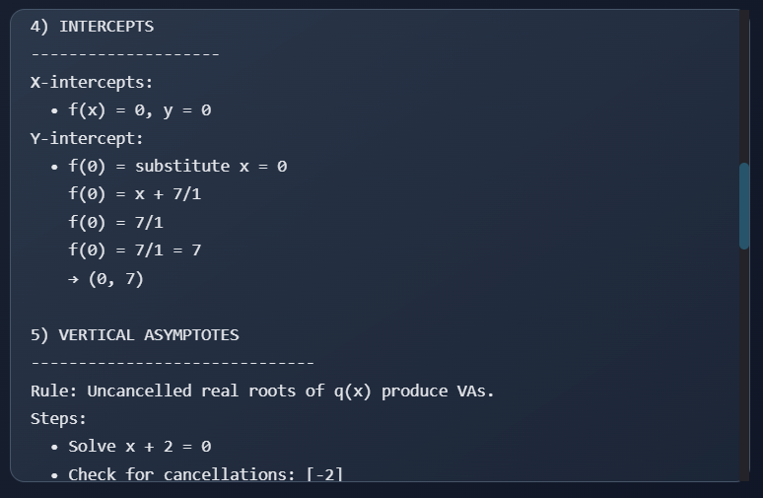

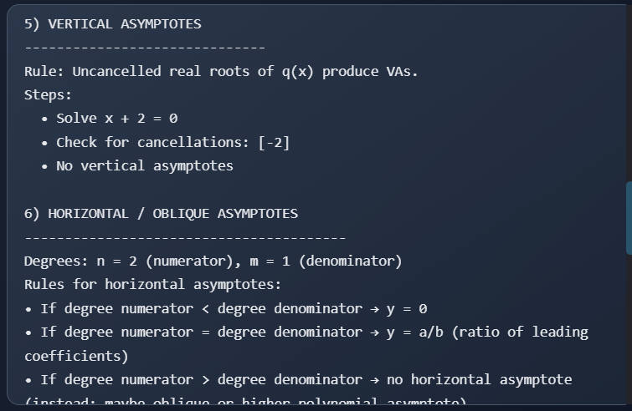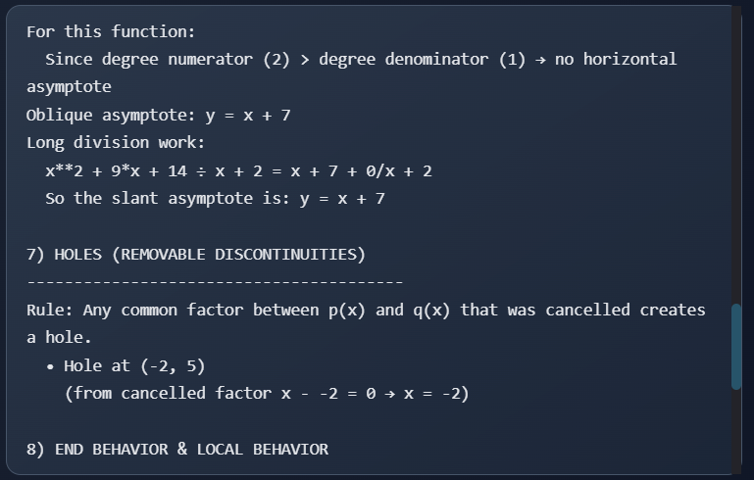

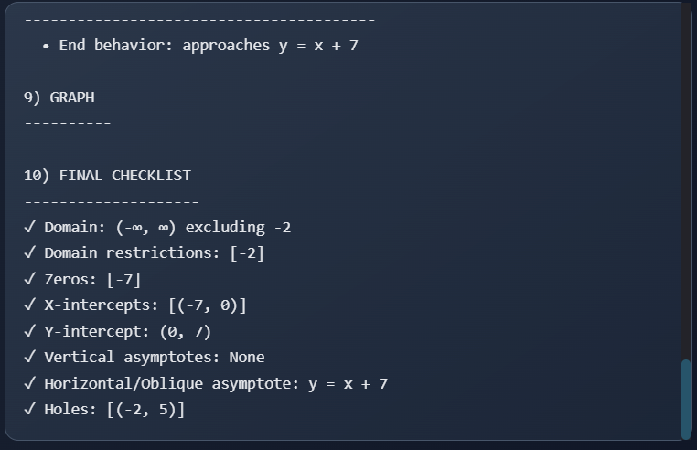

## 

## 

## ***Device actual computation and graph***

**APPENDIX A**

**PERMISSION TO CONDUCT THE RESEARCH**

**Republic of the Philippines**

**Department of Education**

**Region V-Bicol**

**Division of Camarines Norte**

**CAMARINES NORTE SENIOR HIGH SCHOOL**

August 29, 2025

**MAGNOLIA B. DE MESA**

Principal II

Camarines Norte Senior High School

Daet, Camarines Norte

Ma’am:

In preparation for the upcoming Di Mathematics Quest 2025, a team of grade eleven students will be developing a Mathematical Showcase Device. In this light, we are requesting permission from your office to conduct research involving the Grade 11 students of Camarines Norte Senior High School for our study, called CoRTEx: a CNN-based Raspberry Pi mathematical device for solving rational equations and functions.

We are hoping for your favorable action regarding this request. Thank you.

Very truly yours,

**KingNorbeth B. Ilan**

**Marisse R. Magana**

*Researchers*

Approved:

**MAGNOLIA B. DE MESA**

Principal II

**APPENDIX B**

**LETTER TO RESPONDENTS**

**Republic of the Philippines**

**Department of Education**

**Region V-Bicol**

**Division of Camarines Norte**

**CAMARINES NORTE SENIOR HIGH SCHOOL**

**August 29, 2025**

**____________________________**

**____________________________**

**____________________________**

I hope this letter finds you well. In connection with the forthcoming 2025 Division Mathematics Fair, selected eleventh-grade students will be preparing a Mathematical Showcase Device. As part of this initiative, we are conducting a research study titled **CoRTEx**, a CNN-based Raspberry Pi mathematical device for solving rational equations and functions.

With this regard, we kindly request your permission to be one of our research respondents. The research will involve students in manipulating a device designed to enhance their understanding for solving rational equations and functions through a CNN-based Raspberry Pi mathematical device .

We assure you that the research will be conducted in compliance with ethical standards, ensuring the privacy and well-being of all participants. Your support and cooperation will be invaluable to the success of this project.

Very truly yours,

**KingNorbeth B. Ilan**

**Marisse R. Magana**

*Researchers*

Noted by:

**MARJORIE JOY N. RELAVO**

Coach

**APPENDIX C**

**LETTER TO PROFESSIONAL EXPERTS**

**Republic of the Philippines**

**Department of Education**

**Region V-Bicol**

**Division of Camarines Norte**

**CAMARINES NORTE SENIOR HIGH SCHOOL**

August 29, 2025

____________________________

____________________________

We hope this message finds you well. As part of the upcoming 2025 Division Mathematics Quest, selected eleventh-grade students from our school will be preparing a Mathematical Showcase Device. In line with this, we are conducting a research study titled CoRTEx, a CNN-based Raspberry Pi mathematical device for solving rational equations and functions.

The purpose of this study is to explore the potential of a CNN-based Raspberry Pi mathematical device for solving rational equations and functions. We seek the support and expertise of professionals such as yourself to guide, evaluate, and provide feedback on this educational initiative. Your knowledge and experience would be invaluable to ensuring the device’s educational effectiveness and the accuracy of its mathematical content.

We kindly request your permission and cooperation in being part of this research project, where your input will significantly contribute to enhancing the learning experience for our students. Your guidance and professional insights will play a pivotal role in shaping the success of this endeavor.

Very truly yours,

**KingNorbeth B. Ilan**

**Marisse R. Magana**

*Researchers*

Noted by:

**MARJORIE JOY N. RELAVO**

**Coach**

**APPENDIX D**

# **LEAST MASTERED COMPETENCIES**

|  |  |  |  |  |  |
| --- | --- | --- | --- | --- | --- |
|  |  |  |  |  |  |
| **Topics** | **Item Placement** | **Number of Correct responses** | **Average # of correct responses** | **%** | **Rank** |
|  |
| Functions as Models | 1 | **248** | **248** | **87%** | 3 |  |
| Evaluating Functions | 2-4 | **734** | **245** | **86%** | 4 |  |
| Operations on Functions | 5-7 | **647** | **216** | **76%** | 6 |  |
| Solving Real Life Problems Involving Functions | 8-11 | **592** | **148** | **52%** | 13 |  |
| Representing Real-life Situations Using Rational Functions | 12-14 | **503** | **168** | **59%** | 11 |  |
| Rational Functions, Equations and Inequalities | 15-19 | **894** | **179** | **63%** | 9.5 |  |
| Representatios of Rational Functions | 20 | **233** | **233** | **82%** | 5 |  |
| The Domain and Range of Rational Fucntions | 21 | **256** | **256** | **90%** | 1 |  |
| Intercepts, Zeroes, and Asymptotes of Rational Functions | 22-27 | **857** | **143** | **50%** | 14 |  |
| represents real-life situations using one-to one functions. | 28-31 | **632** | **211** | **74%** | 7 |  |
| represents an inverse function through its: (a) table of values, and (b) graph. | 32-34 | **530** | **177** | **62%** | 9.5 |  |
| solves problems involving inverse functions. | 35-40 | **934** | **156** | **55%** | 12 |  |
| represents real-life situations using exponential functions | 41-45 | **912** | **182** | **64%** | 8 |  |
| distinguishes between exponential function, exponential equation, and exponential inequality | 46-50 | **1248** | **250** | **88%** | 2 |  |
| **TOTAL** |  | **9220** |  |  |  |  |
|  |  |  |  |  |  |  |
|  |  |  |  |  |  |  |
| Prepared by: |  |  |  |  |  |  |
|  |  |  |  |  |  |  |
| **MARIVIC A. BABALA** |  |  |  |  |  |  |
| TEACHER II |  |  |  |  |  |  |
|  |  |  |  |  |  |  |

**APPENDIX E**

**INSTRUMENT FOR STUDENT EVALUATORS**

**CORTEX: A CNN-BASED MATHEMATICAL DEVICE FOR SOLVING RATIONAL EQUATIONS AND RATIONAL FUNCTIONS**

**Name:__________________________________________ Date:___________**

***(Optional)***

We, the Grade 11 STEM students ofCamarines Norte Senior High School, developed a project titled “

” This device was created to help students and teachers solve and understand rational equations and functions more easily and accurately.

We kindly ask for your cooperation in answering this short survey to evaluate our device. Your honest feedback will be valuable in improving CoRTEx and making it more effective for classroom use. All responses will be treated with confidentiality and used only for academic purposes**.**

**Direction:** Please indicate your level of agreement with each statement by checking the column that corresponds to your response.

|  |  |
| --- | --- |
| **Scale** | **Description** |
| 5 | Strongly Agree |
| 4 | Agree |
| 3 | Neutral |
| 2 | Disagree |
| 1 | Strongly Disagree |

|  |  |  |  |  |  |
| --- | --- | --- | --- | --- | --- |
| Indicators | (Strongly Disagree)  1 | (Disagree)  2 | (Neutral)  3 | (Agree)  4 | (Strongly Agree)  5 |
| **A. USABILITY** |  |  |  |  |  |
| 1. The device is easy to operate even for first-time users. |  |  |  |  |  |
| **2.** The interface and buttons are clear and easy to understand. |  |  |  |  |  |
| **3.** I can navigate through the device without needing help. |  |  |  |  |  |
| **4.** The handwriting recognition is accurate and responsive. |  |  |  |  |  |
| **5.** The step-by-step display helps me understand the process better. |  |  |  |  |  |
| **B. TECHNICAL ASPECTS** |  |  |  |  |  |
| 1. The device performs tasks quickly and efficiently. |  |  |  |  |  |
| 2. The results produced by the device are accurate. |  |  |  |  |  |
| 3. The input, display, and output functions work well together. |  |  |  |  |  |
| 4. The device runs smoothly without system errors. |  |  |  |  |  |
| 5. The device works even without an internet connection. |  |  |  |  |  |
| **C. DEVICE DESIGN** |  |  |  |  |  |
| 1. The design of the device is suitable for students. |  |  |  |  |  |
| 2. The display layout and visuals are appealing and engaging. |  |  |  |  |  |
| 3. The materials used are durable and appropriate. |  |  |  |  |  |
| 4. The device is lightweight and compact, making it easy to transport and use on the go. |  |  |  |  |  |
| 5. The overall appearance motivates me to use it more often. |  |  |  |  |  |

**Scoring and Interpretation**

|  |  |
| --- | --- |
| **Range** | **Interpretation** |
| 4.21 – 5.00 | Very Highly Acceptable |
| 3.41 – 4.20 | Highly Acceptable |
| 2.61 – 3.40 | Moderately Acceptable |
| 1.81 – 1.80 | Slightly Acceptable |
| 1.00 – 1.80 | Not Acceptable |

THANK YOU

**APPENDIX F**

**ACCOMPLISHED INSTRUMENT OF A STUDENT EVALUATOR**

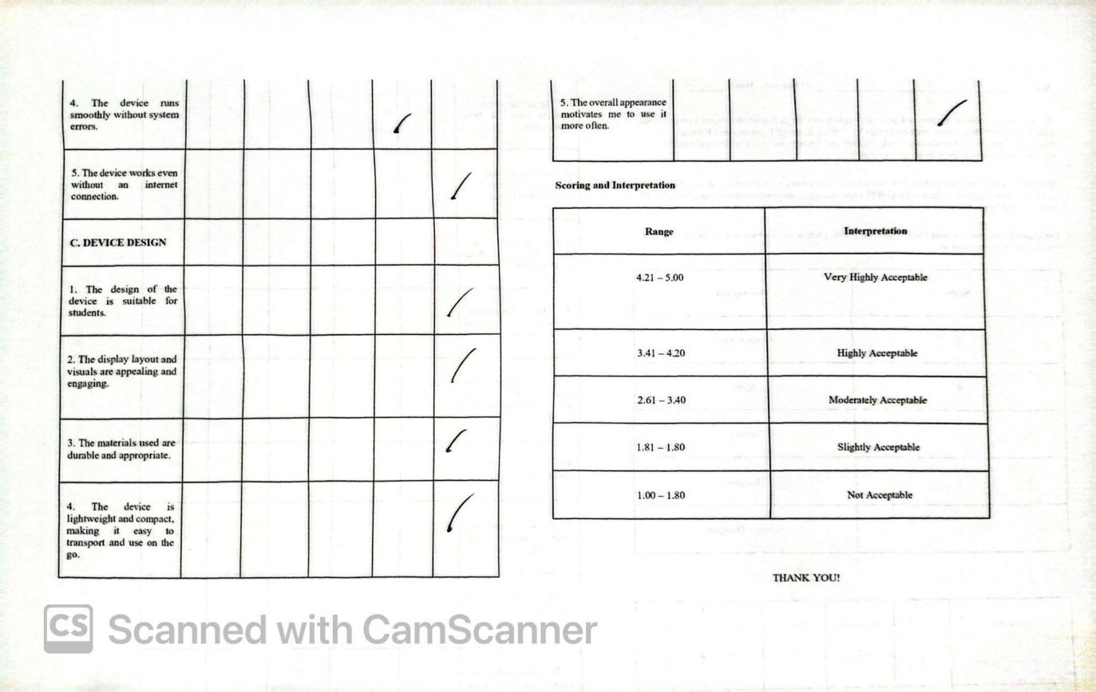

**APPENDIX G**

**INSTRUMENT FOR TEACHER EVALUATORS**

**CORTEX: A CNN-BASED MATHEMATICAL DEVICE FOR SOLVING RATIONAL EQUATIONS AND RATIONAL FUNCTIONS**

**Name:__________________________________________ (Optional) Date:___________**

We, the Grade 11 STEM students of Camarines Norte Senior High School, developed a project titled “CoRTEx: A CNN-Based Mathematical Device for Solving Rational Equations and Rational Functions.” This device aims to assist teachers in demonstrating and solving rational equations and functions more efficiently in the classroom.

We kindly seek your cooperation in answering this short survey to evaluate the device’s accuracy, usability, and overall design. Your honest responses will be very helpful in improving CoRTEx. All answers will be kept **confidential** and used **solely for academic purposes**.

**Direction:** Please indicate your level of agreement with each statement by checking the column that corresponds to your response.

|  |  |
| --- | --- |
| **Scale** | **Description** |
| 5 | Strongly Agree |
| 4 | Agree |
| 3 | Neutral |
| 2 | Disagree |
| 1 | Strongly Disagree |

|  |  |  |  |  |  |
| --- | --- | --- | --- | --- | --- |
| Indicators | (Strongly Disagree)  1 | (Disagree)  2 | (Neutral)  3 | (Agree)  4 | (Strongly Agree)  5 |
| **A. ACCURACY OF DEVICE IN SOLVING & GRAPHING** |  |  |  |  |  |
| 1. The device generates accurate results for rational equations |  |  |  |  |  |
| **2.** The device produces precise graphs of rational functions. |  |  |  |  |  |
| **3.** Thestep-by-step solution follows proper mathematical procedures. |  |  |  |  |  |
| **4.** CoRTEx can match the accuracy of manual solving. |  |  |  |  |  |
| 5. The device gives consistent results when used multiple times. |  |  |  |  |  |
| **B. PEDAGOGICAL VALUE** |  |  |  |  |  |
| 1. The device can help simplify the discussion of rational equations. |  |  |  |  |  |
| 2. The device may encourage student engagement in learning mathematics. |  |  |  |  |  |
| 3. The device can promote independent learning among students. |  |  |  |  |  |
| 4. The device can serve as an effective visual aid during lessons. |  |  |  |  |  |
| 5. Using the device can improve students’ conceptual understanding. |  |  |  |  |  |
| **C. USABILITY** |  |  |  |  |  |
| 1. The device is easy to operate even without prior training. |  |  |  |  |  |
| 2. The device interface will likely be user-friendly for both teachers and students. |  |  |  |  |  |
| 3. The device offers connectivity options for enhanced visibility during presentations or group learning. |  |  |  |  |  |
| 4. The device consistently delivers accurate calculations and precise graphical representations. |  |  |  |  |  |
| 5. The device can be integrated with other subjects, enhancing its versatility and educational value. |  |  |  |  |  |
| **D. TECHNICAL ASPECTS** |  |  |  |  |  |
| 1. The device runs smoothly without errors. |  |  |  |  |  |
| 2. The computation and response time is be fast. |  |  |  |  |  |
| 3. The device works even without a stable internet connection. |  |  |  |  |  |
| 4. The device produces consistent results across tests. |  |  |  |  |  |
| 5. The device has dependable power and hardware performance. |  |  |  |  |  |
| **D. DEVICE DESIGN** |  |  |  |  |  |
| 1. The design is visually appealing and suitable for classrooms. |  |  |  |  |  |
| 2. The materials used are durable and safe. |  |  |  |  |  |
| 3. The overall design promotes focus and convenience. |  |  |  |  |  |
| 4. The display layout is likely clear and easy to read. |  |  |  |  |  |
| 5. The device’s physical design can attract students’ interests. |  |  |  |  |  |

**Scoring and Interpretation**

|  |  |
| --- | --- |
| **Range** | **Interpretation** |
| 4.21 – 5.00 | Very Highly Acceptable |
| 3.41 – 4.20 | Highly Acceptable |
| 2.61 – 3.40 | Moderately Acceptable |
| 1.81 – 1.80 | Slightly Acceptable |
| 1.00 – 1.80 | Not Acceptable |

**APPENDIX H**

**ACCOMPLISHED INSTRUMENT OF TEACHER EVALUATOR**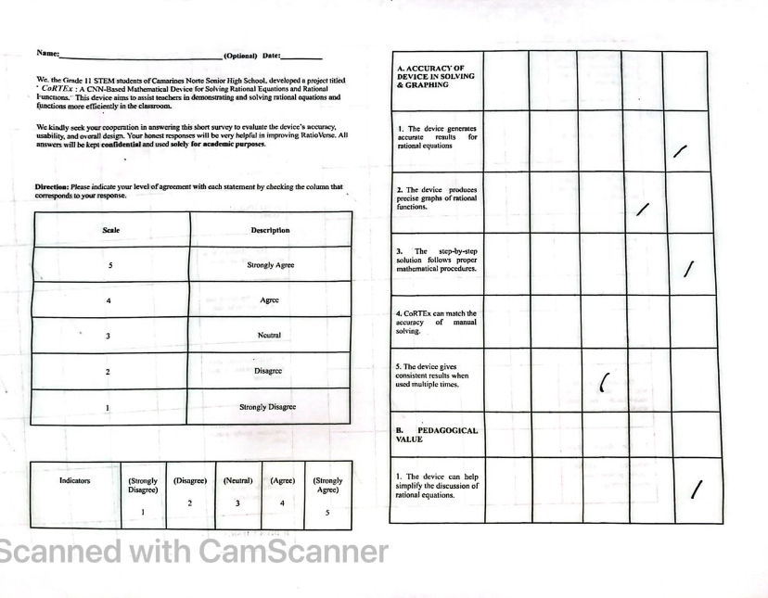

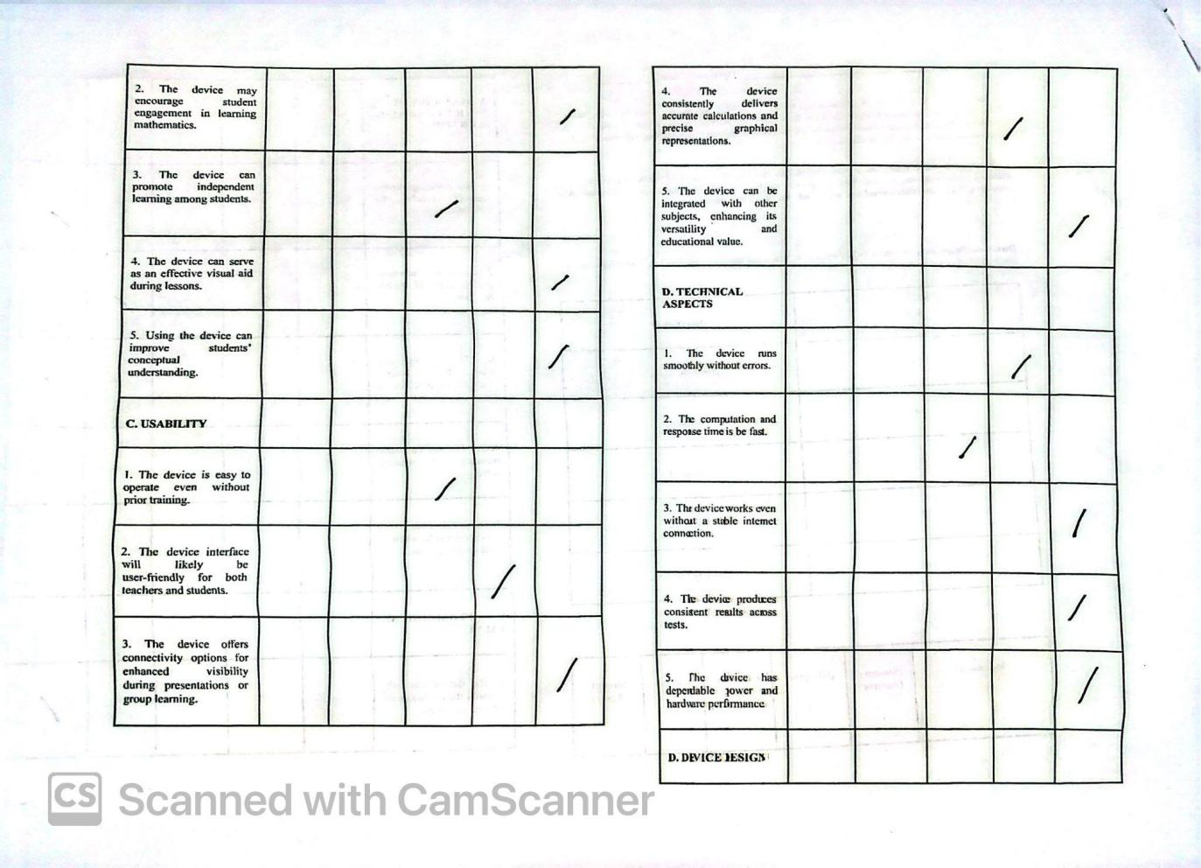

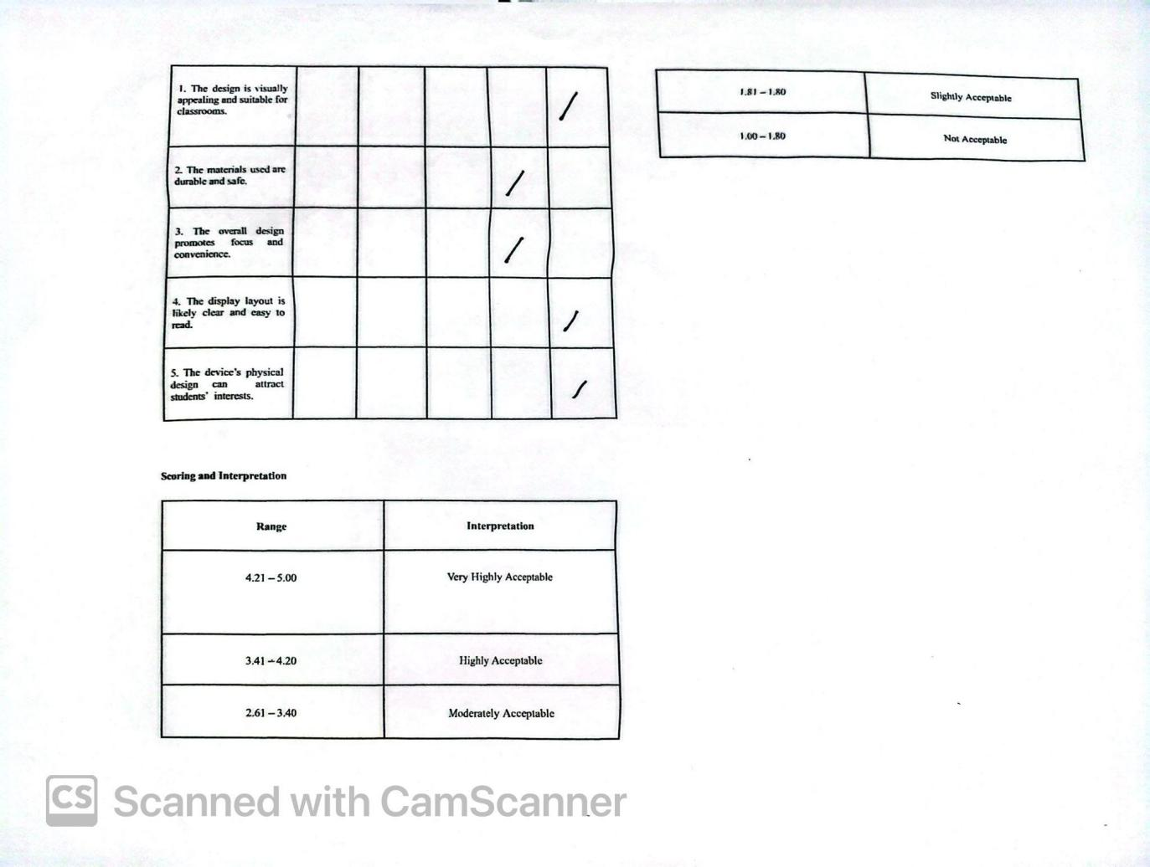

**APPENDIX I**

**TEST INSTRUMENT USED IN PRETEST AND POST TEST**

**CoRTEx:** A CNN-Based Mathematical Device for Solving Rational Equations and Rational Functions

Name: _______________________   Score: _______________________

**Direction:** Solve the following rational equations and encircle the correct letter. Write the solution on the back of the test paper.

1. What is the value of x in the rational equation (x / 4) = 3?

A. 7 B. 12 C. 4 D. 1

2. What is the value of x in (x + 2) / 3 = 5?

A. 10 B. 13 C. 15 D. 6

3. Solve for x: (3 / (x - 1)) = 9

A. x = 4/3 B. x = ⅓ C. x = ⅔ D. x = 1/9

4. Find the value of (x + 1) / (x - 3) = 2.

A. 4 B. 5 C. 6 D. 7

5. What is the value of x in (5 / x) = (3 / 2)?

A. x = 10/3 B. x = 5/3 C. x = 2.5 D. x = 3

6. Solve for x: (3 / (x + 2)) = (2 / 5).

A. x = 11/2 B. x = 15/2 C. x = 7/2 D. x = 9/2

7. Which equation has no solution?

A. (x + 1) / (x - 1) = 1 C. (x + 4) / (x + 4) = 1

B. (x - 3) / (x - 3) = 1 D. (x - 2) / (x - 2) = 1

8. Which of the following is a rational equation?

A. x² + 3x = 0 C. 3x + 5 = 7

B. (2x + 1) / (x - 4) = 3 D. 2x² = 8

9. Which of the following is a rational function?

A. f(x) = 3x + 2 C. f(x) = √x

B. f(x) = (x + 1) / (x - 2) D. f(x) = x² + 4x + 4

10. What is the domain of f(x) = 1 / (x - 3)?

A. All real numbers B. x ≠ 3 C. x > 3 D. x < 3

11. What is the vertical asymptote of f(x) = 2 / (x + 1)?

A. x = 0 B. x = 2 C. x = -1 D. x = 1

12. What is the horizontal asymptote of f(x) = 3x / (x + 4)?

A. y = 3 B. y = 4 C. y = 1 D. y = -4

13. The graph of f(x) = (x - 2) / (x + 1) will have a vertical asymptote at:

A. x = -1 B. x = 2 C. x = 1 D. x = 0

14. Under what condition does a hole appear in the graph of f(x)?

A. When the denominator equals 0 and cannot be canceled

B. When the numerator is 0

C. When a factor cancels from numerator and denominator

D. When x = 0

15. Find the x-intercept of f(x) = (x - 4) / (x + 2).

A. (0, 0) B. (4,0) C. (-2,0) D. (2,0)

16. Which function could have a vertical asymptote?

A. ( f(x) = 3x ) B. ( f(x) = x + 5 ) C. ( f(x) = 1 / x ) D. ( f(x) = x^2 + 1 )

17. Which of the following graphs represents a **rational function**?

A. B.

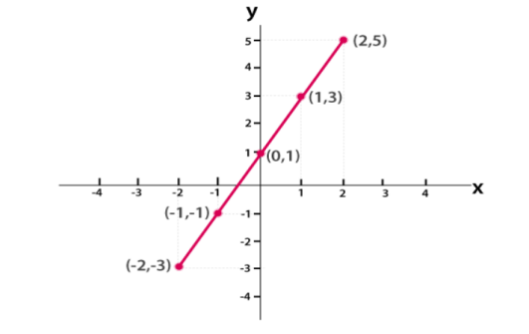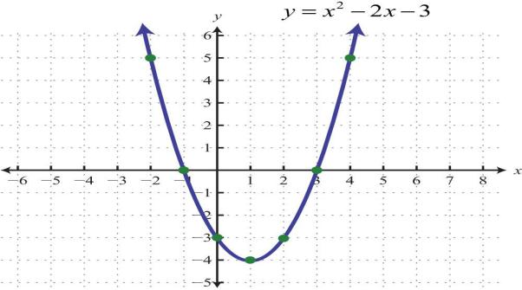

C. D. 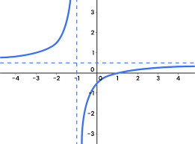

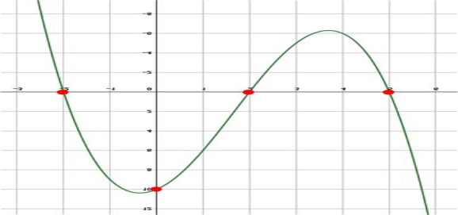

18. Which rational function presents a graph with two vertical asymptotes?

A. f(x) = (x + 1)(x - 2) C. f(x) = (x² + 1) / (x + 1)

B. f(x) = 1 / ((x + 1)(x - 2)) D. f(x) = 1 / x²

19. The cost C (in pesos) of producing x items of a product is given by C(x) = 500 + 20x. The average cost per item is given by A(x) =

$\frac{C(x)}{x}$ = $\frac{500+20x}{x}$. How many items must be produced so that the average cost per item is Php 25?

1. x = 0
2. x = 1
3. x = 2
4. No solution

20. A local baker sells special boxes of Pili Tarts. The baker's daily profit, p, in hundreds of Philippine Pesos, depends on the price, x, of one box of tarts in pesos. The profit is modeled by the function:

P(x) = $\frac{120}{x−4}$ + $\frac{180}{x − 60}$- 10

The baker wants to know the price points at which she will **break even**, meaning she makes zero profit (P(x)=0)

Which of the following equations must be solved to find the break-even price(s) for a box of Pili Tarts?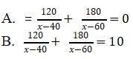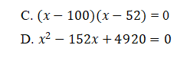

**ANSWER KEY**

1. B 2. B 3. A 4. D 5. A 6. A 7. A 8. B 9. B 10. B

11. C 12. A 13. A 14. C 15. B 16. C 17. C 18. B 19. D 20. B

**APPENDIX J**

**ACCOMPLISHED TEST INSTRUMENT USED IN THE PRE TEST AND POST TEST** 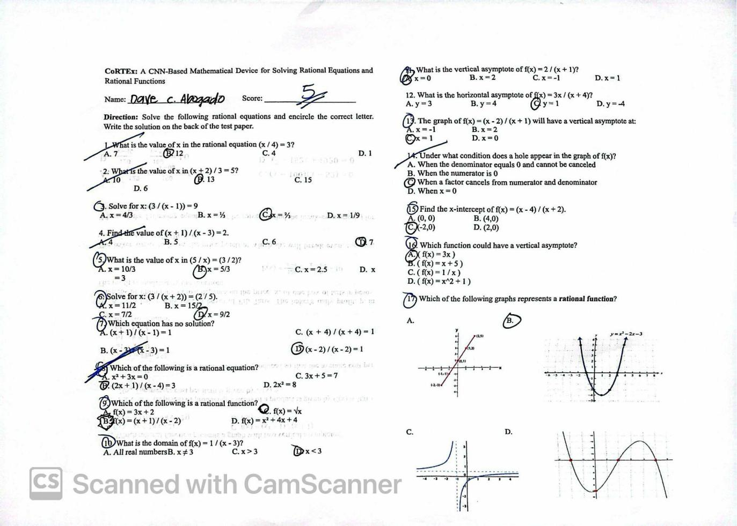

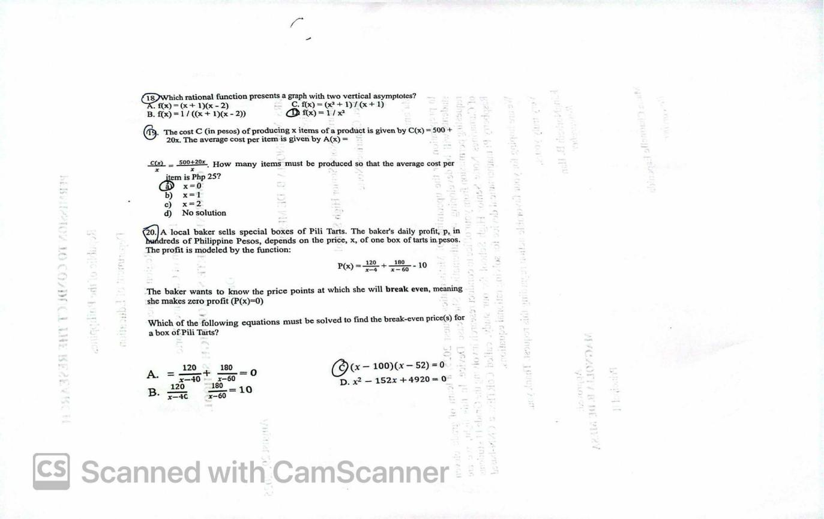

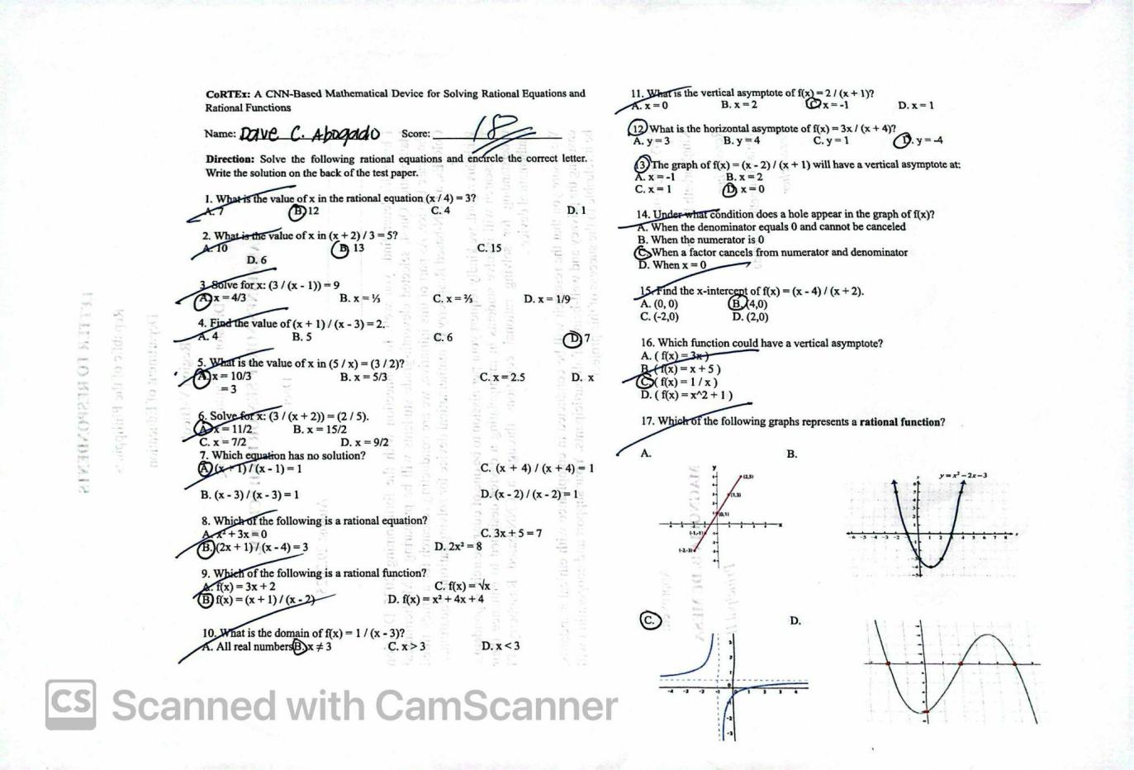

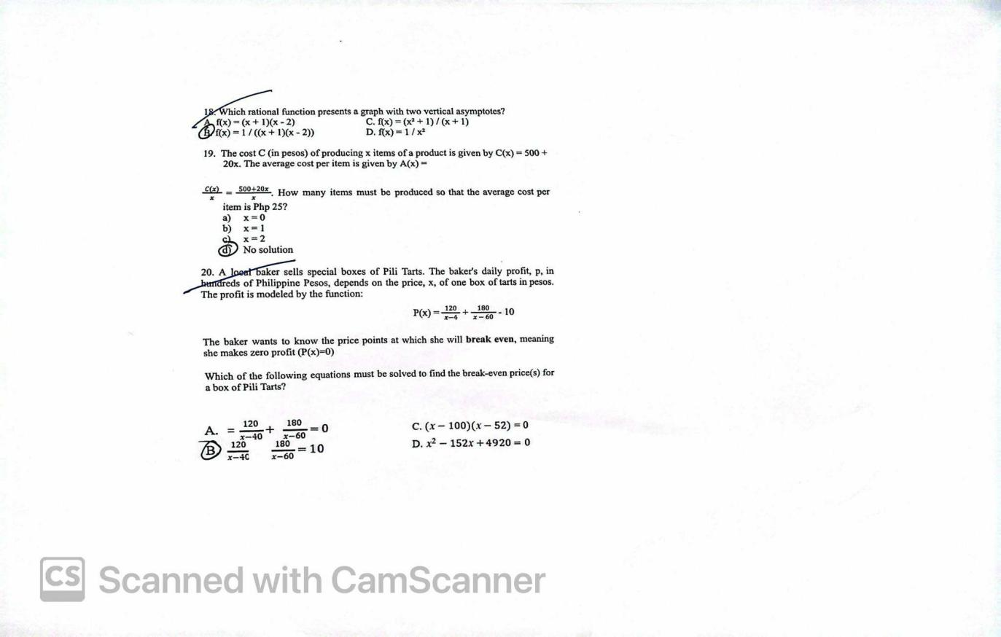

# **APPENDIX K**

# **PROGRAM CODE DOCUMENTATION**

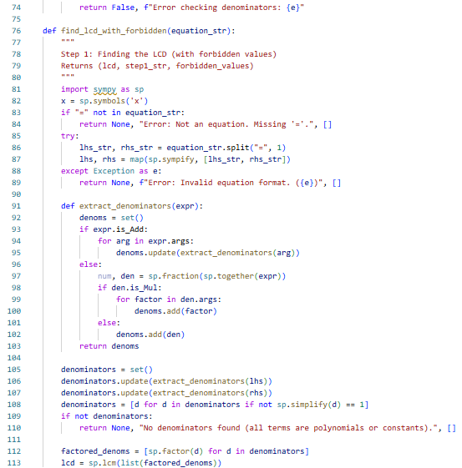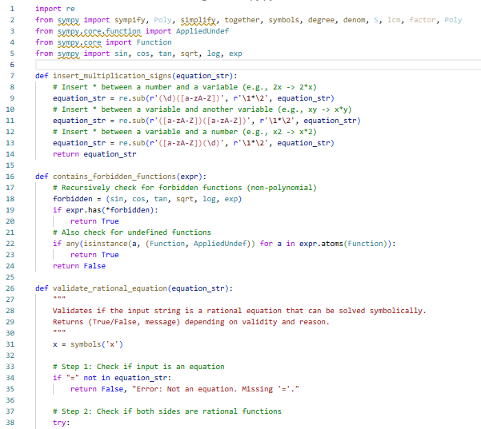

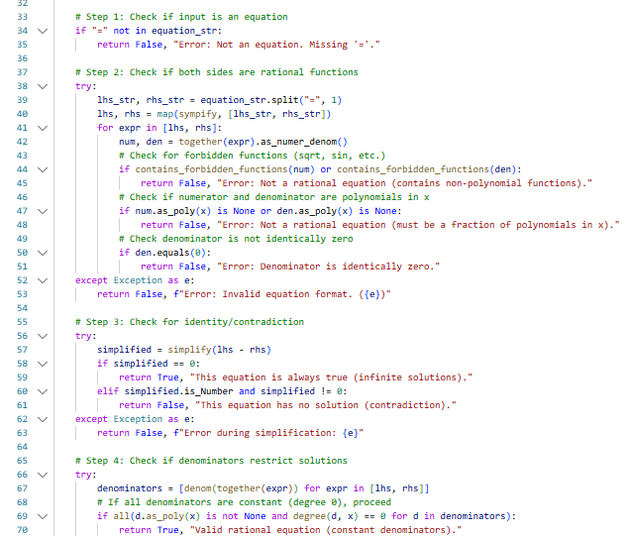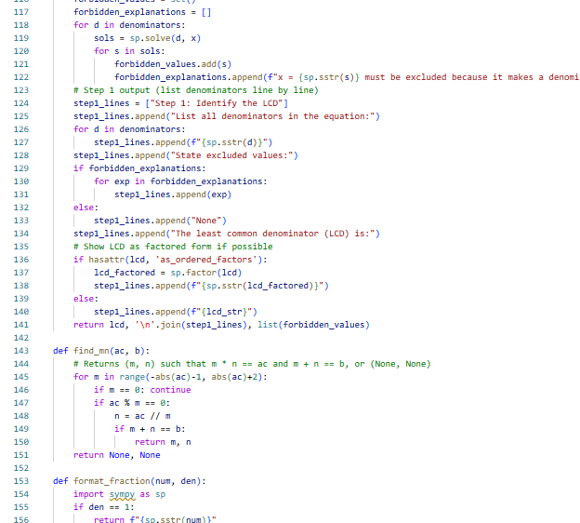

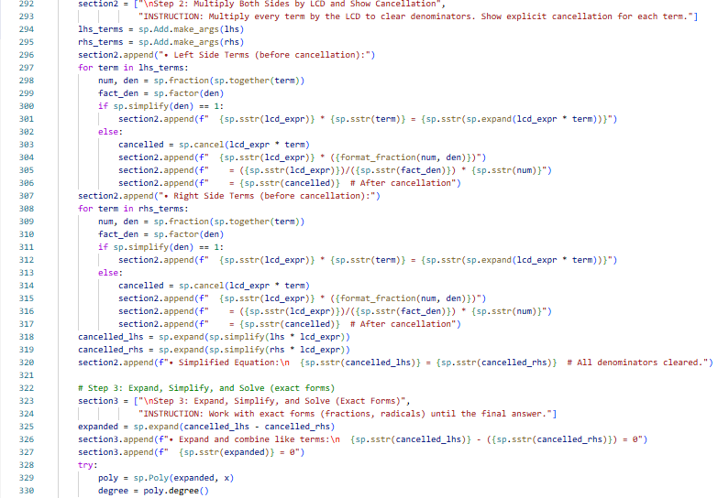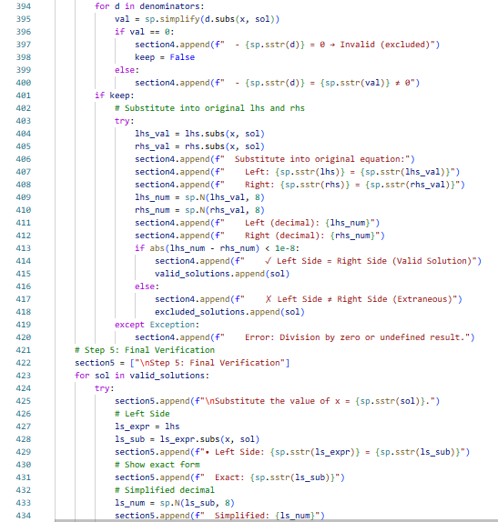

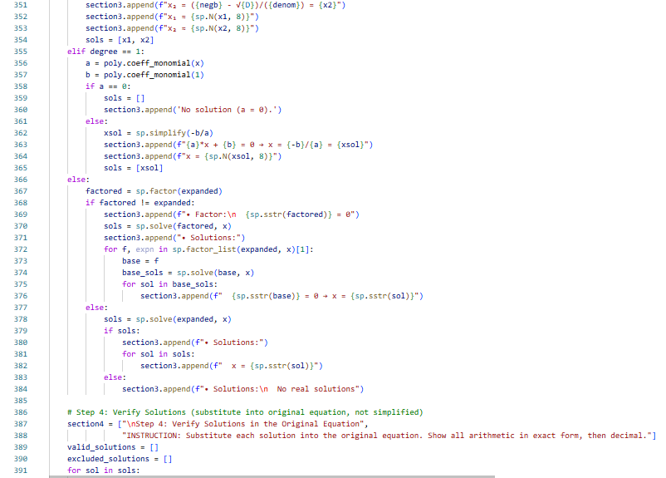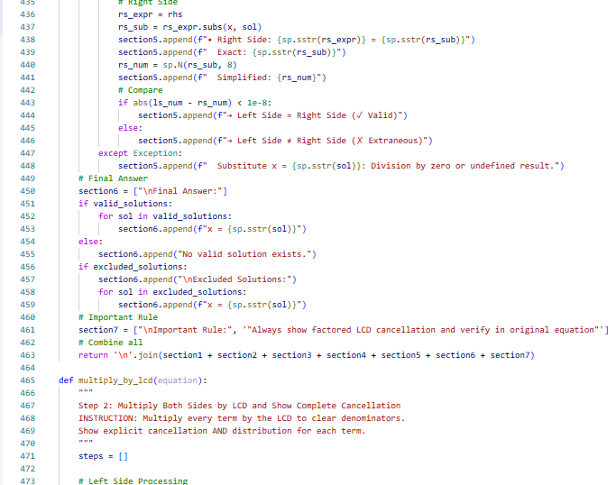

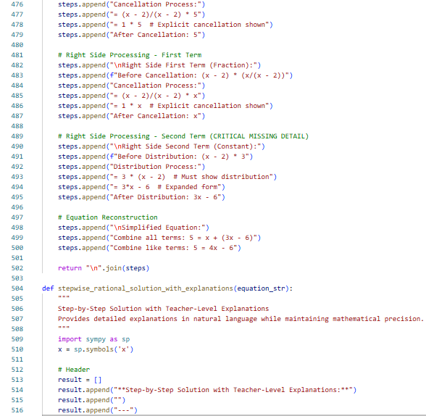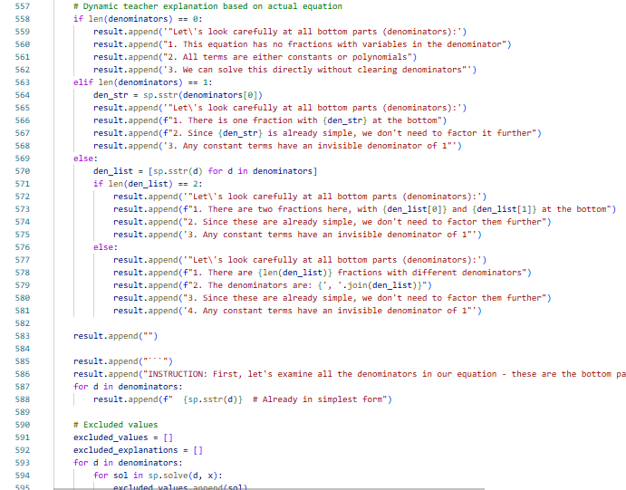

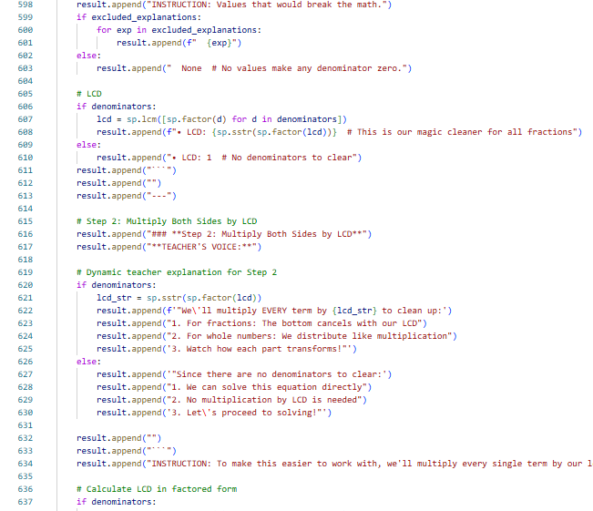

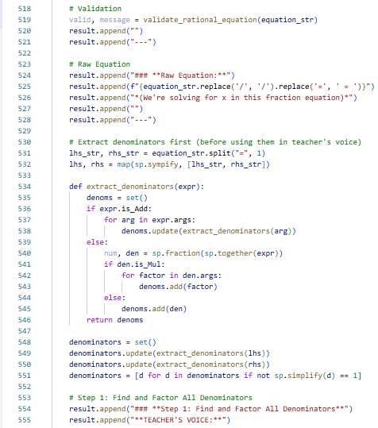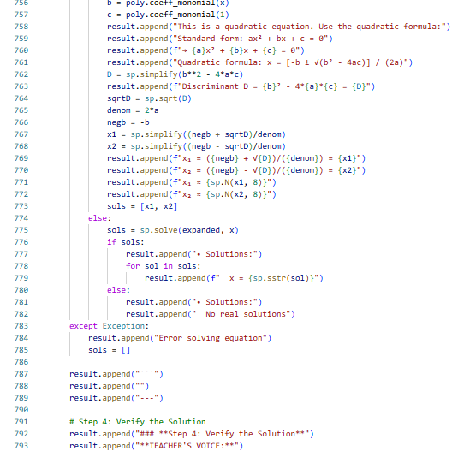

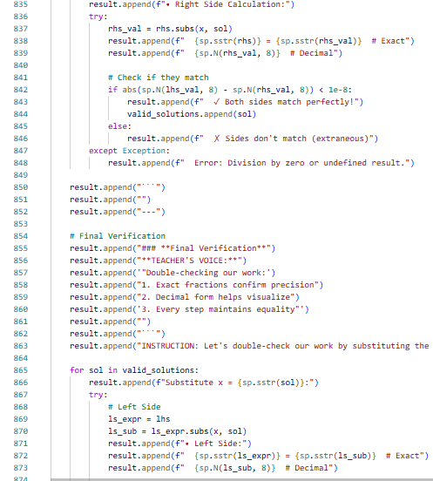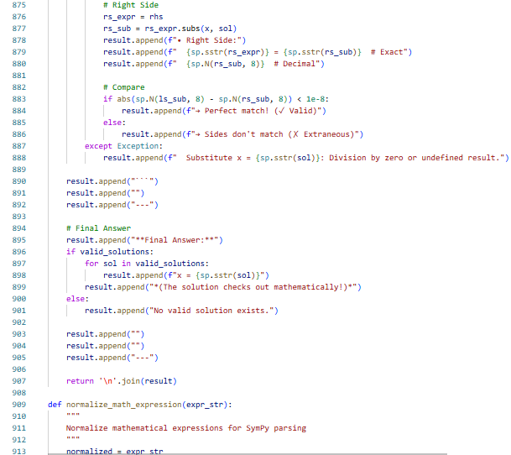

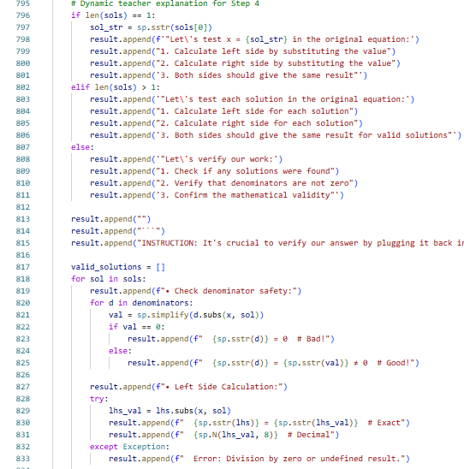

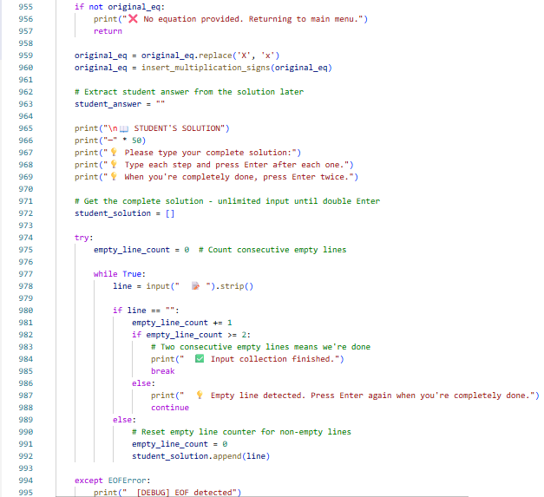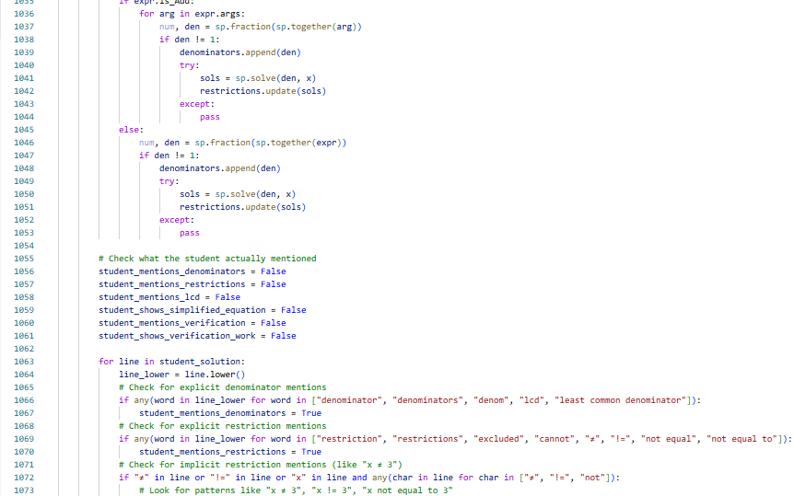

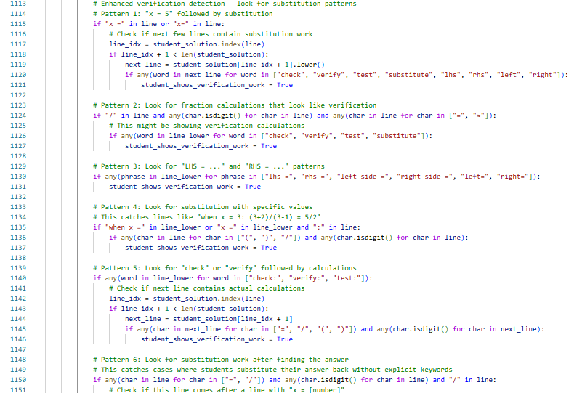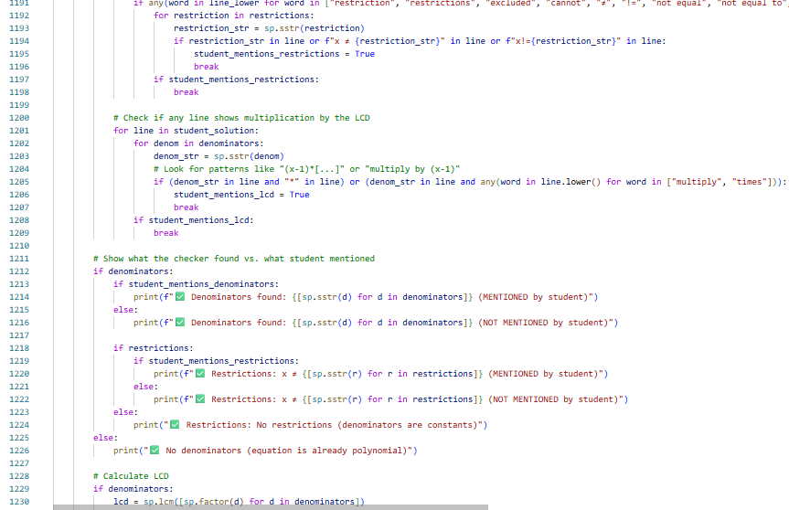

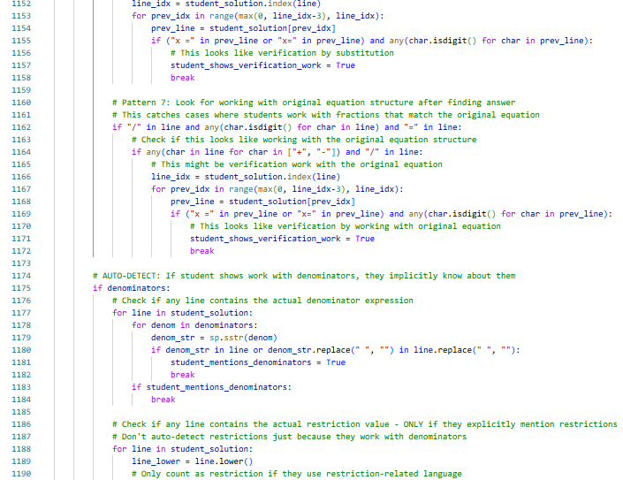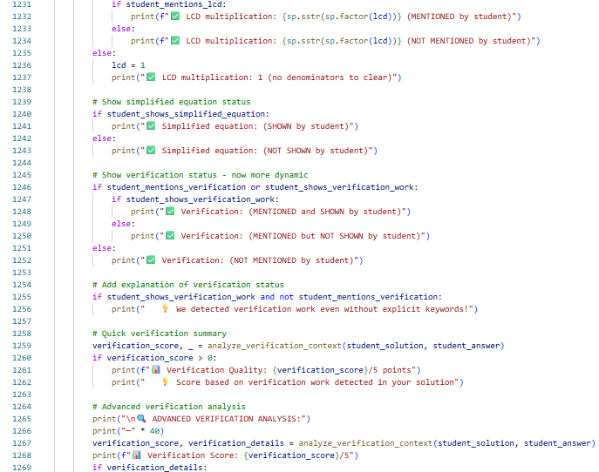

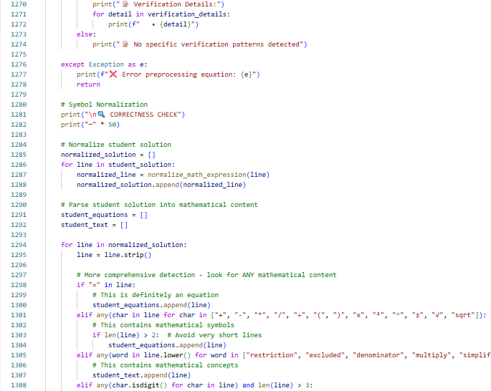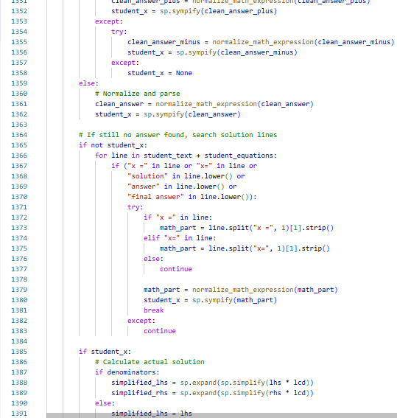

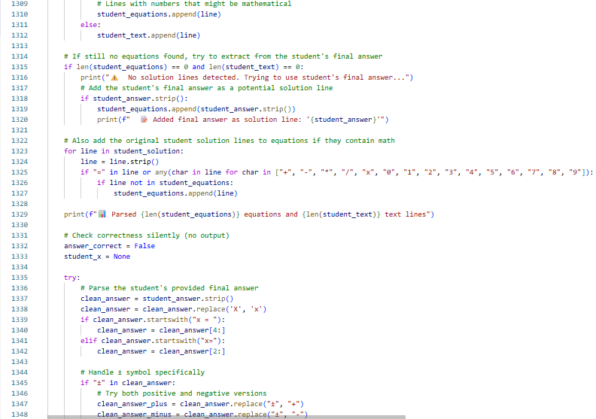

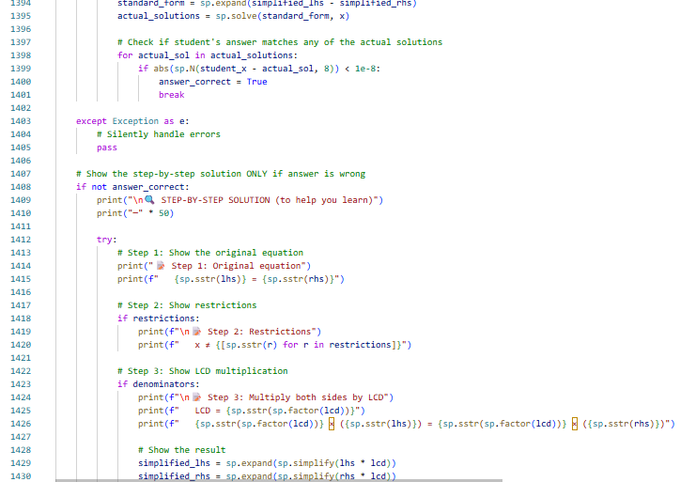

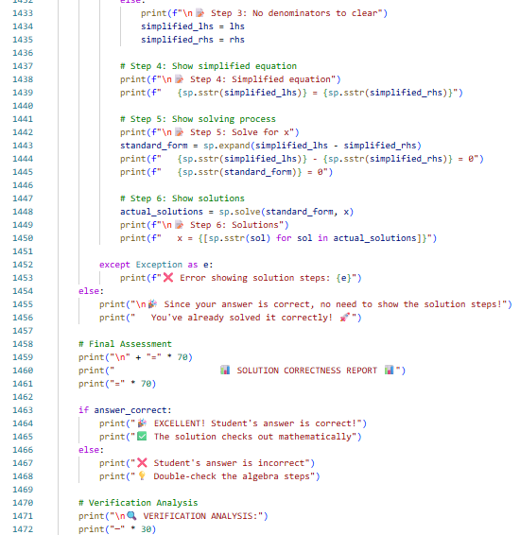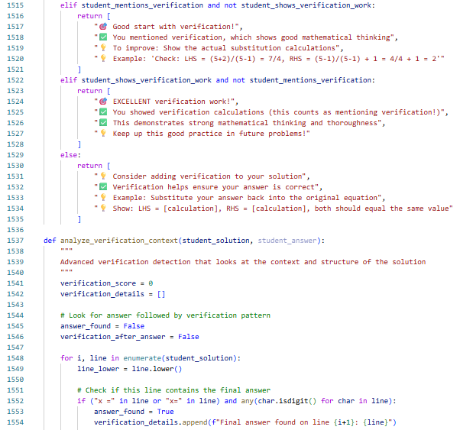

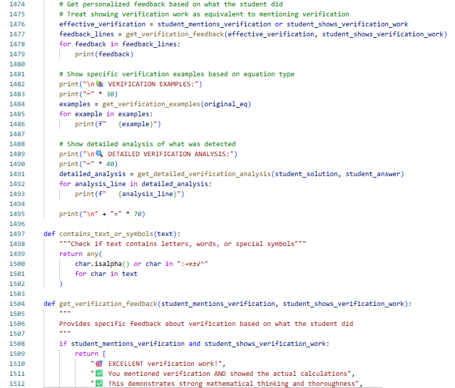

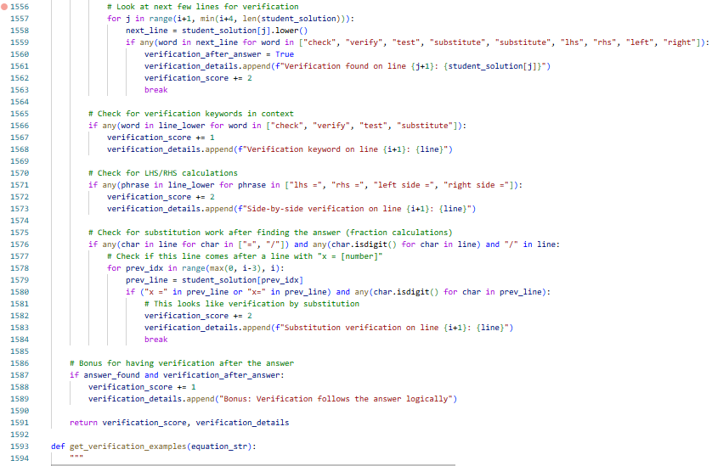

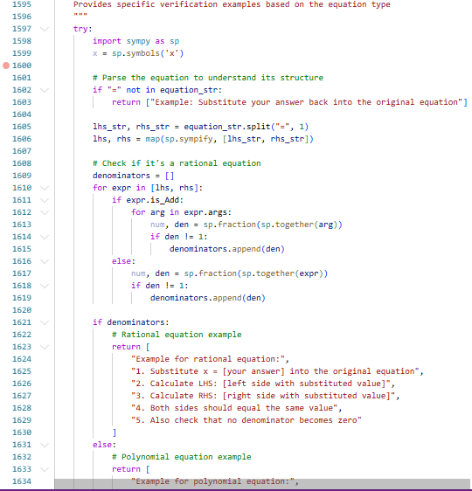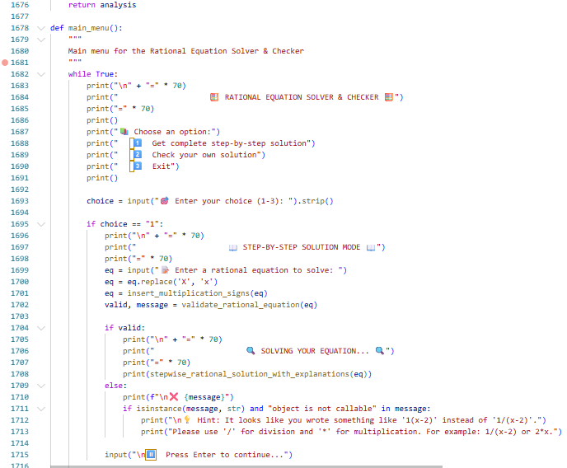

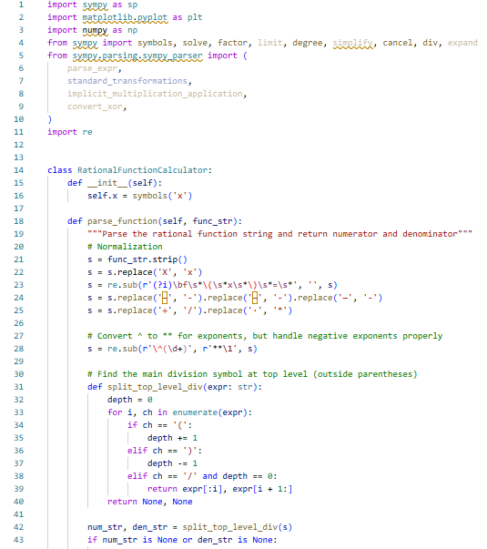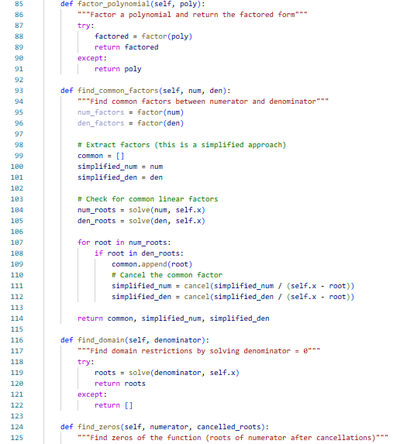

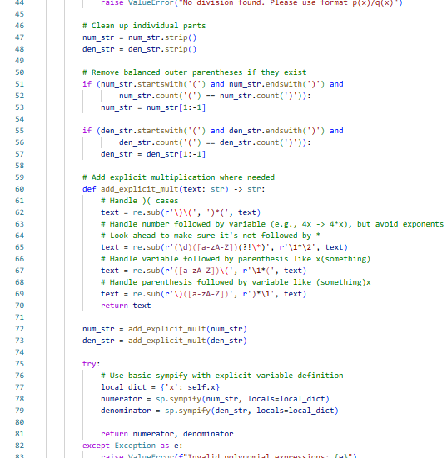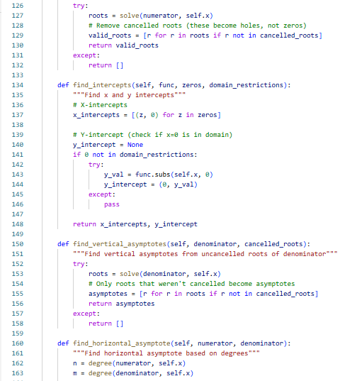







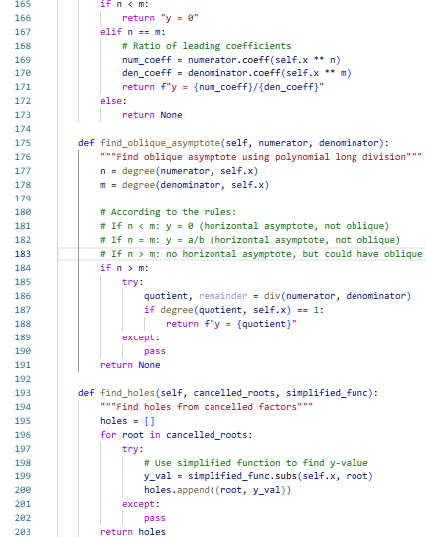

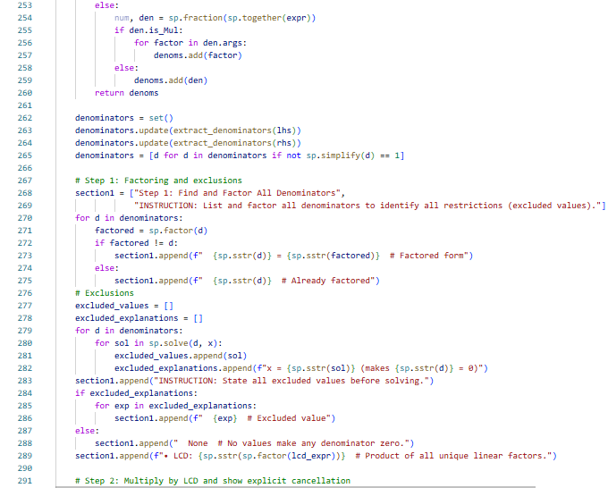

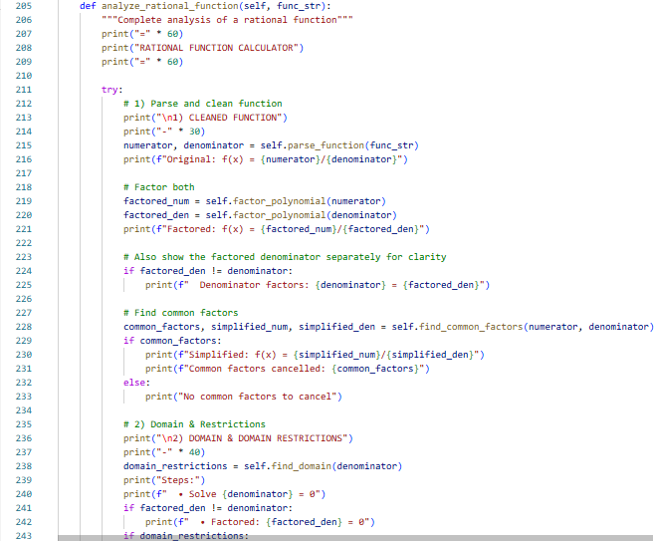



**APPENDIX L**

**COST ANALYSIS**

|  |  |  |  |
| --- | --- | --- | --- |
| **QUANTITY** | **UNIT** | **DESCRIPTION** | **AMOUNT** |
| 1 | pc | Raspberry pi 3 2GB RAM | P 1000.00 |
| 1 | pc | 7 INCH WAVESHARE DSI LCD | P 700.00 |
| 2 | pcs | XPPEN Drawing Tablet | P 500.00 |
| 2 | pcs | 20000 MAH Powerbank | P 250.00 (Reuse) |
| 1 | pc | Mini Metal Stereo Speakers | P 70.00 (Reuse) |
| 6 | pcs | Aluminum Carrying Case 18*11*5.5cm | P 150.00 |
| **SUBTOTAL** |  |  | P 2,670 |

**APPENDIX M**

**RAW SCORES OF STUDENTS IN PRE TEST AND POST TEST EVALUATION**

|  |  |  |  |  |  |  |  |  |  |  |  |
| --- | --- | --- | --- | --- | --- | --- | --- | --- | --- | --- | --- |
| Student Pre Post Diffe  No. Test Test rence  Score Score | | | | Student Pre Post Diffe  No. Test Test rence  Score Score | | | | Student Pre Post Diffe  No. Test Test rence  Score Score | | | |
| 1.  2.  3.  4.  5.  6.  7.  8.  9.  10.  11.  12.  13.  14.  15.  16.  17.  18.  19.  20.  21.  22.  23.  24.  25.  26.  27.  28. | 8  6  9  7  8  5  6  7  8  9  5  6  7  8  9  5  6  7  8  9  5  6  7  8  9  5  6  7 | 12  12  13  12  13  12  13  14  15  16  13  14  15  16  17  14  15  16  17  18  15  16  17  18  19  16  17  18 | 4  6  4  5  5  7  7  7  7  7  8  8  8  8  8  9  9  9  9  9  10  10  10  10  10  11  11  11 | 29.  30.  31.  32.  33.  34.  35.  36.  37.  38.  39.  40.  41.  42.  43.  44.  45.  46.  47.  48.  49.  50.  51.  52.  53.  54.  55.  56. | 7  8  5  6  7  8  9  5  6  7  8  9  5  6  7  8  9  5  6  7  8  9  5  6  7  8  9  8 | 12  13  12  13  14  15  16  13  14  15  16  17  14  15  16  17  18  16  17  18  19  20  18  19  20  20  20  20 | 5  5  7  7  7  7  7  8  8  8  8  8  9  9  9  9  9  11  11  11  11  11  13  13  13  12  11  12 | 57.  58.  59.  60.  61.  62.  63.  64.  65.  66.  67.  68.  69.  70.  71.  72.  73.  74.  75.  76.  77.  78.  79.  80.  81.  82.  83.  84. | 9  7  8  9  5  6  7  8  9  5  6  7  8  9  5  6  7  8  9  5  6  7  8  9  8  7  6  5 | 15  13  14  15  12  13  14  15  16  14  15  16  17  18  15  16  17  18  19  17  18  19  20  20  20  19  18  17 | 6  6  6  6  6  7  7  7  7  7  9  9  9  9  10  10  10  10  10  12  12  12  12  11  12  12  12  12 |

**APPENDIX N**

**ENCLOSURES**



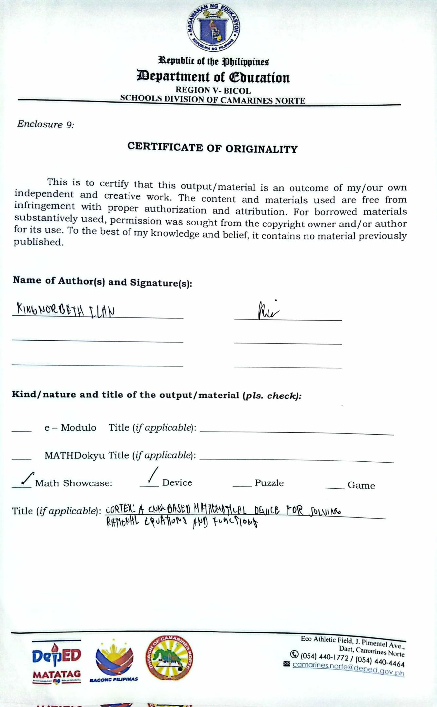



**DIVISION MATHEMATICS FAIR 2025**

**MATH SHOWCASE STUDENT DEVICE CATEGORY**

**Presenters: KING NORBETH B. ILAN**

**MARIA CHARMELLE B. ESPENIDA**

**Respective Position Title/Designation: Grade 11- Trustworthiness**

**School: Camarines Norte Senior High School**

**District: Daet South District**

**Coach: Marjorie Joy N. Relavo**

**School Head: Magnolia B. De Mesa**

**PSDS: Dr. Renita B. Abraham**

